**Streetsblog Chicago**

**CDOT: Direct State/Lake – Red transfer was impossible, but wheelchair access will improve**

By John Greenfield Jul 8, 2021

[https://chi.streetsblog.org/2021/07/08/cdot-direct-state-lake-red-transfer-was-impossible-but-wheelchair-access-will-improve/](https://gcc02.safelinks.protection.outlook.com/?url=https%3A%2F%2Fchi.streetsblog.org%2F2021%2F07%2F08%2Fcdot-direct-state-lake-red-transfer-was-impossible-but-wheelchair-access-will-improve%2F&data=04%7C01%7CMconnelly%40transitchicago.com%7C1b7af1c37f0c40a03fd908d942e12cdc%7C6174173c95354211a564c3c1c562dd6e%7C0%7C0%7C637614357161531122%7CUnknown%7CTWFpbGZsb3d8eyJWIjoiMC4wLjAwMDAiLCJQIjoiV2luMzIiLCJBTiI6Ik1haWwiLCJXVCI6Mn0%3D%7C1000&sdata=Wcq6xQu6P7ElHvt%2BIyFff%2BAuoDTAh5Js3AyrXsZrHu8%3D&reserved=0)

story, comments

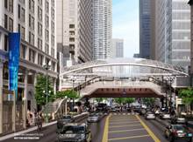

A new elevator just south of Lake Street will make it easier to transfer between the Loop 'L' lines and the Red Line subway.

When Streetsblog Chicago reported on plans for the sleek, wheelchair-accessible new State/Lake ‘L’ station, with a $180 million price tag, there was immediate pushback from readers in the comments and on Twitter.

“Such a missed opportunity that there’s no direct Red Line transfer within the paid zone,” commented one person. “It makes transferring much easier, especially for tourists and occasional riders. And it exists at Clark/Lake for the Blue Line so it’s confusing why CTA won’t attempt it here.” Here’s another response.



Our coverage was based on a news release from the city, which noted that, “The project will also add four elevators located at each corner of State and Lake — there are currently none — to make the station fully accessible… The new station will also improve connectivity between the elevated lines of the downtown Loop and the underground Red Line on State Street.”

But after the outcry from readers, I promised to check in with the Chicago Department of Transportation, which is leading the construction project, to find out why an in-system transfer didn’t appear to be in the works. My assumption was that wheelchair users would still need to exit the station and roll a block and a half south at street level to the existing elevator in front of the Block 37 mall in order to make the transfer to the Red Line.



The existing elevator to the Red Line subway in front of the Block 37 shopping mall, at the southwest corner of Randolph and State. Photo: Google Maps

CDOT spokesperson Mike Claffey confirmed that the new station will not include a direct, in-system transfer between the Loop Elevated lines and the Red Line. “It was physically not possible,” he said. “The  alignment of the subway mezzanine [located one level below the the street] and Red Line underground platform and tracks [located one level below the mezzanine] in relation to the elevated tracks were the determining factors that made a direct elevator and stair connection untenable. The underground mezzanine is too far to the south of the elevated tracks to make a direct elevator connection.”

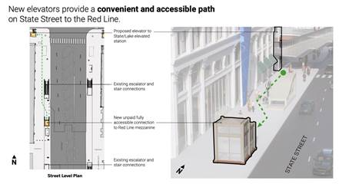

Location of the new elevator. This image is from a presentation that was not previously made available to the media.

The good news is that the project includes two new elevators that will make the wheelchair transfer more convenient than it otherwise would be. Instead of rolling all the way to Block 37 to use the existing street-level elevator, wheelchair users, and others with mobility challenges, will get a new elevator less than half a block, about 160 feet, south of Lake Street on the west side of State. This means they won’t have to cross Randolph.

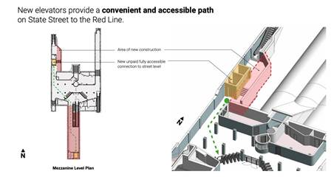

The route from the elevator between the street and station mezzanine, to the elevator between the mezzanine and the platform.

After exiting that elevator into the Red Line station’s mezzanine, wheelchair users will swipe their fare card at the turnstiles. Then they’ll head south down a corridor to a second new elevator that will take them from the mezzanine to the platform.

That’s not a perfect system for making the transfer, since it still requires some travel between three different elevators. But given the physical limitations of the site, it appears to be a reasonable solution.