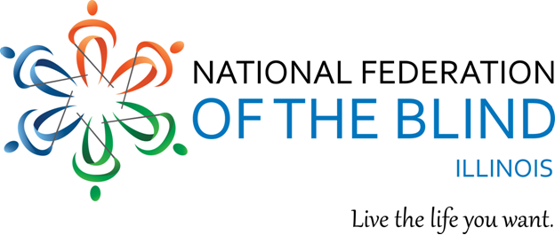
Illinois Association of Blind Students

Background: The Illinois Association of Blind Students (IABS), a division of the National Federation of the Blind of Illinois and a chapter of the National Association of Blind Students, is presenting two Excellent Student Awards to blind/low-vision students between 6th and to 11th grades. Recipients will be awarded certificates and prizes during the presentation at our annual convention of the National Federation of the Blind of Illinois:
Saturday, October 29th, 2022
At the Chicago Marriott Naperville Hotel
1801 N. Naper Blvd., Naperville, Illinois 60563
In order to qualify, the student must show academic excellence, involvement in community service, and leadership skills in the classroom.

Instructions: Please complete the below form and submit it by September 25th, 2022. You may email the completed form to: GMoore3rd@gmail.com or mail your completed nomination form to:
Glenn Moore
P.O. Box 1065
Elgin, IL 60121

Please direct questions to the above addresses or call (847) 899-9801. No nominations will be accepted after September 25, 2022.

Illinois Association of Blind Students
2022 Excellent Student Award
Nomination Form

Name of Nominator: __________________________________________________
Nominator’s Phone and email:
__________________________________________________________________
Name of Student: ____________________________________________________
Grade (6th – 11th): ____
School Where Student Attends: __________________________________________
Teacher, Staff, or Principal’s Phone Number: _______________________________
Teacher, Staff, or Principal’s Email Address: __________________________________________
Parent’s Phone Number:
______________________________________________
Parent’s Email Address: _______________________________________________
Please discuss the characteristics that make him or her an excellent blind student below. Be thorough, but please limit your narrative to 500 words:

