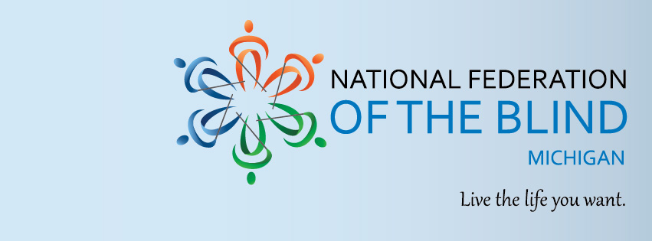

Raising Expectations, Accessing Life (R. E. A. L.)
An NFB Youth and Family Experience

The lives of blind youth and adolescents within the state of Michigan have profoundly changed since the global pandemic’s onset. These changes have created new opportunities for blind children and students to explore their interests and expand their horizons in areas that are not readily available in classrooms. Join the National Federation of the Blind of Michigan (NFBMI) in an engaging, multi-faceted program that encourages academic development and professional readiness for youth and their families across ages.

Dates: June 23-25, 2023
Location: Hilton Garden Inn
110 W. Kearsley St.
Flint, MI 48502

NFBMI R. E. A. L. is a weekend-long developmental program that works with children and students on a wholistic level to support their development and exploration of topics and opportunities that raise the expectations of themselves, their families, and their educational community. Our age-appropriate programming offers a medley of interactive opportunities for children and older students, including:
- Adaptive STEM Instruction and Exercises for Blind Children/Students
- Community Social Activities and Experiences for Attendees
- Advocacy and Networking Skills Development
- Professional Exploration and Document Writing Workshops
- Work Based Experiences
- Academic and Vocational Interest Assessments

Eligibility for this novel, weekend experience requires participants to be:
- A Legally Blind Youth Ages 8-13 (NFB STEM2U Track, must be accompanied by parent/guardian)
- A Legally Blind Student Ages 14+ (NFBMI Scholars Track)
- Willing to Attend NFBMI R. E. A. L. for the duration of the Participant’s Track

Interested participants should visit here to learn more about the program, the track’s offered for children and students, and a full description of the agenda. Scholarship opportunities are available for families that are interested in accessing the full schedule of social activities. For questions about this program, please email President@nfbmi.org.

Scan the QR code below to register today!
