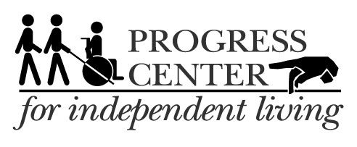

Progress Center invites you…
Illinois ABLE Account Informational Webinar

Wednesday, December 10 at 2:00 pm

Join online from any location, or meet at Progress Center in Forest Park to join the webinar.

Know about tax-advantaged IL ABLE savings and investment accounts if you have a disability or you help someone who has a disability. Join the IL ABLE team to learn:
• Who is eligible to own an IL ABLE Account and expanded eligibility starting January 1.
• Who can open an IL ABLE Account.
• How individuals receiving public benefits such as SSI and Medicaid benefits can build assets with an IL ABLE Account.
• How IL ABLE Accounts work alongside other financial tools such as special needs trusts and retirement accounts.
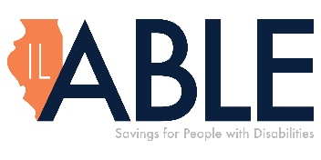
About our webinar presenter: Stephanie Kanter is the Director of the IL ABLE savings and investment program for people with disabilities at the Office of the Illinois State Treasurer. As an advocate and member of Chicago’s disability community, Stephanie’s background is rooted in advancing the empowerment and equity of all people with disabilities.

Register here https://isto.webex.com/weblink/register/re2ef94d4c392bdea2816108b3c5f2135
Or call Progress Center at 708-209-1500 extension 118 or email dkaras@progresscil.org for information on how to join the webinar.

