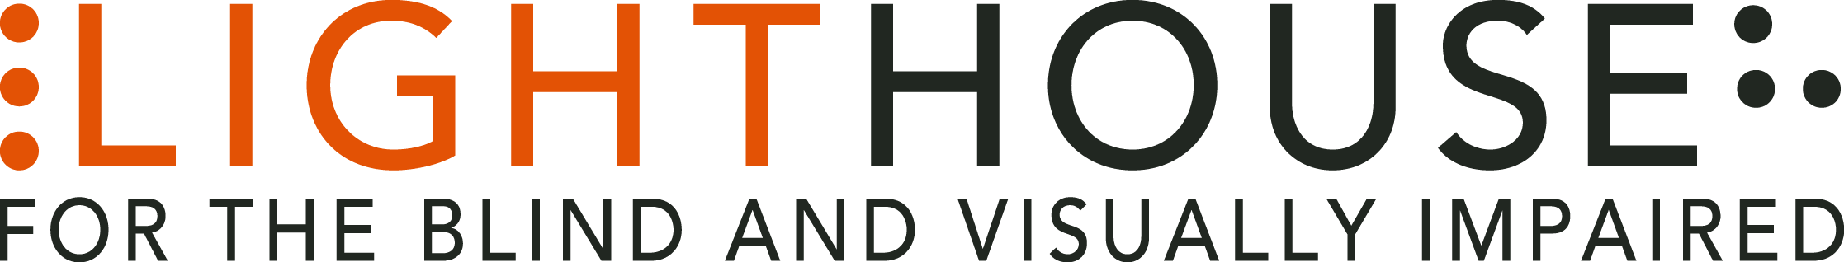

LIGHTHOUSE JOB DESCRIPTION

**POSITION:**  Access Technology Specialist

**REPORTS TO:**  Director, Access Technology

**STATUS:** Exempt

**APPLICATION DEADLINE:** Open Until Filled

**Job Purpose**:

The Lighthouse for the Blind and Visually impaired is seeking an access technology specialist in our Access Technology department. The AT department trains 300 students each year on the use of screen readers and magnification software, and partners with dozens of companies to ensure apps, websites, and products are accessible to blind and visually impaired users.

The Access Technology Specialist is responsible for providing technology assessments and training to blind and visually impaired students both one on one and in group workshops. Specialists work with each student to define learning goals, present material in a clear and comprehensive manner, and document instruction in the Lighthouse database. Specialists stay current on the latest access technology, and the accessibility of mainstream apps to provide high quality assessments to students. Specialists work on Lighthouse consulting projects in the areas of accessible design and user research.

This position may be for you if:

* You keep pace with the latest in mainstream and access technology
* You are interested in the interactions between people and the technologies they use.
* You enjoy spending significant parts of your workday interacting with students
* You enjoy explaining technical concepts to others

**Role Overview: (main duties)**

This role will conduct comprehensive assistive technology assessments. In addition, they will work with students to define schedules, goals, and objectives for technology training.

This position will deliver one on one technology training to blind and visually impaired students on a variety of technologies, at Lighthouse, at work sites, and in students’ homes once it becomes safe to do so. In the meantime, classroom training is conducted virtually, normally via zoom.

This individual will also design and deliver group workshops on current technology topics, design and deliver corporate trainings related to accessibility. The Access Technology Specialist will also provide accessibility feedback on products and websites as part of Lighthouse access technology consulting projects.

Keep accurate and timely records of student progress in the Lighthouse database.

**Other Job Duties:**

* Other duties as assigned.

**Minimum Qualifications:**

The LightHouse welcomes nontraditional applicants and applicants with diverse backgrounds and experience.

* In depth knowledge of the following operating systems:
  + Windows
  + Mac OS
  + iOS
  + Android
* Advanced user of screen reading and magnification software for desktop and mobile operating systems.
* In depth knowledge of non-visual techniques for information access including:
* Efficiently navigating websites,
* Using apps and software to access printed material.
* Using GPS apps for navigation.
* Demonstrated ability to create lesson plans,
* Demonstrated ability to conduct comprehensive technology assessments.
* High level of emotional intelligence to relate to students at all levels of adjustment to blindness.
* Demonstrated ability to convey technical knowledge in a clear and approachable manner,
* Ability to learn new technologies from documentation and tutorials.
* Experienced and comfortable delivering classroom training and presentations via virtual software such as Zoom.

**Preferred Qualifications:**

* Knowledge of web accessibility standards.
* Proficiency in the UEB Braille code.
* Fluency in a second language in addition to English.

**Education:** Bachelor’s degree in education, Rehabilitation Teaching, Computer Science, or comparable degree/experience.

**Compensation:** Depending on Experience; “industry competitive”

**How to Apply:**

After reviewing the complete Job Description please submit an application online via our website at: [https://lighthouse-sf.org/about/careers/](https://lighthouse-sf.org/about/careers/senior-executive-assistant/) as well as a cover letter and résumé as word processing document attachments (no PDFs please), to [hr@lighthouse-sf.org](mailto:hr@lighthouse-sf.org), including the job title in the subject line. We will not consider videos or hyperlinks to online profiles. Due to time constraints, we will only respond to complete submissions. Thanks for your understanding.

**Working Conditions:**

LightHouse is an equal opportunity employer. LightHouse policy and the law prohibit discrimination and harassment based on an individual’s race, ancestry, religion or religious creed (including religious dress and grooming practices), color, age (40 and over), sex, gender, sexual orientation, gender identity or expression, genetic information, national origin (including language use restrictions), marital status, medical condition (including cancer and genetic characteristics), physical or mental disability (including HIV and AIDS), military or veteran status, pregnancy, childbirth, breastfeeding and related medical conditions, denial of Family and Medical Care leave, height and weight, or any other classification protected by federal, state, or local laws, regulations, or ordinances. Our policy and the law prohibit co-workers, third parties, supervisors, and managers from engaging in such conduct.

LightHouse personnel are employed on an at-will basis. Employment at-will means that the employment relationship may be terminated, with or without cause and with or without advance notice at any time by the employee or the Agency. We strive to maintain a scent-free environment and a drug-free workplace.