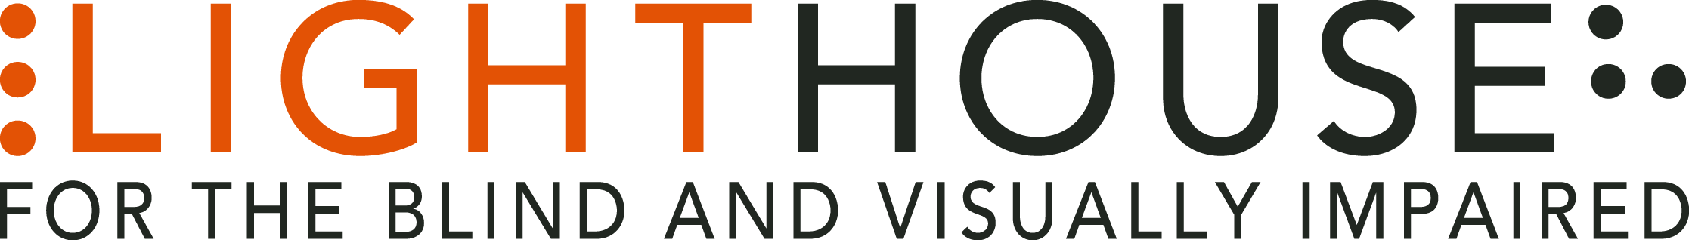

LIGHTHOUSE JOB DESCRIPTION

POSITION: Development Associate

REPORTS TO: Development Manager, Individual Giving

STATUS: Exempt – Full time: 37.5 hours

DEADLINE: Open Until Filled

Role Overview:
Working closely with and reporting directly to the Development Manager of Individual Giving, the Development Associate serves to support several critical aspects of the Fund Development effort. In concert with the entire fundraising team, the Development Associate will help design, implement, evaluate, and refine multiple Development activities with an emphasis on donor relations, recognition, online fundraising, data entry and co-producing an Annual Report.

Diversity and Inclusion: LightHouse intentionally and actively works to minimize barriers to employment faced by many marginalized groups. As a result, we welcome applicants from diverse backgrounds and abilities, including but not limited to applicants who possess various disabilities, racial and ethnic backgrounds, sexual orientation, gender identities, and ages.

Primary responsibilities:
- This position supports the Development Database Coordinator: providing relevant parameters to prepare queries and reports, segmenting donor lists and training with the Development Coordinator on all aspects of donation posting and donor acknowledgement using NXT Database View, to provide backup during busy months or if Coordinator is absent.
- Support donor solicitation and gift acknowledgement efforts
- Plan and support donor recognition events
- Assist in evaluating donor giving frequency/history and prioritize steps to strengthen donor relations
- In collaboration with the Development team: design, coordinate and execute annual Estate Planning mailings and co-host at least two Estate Planning events annually
- Assist with compiling data, stories, photos, and interviews for the LightHouse Annual Report
- Assist in creating collateral packages (brochures, press packages, photos, and short videos) that showcase organizational funding needs, acknowledges donors, and highlights the LightHouse community
- Assist in planning and supporting donor tours: prepare giving reports and donor/guest bios as needed for review prior to tours
- Assist with Creation of Facebook and other online campaigns with a goal of engaging new donors, including support for our Giving Tuesday campaign
- Support the EHC Blind Ambition Capital Campaign
- Maintain Development office supplies: inventory and ordering
- Work with Development and Communications teams to keep the LH web site donor pages, publications, and other communications current and compelling
- Co-manage Giving Tuesday – annual online giving event using social media
- Other duties as assigned

Qualifications:
- Bachelor’s degree or higher
- Strong interpersonal skills: must be comfortable corresponding and interacting with donors, prospects, event attendees and the members of the public: phone calls, email, acknowledgement pieces and in person
- Growth mindset with a willingness to learn the foundational aspects of Fund Development in a nonprofit environment
- Microsoft Office Suite proficiency required
- Professional, kind, and communicative
- Experience in using Raiser’s Edge 7 and RE NXT CRM
- Some knowledge of blindness community with willingness to learn more
- This is an ideal position for an entry level Development professional with a penchant for networking and a desire to hone their skills

Physical Requirements:
- Ability to sit at a desk and perform computer-intensive work for long periods of time; operate standard office equipment; ability to work at home or in office independently.
- Work occasional nights and weekends

Working Conditions:
LightHouse is an equal opportunity employer. LightHouse policy and the law prohibit discrimination and harassment based on an individual’s race, ancestry, religion or religious creed (including religious dress and grooming practices), color, age (40 and over), sex, gender, sexual orientation, gender identity or expression, genetic information, national origin (including language use restrictions), marital status, medical condition (including cancer and genetic characteristics), physical or mental disability (including HIV and AIDS), military or veteran status, pregnancy, childbirth, breastfeeding and related medical conditions, denial of Family and Medical Care leave, height and weight, or any other classification protected by federal, state, or local laws, regulations, or ordinances. Our policy and the law prohibit co-workers, third parties, supervisors, and managers from engaging in such conduct.

LightHouse personnel are employed on an at-will basis. Employment at-will means that the employment relationship may be terminated, with or without cause and with or without advance notice at any time by the employee or the Agency. We strive to maintain a scent-free environment and a drug-free workplace.

How to Apply:
After reviewing the complete Job Description please send an application online via our website at: https://lighthouse-sf.org/about/careers/ as well as a cover letter and résumé as word processing document attachments (no PDFs please), to hr@lighthouse-sf.org, including the job title in the subject line. We will not consider videos or hyperlinks to online profiles. Due to time constraints, we will only respond to complete submissions. Thanks for your understanding.

