

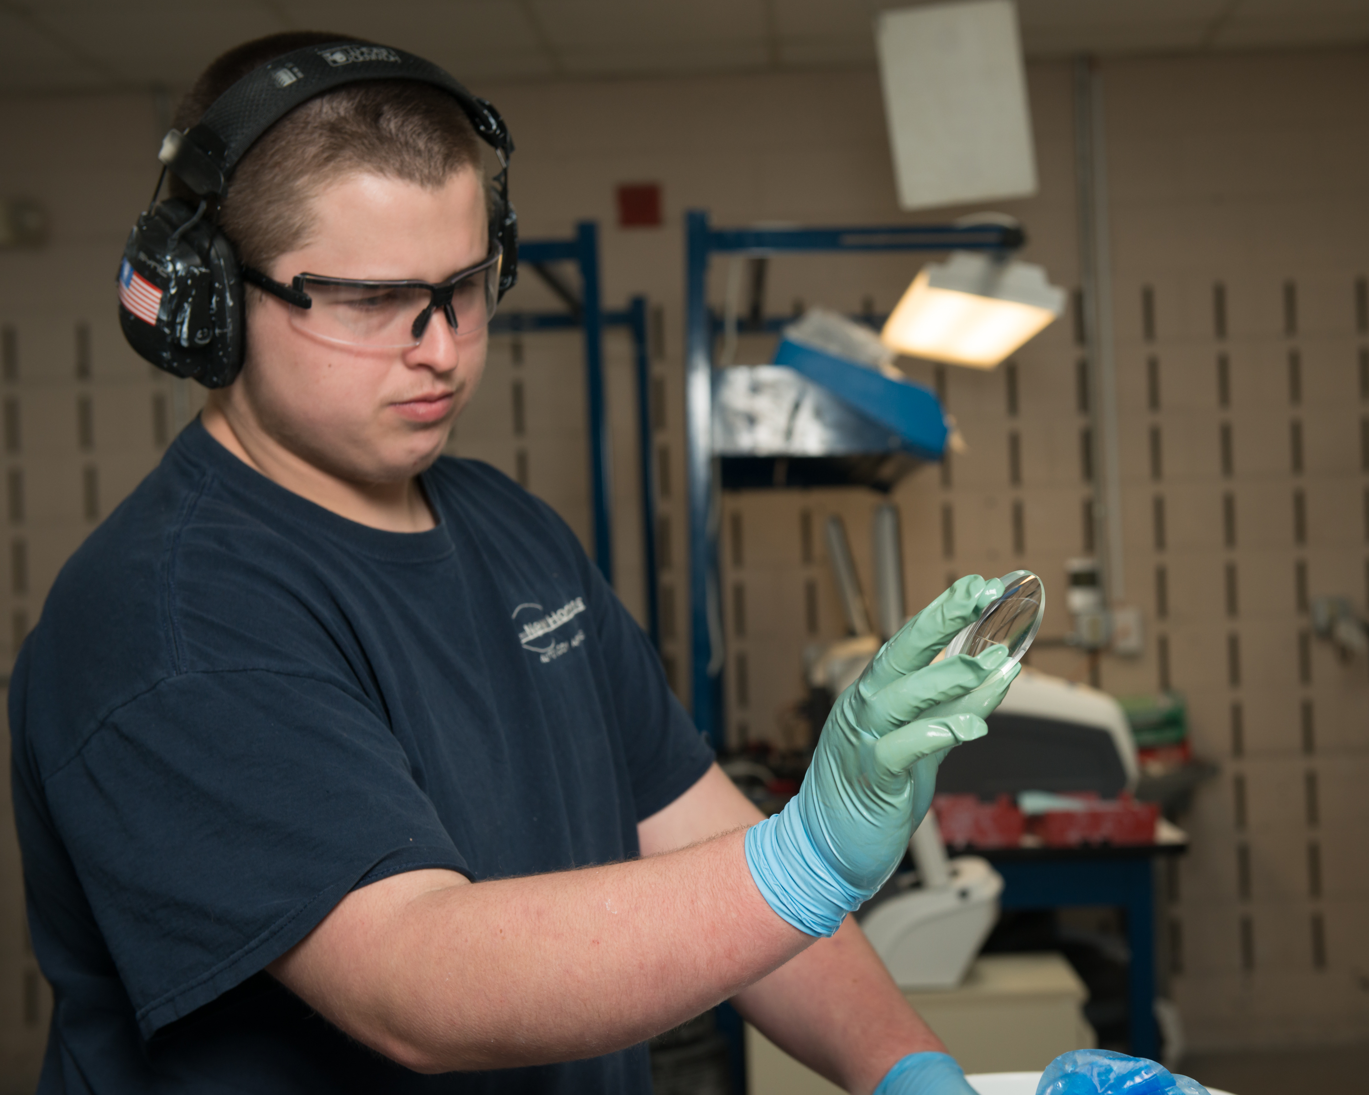
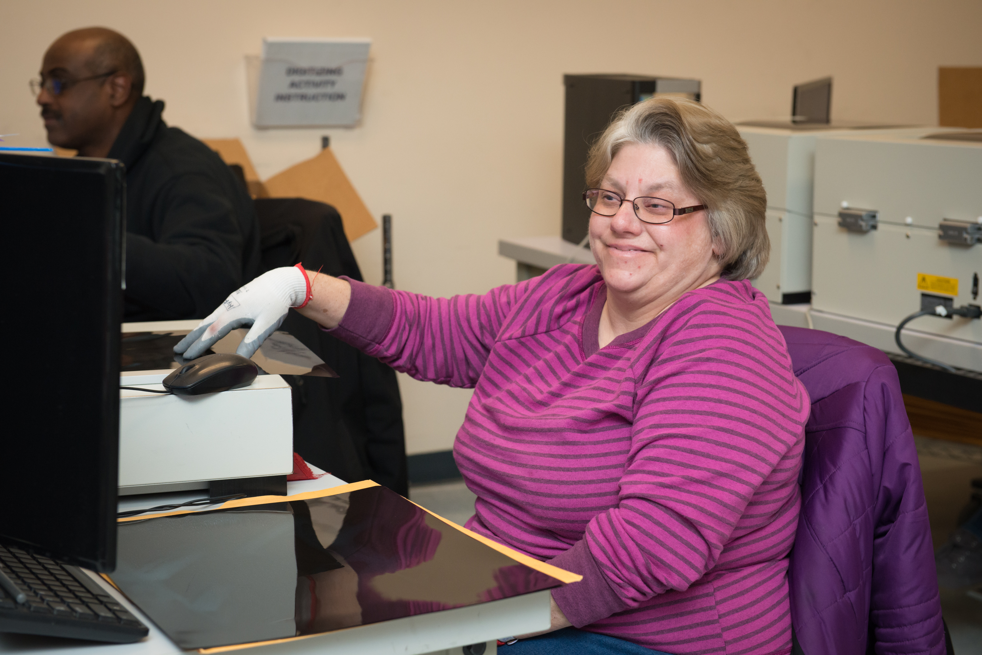

Interested in applying?

- All jobs are posted on www.versability.org.
- Click the orange “Join our Team” button at the top of the homepage to apply.
- Or Click this link: VersAbility Resources Inc. Career Opportunities (prismhr-hire.com)
- Questions : phardy@versability.org or wehire@versability.org

Galley Worker food service Northwest Annex Galley Chesapeake, VA
Food Service
CHESAPEAKE, VA
$17.20 Hourly

Custodian Janitor Part time Yorktown Naval Weapons Station Yorktown
Custodial
YORKTOWN, VA
$17.20 Hourly

Custodian Medical Clinic Janitor -Yorktown
Custodial
YORKTOWN, VA
$17.20 Hourly

Laborer Norfolk Ship Food Provisions, Ship Provisioning Norfolk, Va
Laborer
NORFOLK, VA
$24.80 Hourly

Signing Employment Specialist
Supported Employment
HAMPTON, VA
$24.82 Hourly

Landscaping Grounds Worker Yorktown Naval Weapons Station Yorktown VA
Grounds
YORKTOWN, VA
$17.20 Hourly

Food Service Part Time 6a to 10a Worker Yorktown VA Galley

Food Service
YORKTOWN, VA
$17.20 Hourly

Floor Technician Janitor -Yorktown Naval Weapons Station
Custodial
YORKTOWN, VA
$17.20 Hourly

Finance Coordinator- Payroll
Staff
HAMPTON, VA
$21.84 ‒ $26.50 Hourly

Service Coordinator- Early Intervention Services
Staff
HAMPTON, VA
$24.82 Hourly

Direct Support Professional - Puller Center
Direct Support
GLOUCESTER, VA
$17.57 Hourly

PART-TIME Direct Support Professional- Community Living
Direct Support
NEWPORT NEWS, VA
$17.57 Hourly

FULL TIME EVENING Direct Support Professional- Community Living
Direct Support
NEWPORT NEWS, VA
$17.57 Hourly

Production Worker Lens Lab General Clerk I Yorktown VA
Ability One
YORKTOWN, VA
$17.20 Hourly

Executive Vice President of Strategy and Development
Staff
HAMPTON, VA
$225,000 ‒ $275,000 Annually

Production Control Clerk Norfolk Administrative Contract
Administrative
NORFOLK, VA
$30.09 Hourly

Medical Records Clerk Norfolk Administrative Contract MSC Norfolk Va
Administrative
NORFOLK, VA
$20.04 Hourly

Direct Support Professional - Hampton Day Program
Direct Support
HAMPTON, VA
$17.57 Hourly

Supervisor Working Supervisor Yorktown Custodial- Yorktown, Va
Custodial
YORKTOWN, VA
$19.70 Hourly

General Clerk II Norfolk Administrative Norfolk VA
Administrative
NORFOLK, VA
$17.20 Hourly

Lead Custodian Evenings Yorktown Custodial
Custodial
YORKTOWN, VA
$18.45 Hourly

