Tribute Concert to Shaun Coughlan 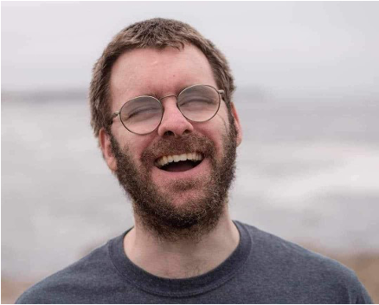

**Sunday October 8th at 2:00 PM**

**Church of St Andrew and St Monica**

**3600 Baring Street, Philadelphia 19104**

***Light refreshments to follow***

​​Shaun Coughlan and Simon Bonenfant had been friends for many years. Shaun and his relatives welcomed Simon into their family as one of their own. When Shaun passed away from kidney cancer at 32 years old, he left his friends and family with vibrant memories of his charming wit, profound wisdom and compassionate spirit.

One of Shaun’s greatest passions was music. To honor Shaun and his memory, come gather with Simon and other professional choral musicians, pianists, organists and violinists as we celebrate Shaun and his legacy. Hear some of Shaun’s favorite works such as Abide with Me, The Day Thou Gavest, Amazing Grace, and more.

Pre-registration for this concert is encouraged for either the live or online streaming options. Funds raised from this event will benefit the music program at the Perkins School for the Blind, where Shaun was a proud graduate. Any donation is greatly appreciated. Click on the QR Code below for more information and to register.

Suggested donation: $25 to help us reach our fundraising goal of $2500.

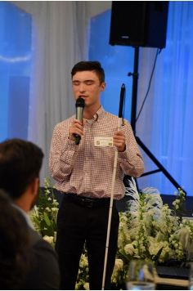

**[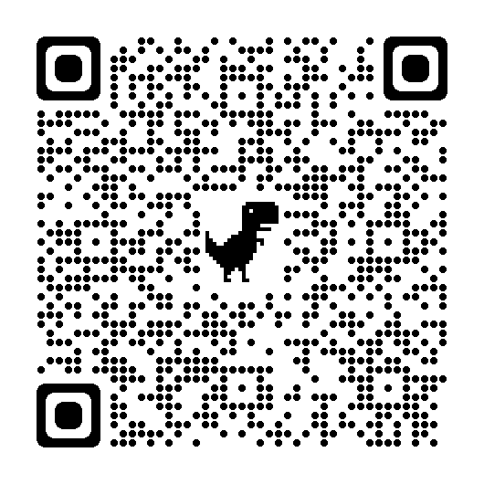](https://www.eventbrite.com/e/tribute-concert-to-shaun-coughlan-2023-tickets-700906780047?aff=oddtdtcreator)**