The State Library of Louisiana’s
Talking Books and Braille Library
Summer Reading Program 2016
Registration Form
Name: _______________________________________________ Age: ______________
...
Address: _____________________________________________ New Address?_______
...
City/State/Zip: ___________________________________________________________
...
Telephone: (______) ____________________Cell Phone: (_____)__________________
...
Grade this fall (2016):________ Reading Level_________ Listening Level__________
...
Email Address: ___________________________________________________________

Choose Your Summer Reading Program!
_____ Read-to-Me – (for the very young – or – for those who are “read to”)
_____ Children’s Summer Reading Program – (for readers in elementary school)
_____ Teen Summer Reading Program – (for readers in middle school -or- high school)

Welcome Packet Information:
After you register, we will send you a Welcome Packet containing instructions for the program, a list of suggested books to read, and some other items. In what format would you like to receive your printed Summer Reading Program materials?
_____Large Print Only _____ Braille (grade 2) and Large Print

What Is Your (100% cotton preshrunk) T-shirt Size? (T-shirts run true to size)
...
Child sizes: _____S _____M _____L
...
Adult sizes: _____S _____M _____L _____XL _____XXL _____3XL

How do I sign up for the Summer Reading Program?
By Mail: Return this registration form by folding it in half and sealing it with tape.
By Phone: 1-800-543-4702 (toll-free) or (225) 342-9563 (Baton Rouge)
By Fax: (225) 342-6817 or
By Email: tbblkids@state.lib.la.us



FREE MATTER FOR THE
BLIND OR HANDICAPPED
POSTAL MANUAL 135

State Library of Louisiana/TBBL
P. O. Box 131
Baton Rouge, LA 70821 - 0131

State Library of Louisiana
Talking Books and Braille Library
Attn: Charlene Moore
701 North 4th Street
Baton Rouge, LA 70802



Is this summer’s free Summer Reading Program offered by the State Library of Louisiana’s Talking Books and Braille Library.

You choose the program that best fits you:
.
- The Read-to-Me Program for participants listening to Preschool – 2nd grade level books – or – for anyone at any age who is being “read to” by a caregiver.
- The Children’s Summer Reading Program for those reading or listening to books at the elementary school grade level.
- The Teen Summer Reading Program for those reading or listening to books at the middle or high school grade level.

Everyone who submits the registration form receives a Welcome Packet containing a folder of instructions, a list of suggested books to read, stickers, pencils, reading logs, and some bookmarks!

ALL WHO COMPLETE the program by turning in their reading logs before August 30, 2016 will also get A FREE T-SHIRT, Sports Wallet, Wrist Band, and Keychain! If you read (or listen) to at least four books or magazines, you will get a free t-shirt with the words, “On Your Mark, Get Set… Read”. The shirt color is Red and depicts a baseball crest.

The 2016 Summer Reading Program begins on May 1st and ends on August 30th ..

Your Welcome Packet will arrive soon after you return the enclosed Registration form!
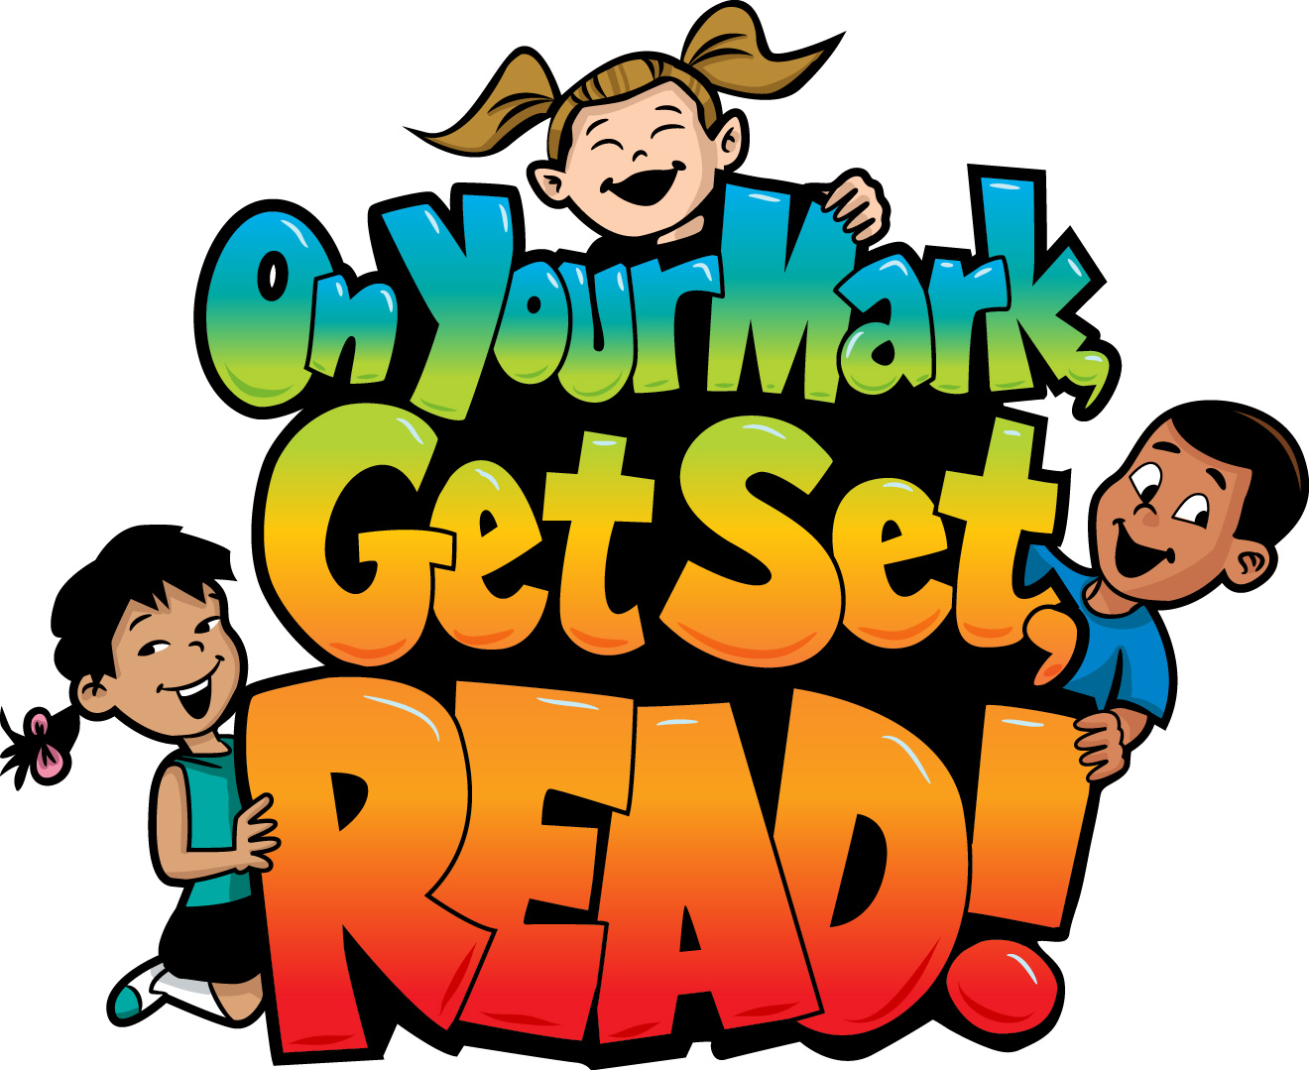
Invitation for the 2016 TBBL Summer Reading Program inside!
State Library of Louisiana
Talking Books and Braille Library
701 North 4th Street
Baton Rouge, LA 70802
FREE MATTER FOR THE
BLIND OR HANDICAPPED
POSTAL MANUAL 135



