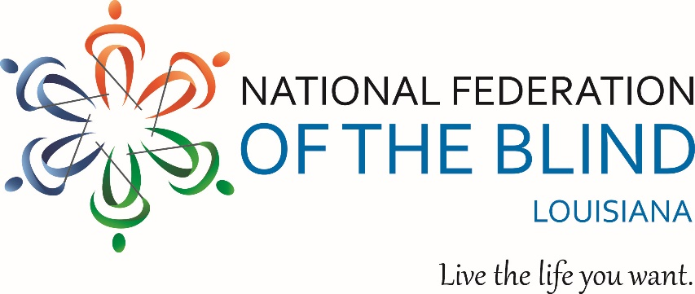

2017 SCHOLARSHIP APPLICATION

Carefully read and follow the instructions included with this application. Only fully completed applications will be considered by the Committee. This form may be duplicated, but only if instructions are also included. Mail the completed application and accompanying documentation to: Eric Guillory, Chairperson; NFBL Scholarship Committee; 101 S. Trenton Street; Ruston, LA 71270. All applications must be received on or before February 24, 2017. If you have questions, please call the Chairperson at 800-234-4166 or send an email to eguillory@louisianacenter.org.

Name:
Home Address:
City/State/Zip Code:
Primary Phone Number(s):
Date of Birth: Gender:

School You Currently Attend:
Class Standing (e.g., freshman, senior, etc.):
Cumulative GPA:
School you will attend in the fall of 2017:
State Your Major (If in high school, state your proposed major when you enter college):

Vocational Goal:
Awards and Honors (attach separate sheet if necessary):
Community Service (attach separate sheet if necessary):

When did you become legally blind (year)?:________Visual Acuity:
Cause of Blindness: ___

NATIONAL FEDERATION OF THE BLIND OF LOUISIANA SCHOLARSHIP PROGRAM INSTRUCTIONS
Each year at its State Convention, the National Federation of the Blind of Louisiana (NFBL) awards scholarships to recognize the achievement of blind scholars. This year we will be awarding four scholarships ranging from $750 to $1,500. Applicants for these scholarships must be: (1) legally blind, (2) residents of Louisiana, (3) pursuing or planning to pursue a fulltime, postsecondary course of study at an accredited college, university, or trade/technical school in the fall of 2017.

CRITERIA: All scholarships are awarded on the basis of academic excellence, leadership ability, community service, and financial need. Previous winners of NFBL scholarships and others who have applied in the past are encouraged to reapply.

MEMBERSHIP: The National Federation of the Blind of Louisiana is dedicated to providing opportunities for all blind people. Recipients need not be members of the National Federation of the Blind.

DEADLINE: All applications and accompanying documentation must be in the committee chairperson’s office no later than February 24, 2017.

WINNERS: The Scholarship Committee reviews all applications and selects all winners. These winners, the same number as there are scholarships to be awarded, will be notified of their selection in writing no later than March 3, 2017 and will be brought to the NFBL state convention at Federation expense. The convention is scheduled for the weekend of March 24-26, 2017 in Shreveport. Attendance of the entire convention is mandatory for all winners. This year, the winner of our $1,500 scholarship will also receive paid room and transportation to two events--our organization’s national convention, in Orlando, Florida, from July 10-15, 2017 and our Washington Seminar held in January, 2018. The two $1,000 scholarship winners will also be awarded the opportunity to attend Washington Seminar. Both national convention and Washington Seminar provide excellent opportunities to meet and network with other blind people and be immersed in the Federation’s positive philosophy and advocacy efforts to change what it means to be blind. They also feature student-driven gatherings by and for blind high school and college students. Hosted by the National Association of Blind Students (NABS), these meetings are high-energy, informative, and a great opportunity to meet and exchange information with other students and young professionals from around the country.

A complete application includes a 2017 NFBL Scholarship Application along with the following:
- Applicant's Letter: Along with your application, please include a letter that provides the following: general background information, a brief description of your education and employment goals, details of noteworthy accomplishments, and a concise summary of alternative techniques you have used to become a successful blind student. Finally, tell us how the scholarship would benefit you.
- Transcripts: Provide a current official transcript from the institution you are attending as well as official transcripts from all postsecondary institutions you have attended. If you have not yet attended an institution of higher learning or have not completed one year of study at such an institution, provide an official high school transcript.
- Recommendation Letters: Two letters of recommendation.
- Acceptance Letter: High school seniors are required to provide the Committee with an acceptance letter from the school they plan to attend in the fall of 2017. However, the committee recognizes that many students will not receive this document prior to our deadline. Therefore, we require that all winners submit this document as soon as it is available, and applicants are advised that no funds will be disbursed to winners until we have received a copy of this document.
Send your completed application and other required documents to:
Eric Guillory, Chairperson

NFBL Scholarship Committee
101 South Trenton Street
Ruston, LA 71270

PLEASE NOTE: LATE OR INCOMPLETE APPLICATIONS WILL NOT BE CONSIDERED BY THE COMMITTEE. All applications must be received in the Chairperson’s office on or before February 24, 2017.

