NATIONAL FEDERATION OF THE BLIND
2017 NATIONAL CONVENTION

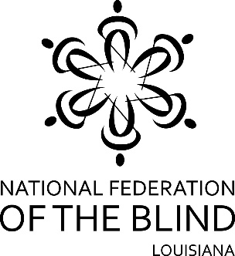
Returning to Orlando, Florida
July 10 - 15, 2017

This summer, thousands of the nation’s blind will be heading to Orlando, Florida, to attend the 2017 Annual Convention of the National Federation of the Blind from Monday, July 10th to Saturday, July 15th. You can visit www.nfb.org to pre-register for the convention beginning March 1st, or you may register on-site starting July 11th. (Pre-registration rates are discounted.)

In addition to well-known featured speakers and an enormous exhibit hall filled with technology, literature and services, there will be numerous special interest meetings, including... a Parents of Blind Children seminar... a meeting for blind high school and college students... a meeting for blind diabetics... workshops for those interested in computers and technology... meetings for various professionals, and much more! Social activities will be scheduled throughout the week as well.

This year’s convention will be held at the Rosen Shingle Creek Resort. Room rates, as always, are phenomenal: singles and doubles $83, triples and quads $89 a night, plus tax (which is presently 12.5%). There will be no charge for children (17 and under) in the room with parents as long as no extra bed is requested. A $95 deposit is required to make a reservation. Fifty percent of the deposit will be refunded if notice is given to the hotel of a reservation cancellation before June 1, 2017. The other 50% is not refundable. For reservations, please call the Rosen Shingle Creek Resort at 866-996-6338.

The 2017 Convention of the National Federation of the Blind will be a truly memorable event as we celebrate how the organization has transformed dreams into reality. For additional information, please call Pam Allen, President, NFBL, at 800-234-4166. Transportation assistance is available for (dues paying) members of the National Federation of the Blind of Louisiana who wish to attend this convention. (There is a $100 nonrefundable fee required to ride the bus. Space is limited. For those riding the bus, hotel reservations must be made to check in on July 9th and check out on July 16th. ) Please call Susan Clark to discuss transportation options before June 1st.

