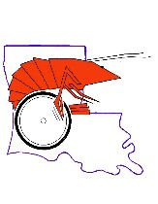
-GUMBO GAMES ARE COMING TO NORTHEAST LOUISIANA
(GAMES UNITING MIND AND BODY)
WHEN: May 6, 2017; 1:00
WHERE: University of Louisiana at Monroe, Brown Stadium, 518 Warhawk Way, MONROE, LA
WHO: Games Uniting Mind and Body (GUMBO) is an interscholastic track and field competition designed for children ages 5 years to adult who have physical or visual disabilities. The events are not unlike those at any other track and field event: races, shot put, discus, etc. What makes GUMBO different is the fact that all of the athletes have mobility or visual impairments and many, but not all, compete with leg braces, wheelchairs, or assistance from sighted guides. The athletes competing in GUMBO are not intellectually disabled. Eligibility for competition comes from having a physical disability or visual impairment and athletes compete with athletes who have similar or like impairments.

WHAT: GUMBO strives to support students with disabilities by developing active minds, self-confidence, dignity, discipline, competitive spirit and comradeship. Like other competitive sporting events GUMBO competitions challenge athletes to improve performance, strength, speed, endurance and coordination.

How: Contact State GUMBO Coordinator, Pam Carey at 1-800-259-7200 or 318-452-7771, Meet Director, Cindy Daniels at 318-614-2874 , Assistant Directors, Angie Culpepper at 283-3452, or Daphne Kennedy or Leslye Barnes at 318-283-3453.

Cost: NONE! There is no registration fee!
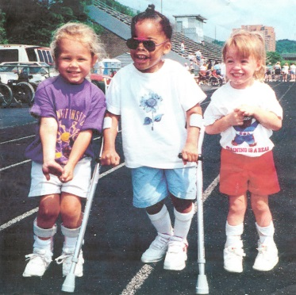
PLEASE SHARE THIS INFORMATION WITH OTHERS.
Learn more at www.gumbogames.com

