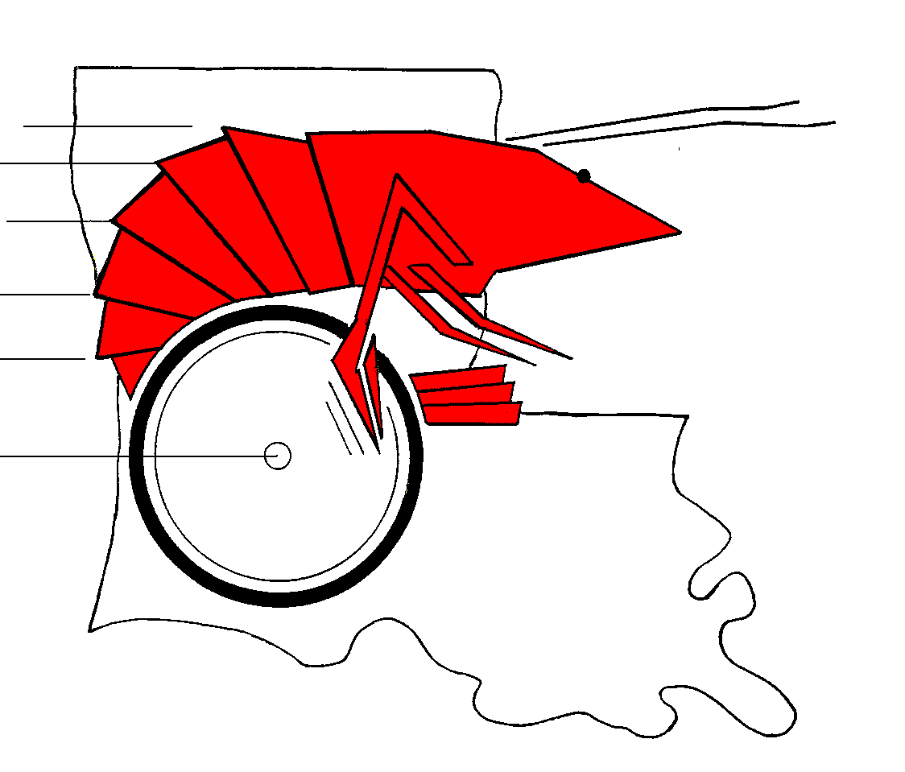
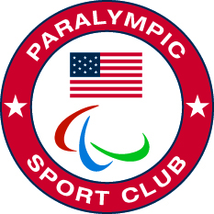

Frequently Asked Questions about GUMBO:
- Who is it for?
  - Any person 5 years or older with a physical or visual impairment that is a typical learner and able to understand rules and follow them from Arkansas, Louisiana, or Mississippi that would like to be an athlete.
- What is GUMBO?
  - Track and Field for individuals with physical or visual disabilities who function independently, but may need assistive devices (guide runners, walkers, braces, power or manual wheelchairs).
- Where is this meet going to be held?
  - Ouachita High School: Monroe, LA
- What are some orthopedic disabilities that may qualify a person to compete in GUMBO?
  - Spinal bifida, Muscular Dystrophy, Multiple Sclerosis, Amputee, Dwarfism, Cerebral Palsy, Blindness, Partially Sighted (Any student with an IEP for Visual Impairment), albinism that effects the eyes, Individuals wearing leg or arm braces, Burn victims with contractures, and many others.
- How many regional meets are held annually and when?
  - Currently 5 held in the Spring: Lafayette, Shreveport, Alexandria, Harvey, Monroe
  - Individuals may enter in 5 events at 1, 2, 3, 4 or all 5 regional meets.
- How are students divided into categories for competition?
  - Three ways: 1. Boys and girls are separated for purposes of receiving ribbons and finishing status, but may actually compete at the same time. 2. There are 4 age categories (bantam, junior, senior, and master). 3. There are 10 classifications (1-4 are for various levels of blindness, 5 is for wheelchairs (electric and manual are separated), 6 is for assistive devices (crutches or walkers), 7-9 are for various degrees of independent ambulation, and 10 is for dwarfism.
- Is there a State Meet, and how do you qualify?
  - Yes, it is held during the fall in Alexandria. To qualify in an event, an athlete must place 1st, 2nd, or 3rd in an event at one regional meet.
- How much does it cost?
  - It is free.
- Do athletes win prizes?
  - Yes, ribbons at regionals and medals or ribbons at state.
- Is there a travel team?
  - Yes, the Mudbugs are the elite team selected to compete in an international event within the United States (prior to 911 they went to Canada) during the summer.
- Do you have to be on a team?
  - No, but school systems may form teams if they desire. Most compete individually.
- Are there other ways to help?
  - Yes: 1. We need corporate sponsorship for the MUDBUG Team and for the individual meets.
2. We need volunteers to help run the meets.
3. We need water, bananas, apples, and snack bars for the regional and state meets.
4. We need individuals willing to go through 2 hour training sessions to be officials.
5. We need sponsors for t-shirts and other supplies.
6. We need food donated and served at each meet.
7. We need assistance with promoting the program (television, radio, fliers, outreach).
13. Can people with limited muscular strength participate?
a. Yes; there is a soft toss if they qualify. Those in electric wheelchairs may compete in the slalom and races.

Go to www.gumbogames.com to learn more about this wonderful and challenging program.
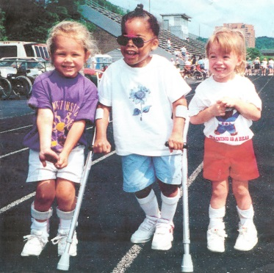
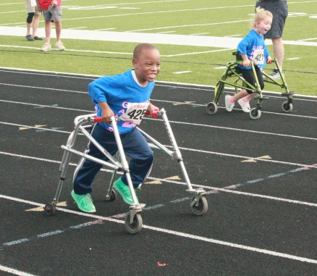
In Morehouse Parish our athletes are honored at school board meetings, their schools, and allowed to Letter in their sport when they have competed at 2 state meets. It provides an opportunity for challenging sport participation and family opportunities to celebrate athletic success with their child.

