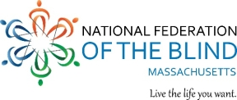

August 21, 2023

Dear Friend,

I am writing to invite you to the David Ticchi National Federation of the Blind (NFB) Cambridge Annual Walk on Sunday, October 8th, from 9:00 a.m. to 1:00 p.m. at the Fresh Pond Reservoir in Cambridge, MA. In 2019, in honor of our beloved leader and mentor, we renamed the Cambridge Chapter Walk to the David Ticchi NFB Cambridge Annual Walk. This is in honor of David, not a memorial, thank goodness.

Last fall, through the generous contributions of our friends like you, we raised close to $6,000. We thought you’d like to know how your money was used during this past year.

Scholarships were created to provide assistance for college-bound blind students.

Members of the Cambridge Chapter were able to meet with the Massachusetts Congressional delegation on Capitol Hill as part of the NFB Washington Seminar.

Members supported and participated in seminars for emerging leaders and blind students.

The Cambridge Chapter of the NFB has funded these local initiatives and many others because of the generous support of our contributors, like you.

**Please save Sunday, October 8th, and join us at Fresh Pond Reservoir in Cambridge for a great morning of fun, friendship and fundraising.** We’ll be meeting at the front door of the Water Department building at 250 Fresh Pond Parkway.

**You can help by participating and obtaining sponsors or sponsoring other participants. If you are unable to attend and would like to contribute, please make checks payable to Cambridge NFB and mail to Samira Elazraoui, Cambridge Savings Bank, 1374 Massachusetts Avenue, Cambridge, MA 02138. Donations can also be made online using credit card or PayPal at** www.nfbma.org/chapters-and-divisions/cambridge-chapter. We are also now able to receive payments through Zelle, using Treasurer@NFBMA.org. Please note on any online payment that your donation is for our David Ticchi Walk.

**All monies should be remitted by December 1, 2023.**

For questions, please call me, President and Walk Coordinator at 617-304-0347.

Sincerely,

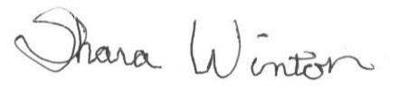

# Shara Winton, President

NFB of Massachusetts