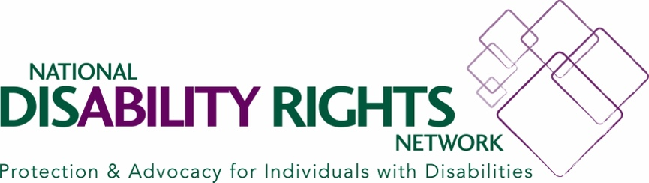

The National Disability Rights Network, a leading national disability rights organization, is working on a documentary short that will tell the stories of voters with disabilities in the lead up to the 2024 presidential election. We will be doing interviews in Maryland, Massachusetts, New Hampshire, South Carolina, Virginia and the District of Columbia. We want to capture the issues that motivate voters with disabilities and paint a rich picture of their lives, because our community, despite being over 25% of the American population it's often ignored by politicians.

We are seeking to get a look at the home life and day-to-day of voters with disabilities so we can connect the political issues that matter to their daily life. **Interviews would take approximately two to three hours. We want to conduct the interview and film footage to compliment it. For example: navigating to work, arranging paratransit, going over how much their healthcare costs or showing any durable medical equipment they use, explaining how a home health aide would enable them to experience greater independence.**

The goal of this project is to highlight the biggest minority group that gets often ignored by the candidates of all parties. The project is strictly nonpartisan. We are seeking to ensure we have a diverse range of perspectives included in terms of the issues that matter and the life experience those voters come with.

We are looking to speak to first time and long time voters, we want to interview those fresh out of school (and even graduating seniors) as well as people who have spent long in the workforce or even found themselves excluded from the workforce. We want to speak to voters with disabilities of all stripes and capture the diversity of our community.

If you are interested please contact us at [storytelling@ndrn.org](mailto:storytelling@ndrn.org). We look forward to working with you to help politicians understand that our community cannot be ignored any longer.

Dates by location:

* Southern New Hampshire/Boston Massachusetts: January 18th to 24th
* Charleston, South Carolina area: January 31st to February 4th
* Columbia, South Carolina area: February 20th to February 24th
* Maryland/Virginia/DC: March 5th to March 28th