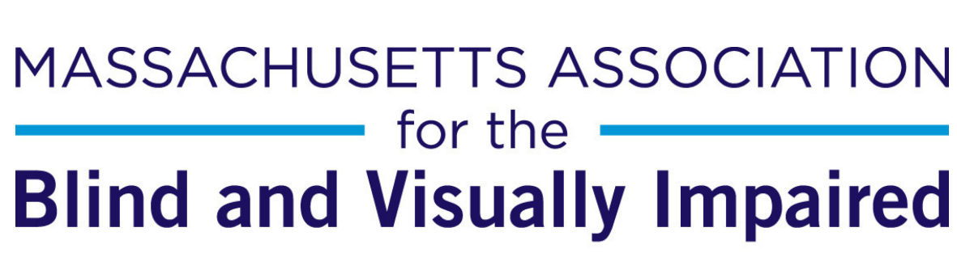

**Job Posting: Director of Social Services - LICSW**

The Massachusetts Association for the Blind and Visually Impaired is seeking an experienced LICSW to lead its Social Services and Peer Support Programs, including Adjustment to Vision Loss Counseling, Low Vision Peer Support Groups, and Participant Intake.

Required: Lived experience of blindness/low vision OR extensive experience in the blindness field.

Required: LICSW in Massachusetts or ability to obtain reciprocal licensure.

Fully remote with some in-state travel and in-person obligations.

40 hours, benefits-eligible. A part time role would be considered if an LICSW-candidate is not looking to work full time.

# Duties Include:

## Adjustment to Vision Loss Counseling Program

Screen participants for referral to Adjustment to Vision Loss Counseling and refer to appropriate MABVI counselor or outside provider.

Supervise team of 3 Adjustment Counselors (MSW-level counselors in varying stages of licensure).

Work with MABVI leadership to explore billing opportunities for counseling program and mental health services. Support staff in obtaining licensure as appropriate.

Manage policies and uphold standards for counseling. Train staff and community providers on referral procedures.

## Low Vision Peer Support Groups

Supervise Deputy Director of Social Services, who manages the Peer Empowerment Low Vision Support Group Program (34 support groups). Assist with facilitation of peer model, coordinator training, speaker procurement, teleconferencing management, scheduling and site management as needed.

Assist with managing contract relationship with Massachusetts Commission for the Blind.

## Participant Intake

Supervise 2 Participant Intake Coordinator/s and Manage intake process for consistency and quality.

Provide education and case management support to community-based organizations and healthcare providers.

## General

Set program standards, standard operating procedures, and policies. Develop measures for quality assurance and outcome reporting. Support program evaluation efforts across the organization.

Support MABVI efforts to increase access to services to under-resourced and under-served communities, including BIPOC and limited English proficiency individuals. Help identify strategies for engaging participants and increasing participation in services.

Support MABVI’s outreach and education efforts as requested, such as presentations, panel discussions, and media opportunities. Help support the development of education modules and written materials for dissemination to providers and family members.

Support and facilitate case management across departments and teams. Provide training to MABVI staff about adjustment to vision loss and referral to Peer Support Programs.

Oversee program documentation, contracts, and budgets in conjunction with MABVI leadership.

Work with grants team and MABVI leadership on fundraising requests and grant reporting.

Participate in MABVI leadership meetings as requested.

Follow all confidentiality laws and HIPAA digital compliance standards and ensure direct reports are complying with all appropriate regulations and reporting structures.

Other Duties may be assigned as requested.

# Skills/Experience

Strong team leadership and supervision experience.

Excellent communication skills.

Knowledge of Massachusetts social service structure and blindness resources a plus

LICSW in MA or ability to acquire reciprocal license. 5-10 years’ experience as a counselor.

Lived experience with blindness OR strong experience in the blindness field preferred.

Position is fully-remote but MA residency preferred. Some travel to support groups and in-person trainings is required.

Job Types: Full-time, Part-time

Benefits:

* 403(b)
* Dental insurance
* Employee assistance program
* Flexible spending account
* Health insurance
* Life insurance
* Paid time off
* Vision insurance

Work Location: Remote

# To Apply:

Please apply through this [link at Indeed](https://www.indeed.com/viewjob?jk=343c142b0719eb3c) or send resume and cover letter to:

Andy Sogolow at [asogolow@mabcommunity.org](mailto:asogolow@mabcommunity.org)

and Cynthia Canham at [ccanham@mabcommunity.org](mailto:ccanham@mabcommunity.org)