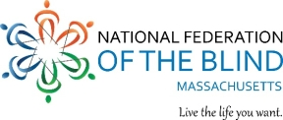

August 20, 2024

**Dear Friend,**

I am delighted to invite you to the **David Ticchi National Federation of the Blind (NFB) Cambridge Annual Walk** on **Sunday, October 6th**, from **9:00 a.m. to 1:00 p.m.** at the Fresh Pond Reservoir in Cambridge, MA.

In 2019, we renamed the Cambridge Chapter Walk in honor of our beloved leader and mentor, David Ticchi. We celebrate this as a tribute to David, not as a memorial—thankfully, he continues to inspire us every day.

Last year, thanks to the generous contributions from supporters like you, we raised over $7,000. We want to share with you the impact your support has had over the past year:

* **Braille Education Literacy and Learning Academy (BELL):** We held an academy for children ages 4-12, where they learned to embrace their differences, gained confidence in their blindness, and developed essential life skills such as cooking, crafting, and participating in field trips.
* **Scholarships:** We provided scholarships to assist blind students on their journey to higher education.
* **Advocacy:** Members of the Cambridge Chapter met with the Massachusetts Congressional delegation on Capitol Hill as part of the NFB Washington Seminar.
* **Leadership Development:** We supported and participated in seminars designed for emerging leaders and blind students.

The Cambridge Chapter of the NFB has been able to fund these and many other local initiatives thanks to the generosity of our contributors, like you.

Please mark your calendar for **Sunday, October 6th** and join us at Fresh Pond Reservoir in Cambridge for a morning filled with fun, friendship, and fundraising. We’ll be meeting at the front entrance of the Water Department building at 250 Fresh Pond Parkway.

You can support us by participating in the walk, finding sponsors, or sponsoring a participant. If you are unable to attend but would still like to contribute, please make checks payable to **Cambridge NFB** and mail them to **Tzu-Ying Lien, Cambridge Savings Bank, 1374 Massachusetts Avenue, Cambridge, MA 02138**. Donations can also be made online via credit card or PayPal at [**www.nfbma.org/chapters-divisions/cambridge-chapter**](https://www.nfbma.org/chapters-divisions/cambridge-chapter). We now also accept payments through Zelle at **Treasurer@NFBMA.org**. Please note that your donation is for the **David Ticchi Walk**. **All monies should be remitted by December 1, 2024.**

For questions, please call me, President and Walk coordinator at 617-304-0347.

Sincerely,

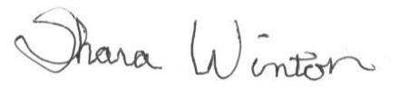

# Shara Winton, President

NFB of Massachusetts