🎉🤣 GIGGLE GALA 2025! 🤣🎉
The funniest night of the year is HERE!
📅 Thursday, December 11, 2025
🕕 6:00 PM – 9:00 PM
📍 Giggles Comedy Club – 517 Broadway, Saugus, MA
🎟 Tickets: $50
Grab yours before they disappear like the last slice of pizza!

🎭 What’s in store?
Prepare for a night packed with:
✨ Side-splitting stand-up comedy
🍕 Free, delicious pizza (because laughing burns calories!)
🎁 A silent auction full of must-have goodies
💰 A 50/50 raffle that could send you home richer
🎉 Fun surprises all night long!

❤️ Laugh for a Cause
Every chuckle, giggle, and belly laugh helps support
The National Federation of the Blind of Massachusetts.

📞 Tickets & Info: 617-600-8130
🌐 bit.ly/3UWUsrY
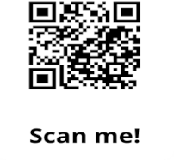
Come laugh with us—and support something amazing at the same time!

