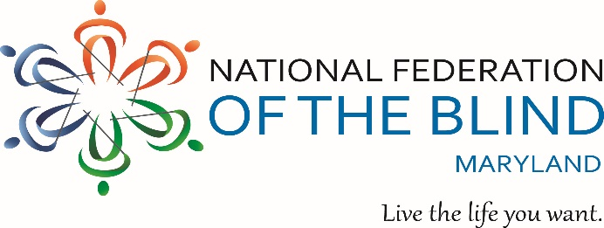

** ANNUAL CRAB FEAST **

To benefit the John T. McCraw Scholarship Fund

**Sunday, October 3, 2021 - 1:00 p.m. to 5:00 p.m.**

**Tall Cedars – 2501 Putty Hill Ave - Parkville, MD 21234**

**Steamed Crabs, Pit Beef, turkey breast, & Ham – All You Can Eat!**

Plus a Buffet of Entrees Including Old Bay wings and

Sausage, Sides, Salad, Cake…

50/50 &

More!

Yuengling and Miller beer

Carbonated Beverages and Coffee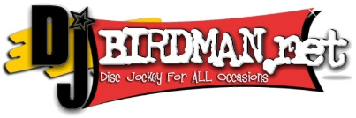

Music, Dancing, Door Prizes

**Tickets: $60.00** per person if purchased on or **before 9/17/21 OR $65.00** per person

if purchased **after 9/17/21**. Children 6 and under are FREE.

Purchaser’s Name: ____________________________________________________

Address: ____________________________________________________________

City: ___________________________ State: ____________ Zip: _____________

Phone: ( ) ________________ Email: ________________________________

Number of Tickets Needed: _______ @ $60.00 each OR ______ @ $65.00 each

Amount Due: $_________________ Tickets Sold By: ______________________

**Buy or Sell 25 or more tickets and your ticket is FREE!**

If you cannot attend, donations are always welcome!

Pay **or donate** online at: [www.nfbmd.org](http://www.nfbmd.org/)

Make checks payable to: NFBMD

Mail to: NFBMD Crab Feast, 1800 Johnson Street, Suite N1, Baltimore, MD 21230

For additional information: Call (443) 426-4110 or email [President@nfbmd.org](mailto:President@nfbmd.org)