An Evening at the Movies
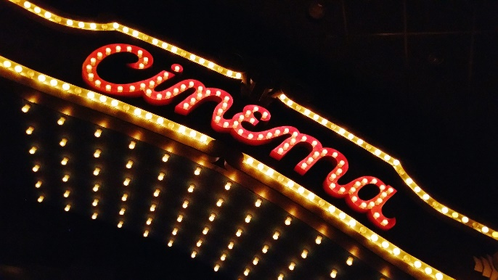
You are cordially invited to explore the power of connections with the At-Large Chapter of the NFBMD. We will present and discuss the movie Feeling Through, a thought-provoking encounter between a deaf-blind man and a sighted individual.

Date: Saturday, October 23rd
Time: 7:00pm
Place: Zoom

Every human being needs interaction. The discussion will be led by two deaf-blind individuals, Janice Toothman and Rania Dima. See how the power of connection applies to you.
Please register by Wednesday, October 20, so that we have time to send you the Zoom information. Be sure to include your email address when you register.
You may donate by going to http://www.nfbmd.org/feelingthrough or you may use CashApp by calling Marguerite Woods at 443-271-1668 and emailing her at mwoods719@gmail.com. You may also send a check made out to NFBMD to Sharon Maneki: 9013 Nelson Way, Columbia, MD 21045. Suggested donation is $12.

