BLIND INDUSTRIES AND SERVICES OF MARYLAND

FINANCIAL INDEPENDENCE WORKSHOP

for Blind and Low Vision NFB State Convention Attendees
(must be 18 years or older)

PRE-REGISTRATION REQUIRED by October 8, 2010
REGISTER EARLY–SEATING LIMITED

LEARN: Tools & Techniques for Managing Money & Financial Tasks

WHERE: Double Tree Hotel, Annapolis, MD
Room To Be Announced

WHEN: Friday, October 22, 2010
1 pm to 4 pm

WHAT: Demonstrations and Hands-on Instruction:
      - SARA Scanner (Scanning & Reading Appliance)
      - Money Identifiers
      - Talking Checkbook Software
      - Talking Calculator

Techniques for:
      - Money Management
      - Writing Checks
      - Reading Mail
      - Paying Bills
      - Banking Services

PLUS: GIFT for every participant completing Workshop!

FOR INFO CONTACT: Ruth Sager, 410-737-2649, rsager@bism.org

Proudly sponsored by:
Blind Industries and Services of Maryland

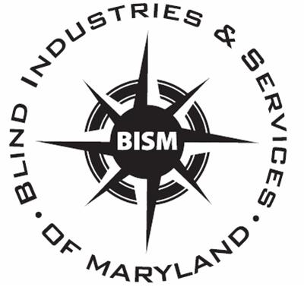

www.bism.org

