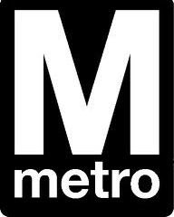 **MetroAccess Town Hall Meetings**

Have a suggestion about the next MetroAccess paratransit contract? Metro and its **Accessibility Advisory Committee** will be hosting three Town Hall Meetings to obtain input from the public. Customers and stakeholders will have the opportunity to talk to Metro leadership to provide their perspectives on any changes they would like to see.

The Town Hall Meeting Open House will begin at **6 p.m**. During the Open House, MetroAccess riders and stakeholders can pick up informational materials and speak with Metro officials. The Town Hall Meetings will begin at **6:30 p.m.** and conclude at **8 p.m.** as follows:

**Monday, October 24, 2011** Jackson Graham Building

600 Fifth Street, NW

Washington, DC 20001

**Tuesday, October 25, 2011** Arlington Central Library

1015 N. Quincy Street

Arlington, Virginia 22201

**Wednesday, October 26, 2011** First United Methodist Church

6201 Belcrest Road

Hyattsville, MD 20782

Unable to attend? You can still submit comments by:

• **Calling 202-962-1141** during the meeting dates and times above and provide comments by telephone

• **E-mailing comments** to access@wmata.com

• **Mailing comments** to WMATA, Attn: MetroAccess, 600 Fifth Street NW, Washington, DC 20001

For more information, visit www.MetroOpensDoors.com