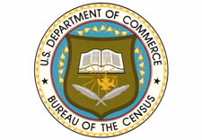
U.S. Census Bureau has openings for Field Representatives. These are PART-TIME positions.
Basic requirements:
- Must be a U.S. Citizen
- Must pass a written test and two scored interviews
- Must have access to a land line phone
- Must have a Driver’s license and use of an insured vehicle

You MUST CALL IN ADVANCE to schedule yourself to take a Mandatory Test at: 866-564-5420.
The tests will be conducted on the following dates:
District of Columbia
- March 9
- April 6
- May 11
- June 8

Testing in Washington, DC is at the Community College of the District of Columbia at 5171 S. Dakota Ave. NE (near the Fort Totten Metro station on the Red, Yellow, and Green lines)
NOTE: You must call in advance to schedule yourself to take the exam and to confirm the address for testing, as the locations are subject to change.
Montgomery County
- Germantown Library, March 5th (from 9 am to 5 pm)
- Rockville Main Library, April 3rd (from 9 am to 5 pm)
- Poolesville Library, May 7th (from 1pm to 9 pm)
You do not have to be a resident of Montgomery County or Washington, DC to take an exam at either location. You must call 866-564-5420in advance to schedule yourself to take the exam.
Individuals who do not call in advance to register for testing will not be allowed to take the exam.

