Ready for Success Training
A Guide to Getting Hired

Know what employers are looking for:

• What do employers search for in new hires?

• What makes you stand out from the others?

• What makes you the one employers want to hire?

We asked dozens of employers these questions
Find out what the answers are and improve
your chances of being hired.

Prepare yourself to outshine the competition so you can get hired faster and move up the ladder of success!

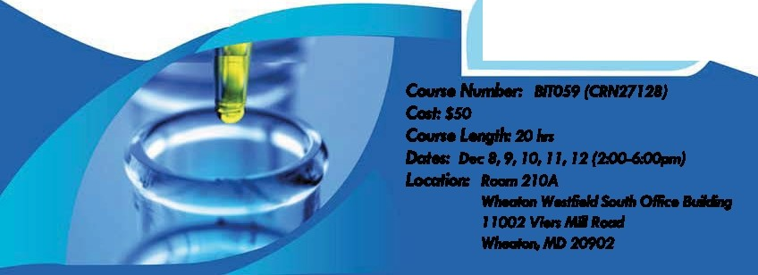
Course Details
Course Number: BIT059 (CRN 27,128)
Cost: No Charge
Course length: 20 hrs.
Dates: December 8th- 12th (2:00-6:00 pm)
Location: Room 210A
Wheaton Westfield South Office Building
11002 Viers Mill Road
Wheaton, MD 20902

Ready for Success course is designed to help people understand and practice the essential workplace skills that companies demand today. Participants of the program will gain a better understanding of the employer's perspective, practical skills, and “the bottom line" in key essential business skill areas.

Communications
- Communicationability Verbal & non-verbal communication in the workplace
- Writeability Written communication in the workplace
- Social Media The use and mis-use of social media as a tool in the workplace.

Fit
- Adaptability Succeeding in a changing environment.
- Suitability Understanding, learning, and adopting the company culture.
- Respectability Thriving in the multi-generational workplace.

Productivity
- Dependability Acting on the employer’s priorities, being on time, staying focused
- Reasonability Managing your mindset in the workplace
- Workability Realities & expectations in today’s workplace

Workplace Transition
- Transitionability Making a smooth job transition
- Presentability Reflecting the desired image of your workplace.

To register: Register in person at Montgomery College WD & CE
3rd Floor at the Westfield Building
11002 Viers Mill Road, Suite 306, Wheaton, MD 20902 Phone: 240-567-5188

Or contact Michael.smith@montgomerycollege.edu for a registration form
For more information on the BIOTrain Program and other continuing education courses contact
Michael Smith
Montgomery College Biotechnology Program Manager
(240) 567 7785
Michael.smith@montgomerycollege.edu
