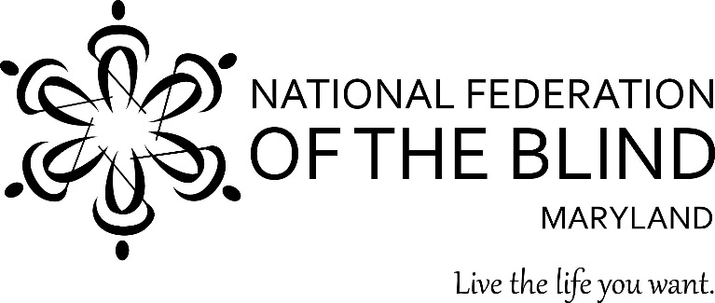

DINE OUT AND JOIN OUR “BID FOR OPPORTUNITIES”
Support the John T. McCraw Scholarship Program and the NFBMD Youth Training Programs.

Date: Saturday, October 1, 2016
Time: 6:30 to 9:30 PM
Location: College Park Knights of Columbus
9450 Cherry Hill Road, College Park 20740
Cost: $40 per person.

Enjoy good food, live music, and an auction for all tastes and budgets.

Make reservations by September 24th. Each table seats 8.
Make checks payable to the National Federation of the Blind of Maryland
Mail to: Debbie Brown, Scholarship Dinner Chairman
11923 Parklawn Drive, #104
Rockville, MD 20852
Contact: Debbie Brown, deborahb14@verizon.net, 301-881-1892

