Get ready to vote. Mark this sample ballot and bring it with you!

Official Voter Guide and Sample Ballot
2016 Presidential General Election

Vote Early

Ten locations open
October 27 - November 3 (8 am - 8 pm) Same-day registration at Early Voting only
To register, bring Maryland Driver’s License, ID, Learner’s Permit or other proof of residence

Vote by Mail

Request your ballot using the application inside

Not sure where to vote on Election Day?
Your polling place is printed on this Guide!

Look near your mailing address:

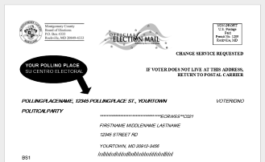
Then postmark your ballot by Election Day (deadlines on p 2)
...or Vote on Election Day

Tuesday, November 8 (7 am - 8 pm)
Your polling place is printed on the back of this Guide

¿Habla español? Su Papeleta de Muestra está en la página 13
Voting information is provided in Spanish as required by Section 203 of the Voting Rights Act of 1975. Sección 203 de la Ley del Derecho al Voto
de 1975 requiere que la información sobre la votación esté disponible en español.

Congressional District 8 — STYLE A Page 1

Voting in Montgomery County

Confirm your voter registration
To vote in the 2016 Presidential General Election in Montgomery County, Maryland, you must be:

- a U.S. citizen
- at least 18 years old by November 8, 2016
- a Montgomery County resident
- registered to vote

You may register or confirm or update your registration at elections.maryland.gov by October 18, 2016, or in person during Early Voting.

Miss the deadline? Try same-day registration!
Bring a Maryland Driver’s License, ID, Learner’s Permit or other proof of residence to register or change your address at any Early Voting site.
Vote Early! You may go to any Early Voting site in Montgomery County. If you vote early, you must not vote by mail or on Election Day.
...or Vote by Mail! Any registered voter may request a ballot at elections.maryland.gov or return the absentee ballot application in this Official Voter Guide and Sample Ballot.

Deadlines

If you want your ballot...
by mail
from Internet in person

The deadline for the Board of Elections to receive your request is:
Tues, Nov. 1 Fri, Nov. 4
Tues, Nov. 8

If you want to return your ballot...
in person
by mail

The deadline for the Board of Elections to receive your ballot is:

Extended Hours
Tues, Nov. 8 Fri, Nov. 18
(if postmarked by Nov. 8)

Our office is open for voting at 18753 N. Frederick Avenue, Suite 210 in Gaithersburg:
  - 8 am - 8 pm, daily between October 27 and November 3
  - 12 pm - 4 pm additional weekends, October 22-23 and November 5-6
You can track the status of your absentee ballot online at elections.maryland.gov or contact us at 240-777-8550 (phone), 240-777-8560 (fax), or absentee@montgomerycountymd.gov. You must mail your ballot or drop it off at the Board of Elections before polls close on Election Day. We cannot accept absentee ballots at the polls, by fax, or by email.
...or Vote on Election Day: Tuesday, November 8! Your assigned polling place is printed on the back cover of this Guide. If you can vote between 10 am and 4 pm in your polling place, there probably won’t be lines. Every polling place is open from 7 am to 8 pm.

Your Time—Your Voice—Your Vote! Choose Your Time . . .
A publication of the Montgomery County Board of Elections. Available in PDF or large type on request. Email us at elections@montgomerycountymd.gov or call 240-777-8683.
Page 2 STYLE A — Congressional District 8

Early Voting

October 27 - November 3
7
3
6
2
1
4
10
9
8
5
8 am to 8 pm
For wait times, driving directions and public transportation information, visit:
www.777vote.org

Mid-County Community Recreation Center
1
2004 Queensguard Road Silver Spring, MD 20906 Parking: free, on-site

Montgomery County Executive Office Building
2
101 Monroe Street
Rockville, MD 20852
Parking: 1 hr free at Jefferson & Monroe garage; on-street metered parking

Germantown Community Recreation Center
3
18905 Kingsview Road
Germantown, MD 20874 Parking: free, on-site

Marilyn J. Praisner Community Recreation Center
4
14906 Old Columbia Pike Burtonsville, MD 20866 Parking: free, on-site

Activity Center at Bohrer Park
506 S. Frederick Avenue Gaithersburg, MD 20877 Parking: free, on-site
6

Damascus Community Recreation Center
7
25520 Oak Drive
Damascus, MD 20872 Parking: free, on-site

Jane E. Lawton Community Recreation Center
8
4301 Willow Lane
Chevy Chase, MD 20815 Parking: free, on-site;
limited overflow parking in residential area

Wheaton Volunteer Rescue Squad
9
2400 Arcola Avenue
Wheaton, MD 20902 Parking: free, on-site;
limited overflow parking in residential area

Silver Spring Civic Building
5
One Veterans Place Silver Spring, MD 20910 Parking: public garage or on-street metered parking
Potomac Community Recreation Center
11315 Falls Road
10
Potomac, MD 20854 Parking: free, on-site

Congressional District 8 — STYLE A Page 3

Mail your application to:
PO Box 10159, Rockville MD 20849-0159

State of Maryland
Request an absentee ballot for the 2016 elections

You must be registered to vote to get an absentee ballot. Read the instructions on how to get an absentee ballot.
Step 1: Tell us the election you want an absentee ballot for.
I want an absentee ballot for the:  primary election  general election  both elections
Step 2: Tell us who you are. Print your information.
Last Name First Middle

Date of Birth Party Affiliation

Phone Number Email address
(Used only if needed to process this request.) (Warning: spam filters might prevent receiving official election mail.)

Print the address where you are registered to vote, even if you do not live there anymore. You can give your new address later.
Street Address Apt

City State Zip
If you do not live at the address you gave above, print the address where you now live. If your new address is in Maryland, we will update your voter registration information. Do not give an address here if you are away for school, work or travel and your address is temporary.
Street Address Apt

City State Zip

When did you move here? If you do not remember the exact date, give the month and year.
Step 3: Tell us where you want your ballot sent.
I want my absentee ballot:  mailed to the address I gave in Step 2. Go to Step 4.
Check only one  mailed to a different address. Complete Step 3.
- posted to the State Board of Elections’ website. You will print the ballot and return it by mail. Make sure you gave an email address in Step 2. Go to Step 4.
For the primary election, I want my absentee ballot mailed to:
Street Address Apt

City State Zip

For the general election, I want my absentee ballot mailed to:
Street Address Apt
City State Zip
Step 4: Sign here. If you do not sign here, we cannot get you a ballot.
X Date
Step 5: Someone helped me with this form. See instructions.
Under penalty of perjury, I hereby certify that this voter needed help with this form because he or she has a disability or is unable to read or write. The voter authorized me to complete this form. If the voter could not sign Step 4 of this form, I printed the voter’s name in Step 4 and wrote my initials.
Signature of Helper Date Printed Name of Helper

Page 4 STYLE A — Congressional District 8

1, 2, 3, VOTE
How Maryland Votes
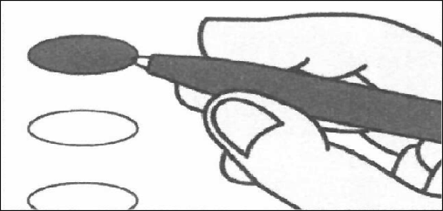
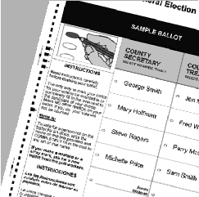
ver.2015.1
1 Mark Ballot
Mark the oval next to your choice using a black ballpoint pen. To cast write-in votes, mark the oval next to the write-in space, then print the candidate’s name.
2 Review Ballot
Review that your ballot is marked correctly. Did you turn it over? There may be contests on the other side!

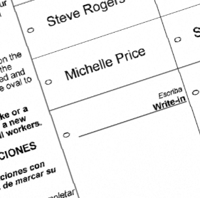
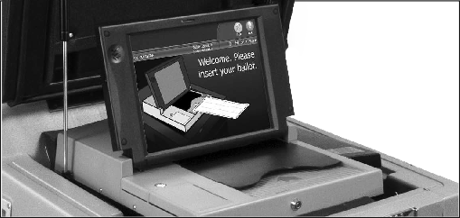
3 Scan Ballot
Mary Smith
Insert your ballot into the ballot scanner. Your ballot can be tabulated in any orientation (right side up, backward, or upside down). A Thank you for voting screen will appear after your ballot is accepted.

Correctly marking your ballot

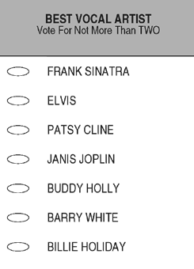
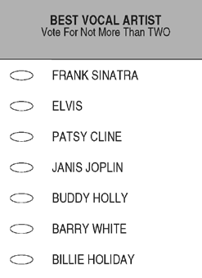
IT IS IMPORTANT TO MARK YOUR BALLOT PROPERLY BEFORE INSERTING IT INTO THE BALLOT SCANNER TO ENSURE THAT YOUR VOTES ARE COUNTED CORRECTLY.

X

- Completely fill in the oval next to your choice using a black ballpoint pen. Do not use an “x” or other notation.
- Do not mark more than the allowable number of selections per contest.
- If you make a mistake when marking your ballot, ask an election worker for a replacement ballot.

- Make sure all of the contests you intend to vote in are marked appropriately.

CORRECT INCORRECT
DO NOT FOLD YOUR BALLOT BEFORE INSERTING IT INTO THE BALLOT SCANNER.

Maryland State Board of Elections elections.maryland.gov #MDvotes2016
Voters With Disabilities
At least one touch-screen ballot marking device will be available at each site with large-print, high contrast, braille and audio capabilities. Each ballot marking device also has a keypad that allows you to navigate the ballot and make choices.

Congressional District 8 — STYLE A Page 5

