Official Ballot
Presidential General Election November 8, 2016
State of Maryland, Montgomery County
BS 1 - Page 1

Papeleta Electoral Oficial Elección General Presidencial 8 de Noviembre del 2016
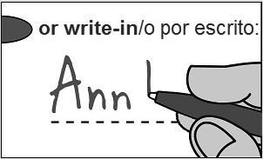
Estado de Maryland, Condado de Montgomery
Instructions
Instrucciones
Making Selections
Seleccionando
Fill in the oval to the left of the name of your choice. You must blacken the oval completely, and do not make any marks outside of the oval. You do not have to vote in every race.
Llene el óvalo a la izquierda del nombre de su selección. Debe rellenar el óvalo completamente y no haga ninguna marca fuera del óvalo. No tiene que votar en cada contienda.
Do not cross out or erase, or your vote may not count. If you make a mistake or a stray mark, you may ask for a new ballot.
No debe tachar o borrar, o su voto no se contará. Si comete un error o hace una marca demás, puede solicitar una nueva papeleta.

Optional write-in
Escritura opcional
To add a candidate, fill in the oval to the left of "or write-in" and print the name clearly on the dotted line.
Para agregar un candidato, llene el óvalo a la izquierda de "o por escrito" y escriba el nombre claramente en la línea punteada.
Sample Ballot—Congressional District 8
Mark this sample ballot and bring it with you!

Donald J. Trump
New York and/y
Michael Pence
Repub
Indiana
Republican/Republicano
Dan Cox
Republican
Republican/Republicano
Jamie Raskin
Democ ratic
Democratic/Demócrata
Jasen Wunder
Libert
Libertarian/Libertario
Hillary Clinton
New York and/y
Tim Kaine
Demo ic
Virginia
Democratic/Demócrata
Nancy Wallace
Green/Verde
Gary Johnson New Mexico and/y
Bill Weld Massachusetts Libertarian/Libertario
Libert
Jill Stein Massachusetts and/y
Ajamu Baraka
een
Georgia
Green/Verde

Judge of the Circuit Court Circuit 6
Vote for up to 3
Juez de la Corte de Circuito Circuito 6
Vote hasta por 3
John M. Maloney
Karla N. Smith
Harry C. Storm

U.S. Senator
Vote for 1 Senador de EE.UU. Vote por 1
Kathy Szeliga
Republican/Republicano
Chris Van Hollen
Democratic/Demócrata
Margaret Flowers
Green/Verde
President and Vice President Representative in Congress
of the United States District 8
Vote for 1 Vote for 1
Presidente y Vicepresidente de Representante en el Congreso los Estados Unidos Distrito 8
Vote por 1 Vote por 1
or write-in/o por escrito:
or write-in/o por escrito:
or write-in/o por escrito:
or write-in/o por escrito:
or write-in/o por escrito:
or write-in/o por escrito:

Page 6 STYLE A — Congressional District 8

Sample Ballot—Congressional District 8
Mark this sample ballot and bring it with you!
Judge, Court of Special Appeals At Large Dan Friedman  Vote Yes or No  For Continuance in Office  Juez, Corte de Apelaciones Especiales Sin Cargo Específico  Dan Friedman Vote sí o no  Para continuar en el cargo | Board of Education District 4  Vote for 1  Junta de Educación Distrito 4  Vote por 1
 | Shebra Evans
Yes/Si | Anjali Reed Phukan
No  No/No |  | or write-in/o por escrito:

Judge, Court of Special Appeals Circuit 7
Patrick L. Woodward Vote Yes or No
For Continuance in Office
Juez, Corte de Apelaciones Circuito 7
Patrick L. Woodward Vote sí o no
Para continuar en el cargo
Yes
Yes/Si
No
No/No

Board of Education At Large
Vote for 1
Junta de Educación Sin Cargo Específico
Vote por 1
Jeanette Dixon
Phil Kauffman
or write-in/o por escrito:

Congressional District 8 — STYLE A Page 7
Board of Education District 2
Vote for 1
Junta de Educación Distrito 2
Vote por 1
Brandon Orman Rippeon
Rebecca Smondrowski
or write-in/o por escrito:

Official Ballot
Presidential General Election November 8, 2016
Sample Ballot—Republican, Congressional District 8
Mark this sample ballot and bring it with you!
State of Maryland, Montgomery County
BS 1 - Page 2

Papeleta Electoral Oficial Elección General Presidencial 8 de Noviembre del 2016
Estado de Maryland, Condado de Montgomery

Question 1
Constitutional Amendment
(Ch. 511 of the 2016 Legislative Session)
Appointments and Special Elections for Attorney General and Comptroller
Pregunta 1
Enmienda Constitucional
(Cap. 511 de la Sesión Legislativa 2016)
Nombramientos y Elecciones Especiales para Procurador General y Contralor

Changes the way the Governor fills a vacancy of the Attorney General or the Comptroller and requires a special election for vacancies that occur on or before a certain date. Under current law, the Governor fills a vacancy by appointing an individual to serve for the remainder of the term. Under the amended law, if the vacating Attorney General or Comptroller was a member of a political party, the Governor must fill the vacancy from a list of three names provided by the political party of the vacating official, and if no names are provided by the political party within a set time period, then the Governor must select a successor from the political party of the vacating official. If the vacating Attorney General or Comptroller was not a member of a political party, then the amended law requires the Governor to appoint any qualified individual. The Governor must make the appointment within a set time period following the vacancy. The amended law requires a special election to replace the successor if the vacancy occurs early enough in the term to allow for candidates to participate in the regular elections held in the second year of the vacating official's term.

(Amending Article V, Section 5 and Article VI, Section 1 of the Maryland Constitution)

Cambia la forma en que el Gobernador llena la vacante del Procurador General o el Contralor y requiere una elección especial para las vacantes que ocurran antes o después de cierta fecha. Conforme a la ley actual, el Gobernador llena la vacante mediante el nombramiento de un individuo para servir el resto del término. Conforme a la ley enmendada, si el Procurador General o el Contralor saliente era miembro de un partido político, el Gobernador llenará la vacante de una lista de tres nombres proporcionada por el partido político del oficial saliente. Si ningún nombre es proporcionado por el partido político dentro de un periodo de tiempo, entonces el Gobernador seleccionará a un sucesor del partido político del oficial saliente. Si el Procurador General o el Contralor no eran miembros de un partido político, entonces la ley enmendada requiere que el Gobernador designe a cualquier individuo calificado. El Gobernador hará la designación dentro de un periodo de tiempo establecido después de la vacante. La ley enmendada requiere una elección especial para reemplazar al sucesor si la vacante ocurre lo suficientemente temprano en el término como para permitir que los candidatos participen en las elecciones regulares celebradas en el segundo año del término del oficial saliente.

(Modifica el Artículo V, Sección 5 y el Artículo VI, Sección 1 de la Constitución de Maryland)

For the Constitutional Amendment/A favor de la Enmienda Constitucional

Against the Constitutional Amendment/En contra de la Enmienda Constitucional

Page 8 STYLE A — Congressional District 8

Question A  Charter Amendment by Act of County Council  County Executive Vacancy - Special Election  Pregunta A  Reforma del Estatuto por acto del Consejo del Condado  Vacantes en la oficina del Ejecutivo del Condado - Edición Especial | Question C  Charter Amendment by Act of County Council  Term of Office - County Council and County Executive - Partial Service of a Full Term  Pregunta C  Reforma del Estatuto por acto del Consejo del Condado  Terminos en la oficina - El Consejo del Condado y el Ejecutivo del Condado - Servicio parcial de un termino completo
Amend Section 205 of the County Charter to recognize that under State law the County Council may provide for a special election to fill a vacancy in the office of County Executive.
Reformar sección 205 del Estatuto del Condado para reconocer que bajo la ley estatal el Consejo del Condado podrá proveer una elección especial para llenar una vacante en la oficina del Ejecutivo del Condado.

For/A favor

Against/En contra
Amend Sections 105 and 202 of the County Charter to provide that partial service of a full term for either a Councilmember or the County Executive means service of more than two years of a term.
Reformar secciones 105 y 202 del Estatuto del Condado para proveer que un servicio parcial de un termino completo, ya sea de un miembro del Consejo o el Ejecutivo del Condado, significa servicio de más de dos años de un termino.

For/A favor

Against/En contra
Question B
Sample Ballot—Congressional District 8
Mark this sample ballot and bring it with you!

Congressional District 8 — STYLE A Page 9

Charter Amendment by Petition
Term Limits - County Council and County Executive
Pregunta B
Reforma del Estatuto por petición
Límites de termino - El Consejo del Condado y el Ejecutivo del Condado
Amend Sections 105 and 202 of the County Charter to:
-- limit the County Executive and members of the County Council to 3 consecutive terms in office;
-- provide that a County Executive and any member of the County Council who will have served 3 or more consecutive terms on December 3, 2018, cannot serve another successive term in the same office; and
-- provide that service of a term includes complete service of a full term and partial service of a full term.
Reformar secciones 105 y 202 del Estatuto del Condado para:
-- limitar a el Ejecutivo del Condado y a los miembros del Consejo del Condado a 3 terminos consecutivos en la oficina.
-- proveer que el Ejecutivo del Condado y cualquier miembro del Consejo del Condado que hayan servido 3 o más terminos consecutivos el 3 de Diciembre del 2018, no podran servir a otro termino sucesivo en la misma oficina; y
-- proveer que el servicio de un termino incluye el servicio completo de un termino y el servicio parcial de un termino completo.

For/A favor

Against/En contra

Constitutional Amendment
United States Senator, Attorney General, and Comptroller – Appointments and Special Elections to Fill a Vacancy Chapter 511 of 2016 (House Bill 260)
Summary Prepared by the Maryland Department of Legislative Services
This proposed constitutional amendment alters procedures for filling vacancies in the offices of Attorney General and Comptroller. Under current provisions of the Maryland Constitution, the Attorney General and the Comptroller are elected to four-year terms by the qualified voters of the State at the same election in which the Governor is elected. When a vacancy occurs in the office of the Attorney General or Comptroller due to death, resignation, or any other reason, the Governor is required to appoint a qualified individual to fill the vacancy for the remainder of the term. In the case of the Comptroller, the appointment is subject to confirmation by the State Senate.
Under this proposed constitutional amendment, the Governor would be required to make an appointment to fill a vacancy in the office of Attorney General or Comptroller from a list of three individuals submitted by the State Central Committee of the political party with which the vacating Attorney General or Comptroller had been affiliated when elected or appointed. An appointee to the office of Comptroller must subsequently be confirmed by the State Senate. The State Central Committee must submit names to the Governor within 30 days after the occurrence of the vacancy, and the Governor must make the appointment within 15 days after the names are submitted. If the State Central Committee fails to submit names by the deadline, the Governor is required to appoint any qualified individual affiliated with the appropriate political party within 15 days after the deadline. If the vacating Attorney General or Comptroller was not affiliated with a political party, the Governor is required to appoint any qualified individual within 15 days after the occurrence of the vacancy.
The appointee serves for the remainder of the term, unless the vacancy occurs 21 days before the deadline for filing a certificate of candidacy for the regular statewide election that is held in the second year of the term, in which case a special election is held at the same time as the regular statewide election. If a special election is held, the appointee serves until a successor is elected at the special election.
The legislation that proposed this constitutional amendment also included statutory provisions establishing a similar process for filling a vacancy in the office of United States Senator. These statutory provisions have taken effect and are not affected by this constitutional referendum.
The Attorney General is the chief legal officer of the State. The Attorney General's Office acts as legal advisor and representative of State agencies and represents the State in litigation. The Comptroller is the chief financial officer of the State and, among other duties, supervises the collection of most State taxes and regulates the alcohol, tobacco, and motor fuel industries. The Comptroller also serves with the Governor and the Treasurer on the Board of Public Works, which reviews and approves most State contracts and exercises other fiscal and regulatory powers.

Page 10 STYLE A — Congressional District 8

Local Questions
Because these questions were not placed on the ballot by the State of Maryland, no summary was prepared by the Maryland Department of Legislative Services.
QUESTION A: CHARTER AMENDMENT BY ACT OF COUNTY COUNCIL
County Executive Vacancy—Special Election
Amend Section 205 of the County Charter to recognize that under State law the County Council may provide for a special election to fill a vacancy in the office of County Executive.
QUESTION B: CHARTER AMENDMENT BY PETITION
Term Limits—County Council and County Executive
Amend Sections 105 and 202 of the County Charter to:
-- limit the County Executive and members of the County Council to 3 consecutive terms in office;
-- provide that a County Executive and any member of the County Council who will have served 3 or more consecutive terms on December 3, 2018,
-- cannot serve another successive term in the same office; and
-- provide that service of a term includes complete service of a full term and partial service of a full term.

QUESTION C: CHARTER AMENDMENT BY ACT OF COUNTY COUNCIL
Term of Office—County Council and County Executive— Partial Service of a Full Term
Amend Sections 105 and 202 of the County Charter to provide that partial service of a full term for either a Councilmember or the County Executive means service of more than two years of a term.

Congressional District 8 — STYLE A Page 11

Write-in Candidates/Candidatos del Voto Escrito
Additional individuals may file after this specimen ballot is printed or listed candidates may withdraw. An up-to-date listing will be posted at Early Voting centers, the Board of Elections and in your polling place. | Adicionalmente, otros candidatos pueden presentar su candidatura después que las papeletas de muestra sean impresas ó candidatos ya listados pueden haberse salido. Una lista actualizada estará puesta en los centros de votación anticipada, en la Junta Electoral y en su centro electoral.
President and Vice President of the United States/Presidente y Vicepresidente

Paij Boring, Republican/Republicano Joann Breivogel, Republican/Republicano Jacqueline Gates, Republican/Republicano
Stephen McCathy, Republican/Republicano Janet L. Reid, Republican/Republicano Paul Adams, Democratic/Demócrata
Cathy Johnson Pendleton, Democratic/Demócrata Mary Thomas, Democratic/Demócrata
William Bowhall, Other/Otro Theodis Brown, Sr., Other/Otro
Darrell L. Castle and/y Scott N. Bradley, Other/Otro Mohammed Keita, Other/Otro
Star Locke, Other/Otro
Michael A. Maturen, Other/Otro
Evan McMullin and/y Nathan Johnson, Other/Otro James Medges and/y Bill Bayes, Other/Otro Michael S. Olkowski, Other/Otro
Coop Smith, Other/Otro Mitchell Williams, Other/Otro
Shelia Bolar, Unaffiliated/Sin Afiliación
Michael David Boyles, Unaffiliated/Sin Afiliación Dana E. Brown, Unaffiliated/Sin Afiliación Robert Buchanan, Unaffiliated/Sin Afiliación Martin Carlisle, Unaffiliated/Sin Afiliación
Richard Duncan, Unaffiliated/Sin Afiliación Ameer Flippin, Unaffiliated/Sin Afiliación Cherunda Fox, Unaffiliated/Sin Afiliación Ben Hartnell, Unaffiliated/Sin Afiliación Gerald Jennings II, Unaffiliated/Sin Afiliación Laurence Kotlikoff, Unaffiliated/Sin Afiliación
Joseph A. Maldanado, Unaffiliated/Sin Afiliación Maurice Symonette, Unaffiliated/Sin Afiliación Kora Roberta Katz Vakil, Unaffiliated/Sin Afiliación Tony Valdivia and/y Aaron Barriere, Unaffiliated/Sin Afiliación
U.S. Senator/Senador de EE.UU.
Bob Robinson, Democratic/Demócrata Charles U. Smith, Democratic/Demócrata Lih Young, Democratic/Demócrata
Greg Dorsey, Unaffiliated/Sin Afiliación Ed Tinus, Unaffiliated/Sin Afiliación
Representative in Congress, District 3/ Representante en el Congreso Distrito 3 Ann Dalrymple, Democratic/Demócrata
Representative in Congress, District 6/ Representante en el Congreso Distrito 6 Ted Athey, Unaffiliated/Sin Afiliación

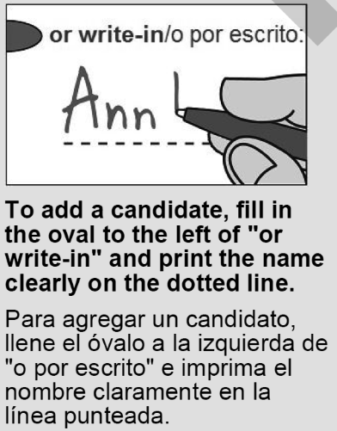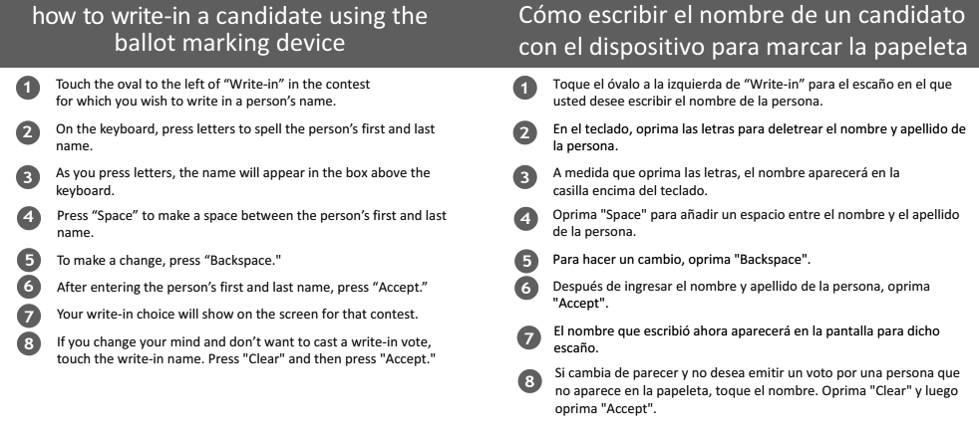
Montgomery County Board of Elections—18753 N. Frederick Avenue, Suite 210—Gaithersburg, Maryland 20879 elections@montgomerycountymd.gov—240-777-VOTE (8683)

Jim Shalleck, President/Presidente  Nahid Khozeimeh, Vice President/Vicepresidente | Alexander Vincent David Naimon | Jacqueline Phillips, Substitute/Substituto Graciela Rivera-Oven, Substitute/Substituto
Mary Ann Keeffe, Secretary/Secretaria

Page/Página 12 STYLE/ESTILO A — Congressional District 8/Distrito del Congreso 8

