Diabetes Self-Management Workshop

   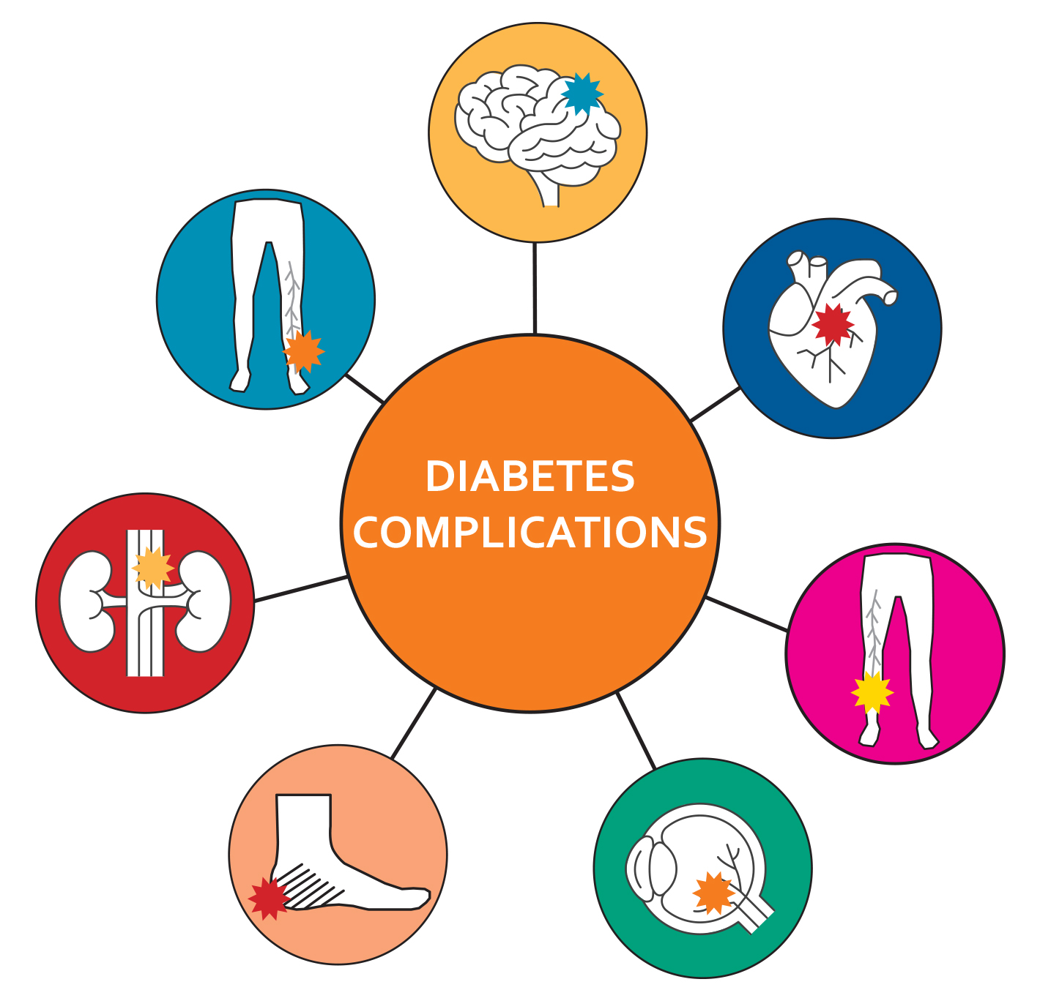

**Nutrition Physical Activity Sleep Managing Symptoms**

**& Complications**

Join this **FREE** virtual six-week workshop to improve your ability to manage your health and maintain an active and happy life while living with Type 2 Diabetes or Pre-Diabetes.

You will learn:

* Ways to manage diabetes symptoms including fatigue, hyper/hypoglycemia, stress, depression, anger, fear and frustration
* Exercises for maintaining and improving strength and endurance
* Healthy eating and appropriate use of medication
* How to improve your sleep
* Working more effectively with health care providers

Anyone living with diabetes or pre-diabetes is welcome to attend this free online workshop delivered via Teams. Caregivers and family members are also welcome to participate. The curriculum is evidence-based and was developed by Stanford University with support from Kaiser Permanente of Northern California. The classes are 2.5 hours, once a week for SIX WEEKS and participants are encouraged to attend ALL SIX SESSIONS.

|  |  |  |  |
| --- | --- | --- | --- |
| Day/Dates | Time | Virtual | Register by |
| Thursdays: 1/5/23 – 2/9/23 | 10:00 am – 12:30 pm | Teams | 1/03/23 |
| Wednesdays: 2/22/23 – 3/29/23 | 1:30 pm – 4:00 pm | Teams | 2/20/23 |
| Mondays: 4/17/23 – 5/22/23 | 6:30 pm – 9:00 pm | Teams | 4/15/23 |

To register for classes click on the following link: [Disease Prevention & Management Silver Spring, Maryland (MD), Holy Cross Hospital (holycrosshealth.org)](https://www.holycrosshealth.org/health-and-wellness/classes-and-support-groups/disease-prevention-and-management?) or call **(301) 754-8800.** Virtual classes are delivered online via Microsoft Teams.



**We are on your team!**