**Chronic pain self-management workshop**

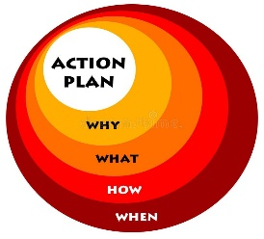 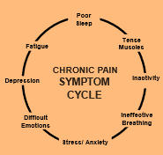 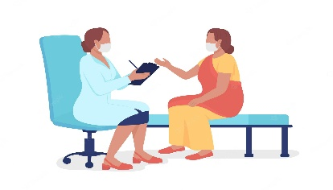  Action Plan Symptom Cycle Communication Nutrition

Join this FREE virtual six-week workshop to get the tools you need to meet health-related goals and learn new ways to manage chronic pain. Participants who have fibromyalgia, post stroke pain, neuropathic pain, or other causes are welcome to attend the workshop as well as caregivers and family members.

You will learn:

* Ways to manage the chronic pain symptom cycle
* The role of the mind and body in chronic pain management
* How to make an action plan to reduce your pain
* How to pace your activities
* How to keep a pain diary for yourself and your healthcare provider
* How to make better nutrition and exercise choices
* How to improve communication with your health care team

Participants receive a copy of “Living A Healthy Life with Chronic Pain," 2nd edition which follows the curriculum and provides additional ways to address specific issues. This evidence-based workshop is delivered online via Teams and participants may join with a computer and webcam, or by phone.

|  |  |  |  |
| --- | --- | --- | --- |
| Day/Dates | Time | Virtual | Register by |
| Wednesdays: 1/11/23 – 2/15/23 | 1:30 pm – 4:00 pm | Teams | 1/09/23 |
| Thursdays: 3/2/23 – 4/6/23 | 10:00 am – 12:30 pm | Teams | 2/28/23 |
| Wednesdays: 4/19/23 – 5/24/23 | 1:30 pm – 4:00 pm | Teams | 4/17/23 |

To register for classes click on the following link [Disease Prevention & Management Silver Spring, Maryland (MD), Holy Cross Hospital (holycrosshealth.org)](https://www.holycrosshealth.org/health-and-wellness/classes-and-support-groups/disease-prevention-and-management?title=Virtual%20Chronic%20Pain%20Self-Management%20Workshop) or call (301) 754-8800. Virtual classes are delivered online via Microsoft Teams.



We are on your team!