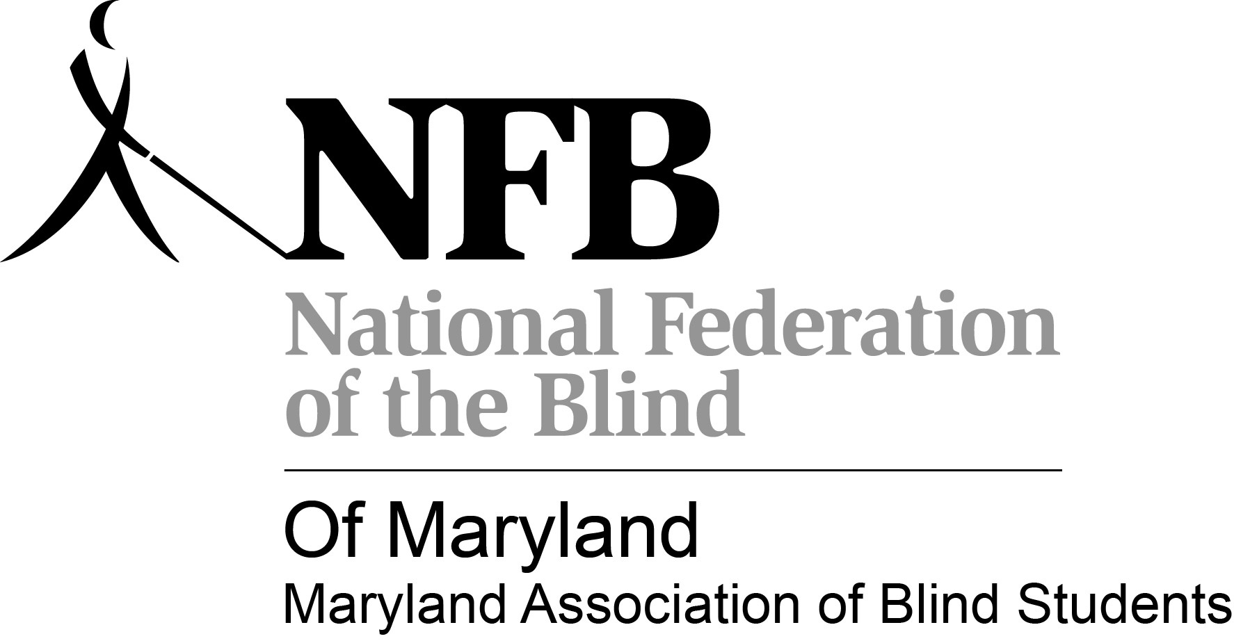

Maryland Association of Blind Students (MDABS) Presents:

**M**otivation for **E**ducation

2012 Back To School Seminar

**When?** August 18, 2012, 10:00 am – 5:00 pm

**Where?** 4805 Edgemoor Lane, Bethesda, MD 20814

**Who’s invited?** Blind high school and college students (both current and prospective)

**What to expect??**

**Expect informative talks on:**

* How to foster a positive attitude towards blindness
* Accessible textbook options
* Scholarships
  + Social life and advocacy at school
  + DORS resources
  + NFB resources, chapters, and divisions
  + NFB training centers
  + How to get involved

**And we can’t forget:**

**FOOD and SOCIALIZING!!!**

Come out and meet other students in Maryland as well as some great mentors!!

Snacks and Lunch will be served. (Please inform us of any dietary needs)

Please bring a $5 donation for registration. If you cannot, come join us anyways!

For more information please contact **Melissa Lomax** by email at **mlomax1@umbc.edu** or by phone at **(410)-608-6118.**