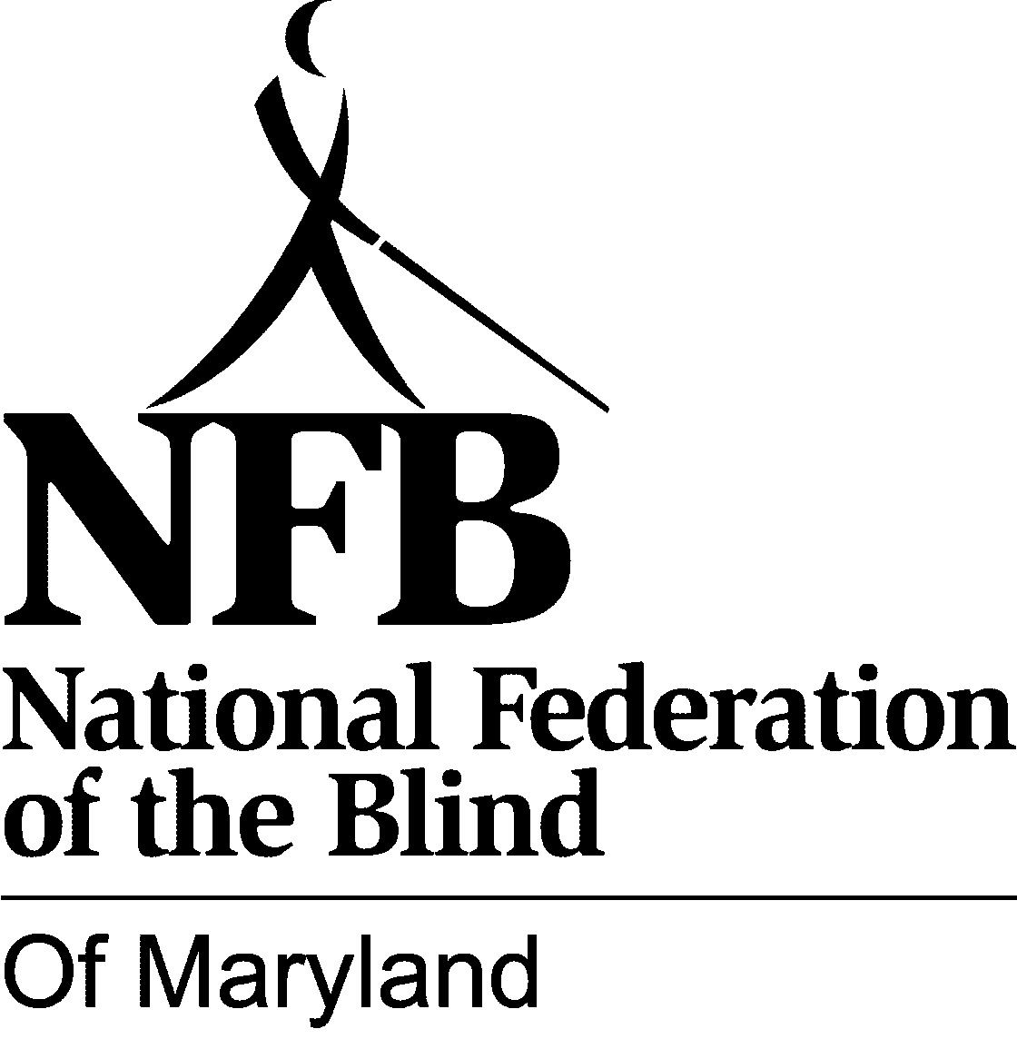
JOHN T. McCRAW SCHOLARSHIP PROGRAM: 2014-15

NATIONAL FEDERATION OF THE BLIND OF MARYLAND

Website: www.nfbmd.org

The National Federation of the Blind of Maryland is pleased to announce that the John T. McCraw Scholarship Program for 2014-15 will include two scholarships in the amounts of $2,000 and $1,500. These scholarships will be awarded to qualified blind students who exhibit academic achievement and community involvement.

The John T. McCraw Scholarship Program has been established to promote post-secondary educational opportunities for Maryland's blind students. The recipients may use these scholarships to defray the cost of educational expenses incurred at any post-secondary institution during the 2014-15 academic year.

NOTE: In addition to these two scholarships, a special scholarship may be awarded to former McCraw Scholarship recipients. To apply for this special scholarship, former recipients must still meet all of the requirements for the McCraw Scholarship Program and submit a new application.

WHO IS ELIGIBLE

A) Any legally blind student is eligible to receive a scholarship who:
1. Is a legal resident of the State of Maryland, or is pursuing post-secondary studies in the State of Maryland;
2. Will be enrolled as a full-time student at any post-secondary institution.

B) Recipients are expected to attend the annual Convention of the National Federation of the Blind, July 1-6, 2014, in Orlando, Florida, as well as the annual Convention of the National Federation of the Blind of Maryland, November 14-16, 2014, in Towson, Maryland. Financial assistance to attend the Conventions will be provided.

C) Applications must be submitted by April 18, 2014. Shortly thereafter, the scholarship committee will select the recipients, but will not determine the amount to be awarded to each recipient until personally interacting with the recipients at both conventions. Scholarships will be awarded at the state convention banquet. Recipients' participation in both conventions is mandatory in order to qualify for these scholarships.

D) The scholarship committee may request additional information from an applicant. The scholarship committee's decision for the recipients of the John T. McCraw Scholarship Program is final.

(Blind students are also invited to apply for the nationwide scholarships offered by the National Federation of the Blind. The application deadline for the national NFB scholarships is March 31, 2014. Visit www.nfb.org/scholarships to apply for the national scholarships.)

SEE REVERSE SIDE FOR APPLICATION
JOHN T. McCRAW SCHOLARSHIP PROGRAM 2014-15
APPLICATION

Name: Date of Birth:

Home address:

Home phone number:

Cell phone number: _

Email Address:___________________________________________________________________________

Institution being attended in spring semester, 2014, with class standing (freshman, sophomore, etc.):

Cumulative grade point average at this institution:

Institution to be attended in fall 2014, with class standing. Send by separate letter if admitted to school after submitting completed application:

List all post-secondary institutions attended with highest class standing attained and cumulative grade point average:

High school attended and cumulative grade point average:

SUPPORTING DOCUMENTS (These items may be mailed separately):

1. A letter by the applicant: What honors have you achieved? What have you done to deal with situations involving your blindness? What are you like as a person? What are your goals and aspirations? How will the scholarship help you?

2. Two letters of recommendation.

3. A current transcript from the institution you are now attending and transcripts from all other post-secondary institutions attended. If you have not yet attended such an institution or have not completed one year of study, send a high school transcript.

EMAIL APPLICATION AND SUPPORTING DOCUMENTS TO (Preferred):
judyras@sprynet.com , with Subject heading: scholarship application
OR SEND COMPLETED APPLICATION AND SUPPORTING DOCUMENTS TO:
Scholarship Committee Chairman, NFBMD, 11909 Coronada Pl. Kensington, Maryland 20895

