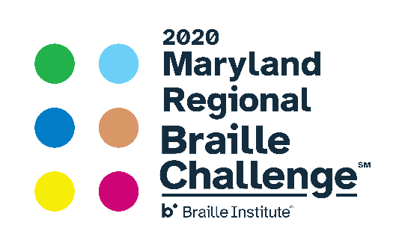

MARYLAND REGIONAL BRAILLE CHALLENGE
Baltimore – February 8, 2020 Snow Date: February 22
PARENT REGISTRATION INFORMATION FORM

Participant’s Name: _________________________________________
Participant’s Height: _________

Lunch Option (circle one): chicken salad turkey roast beef vegetarian italian

Please select: Braille Challenge or Mini-BELL Participant

Name of Parents/Guardians Attending:
__________________________________________________________
Lunch Option (circle one): chicken salad turkey roast beef vegetarian italian

__________________________________________________________
Lunch Option (circle one): chicken salad turkey roast beef vegetarian italian

Accommodations to be provided for Parents/Guardians upon request: Please specify. Large Print Braille Electronic

For Students in Grade 5-12 Only: Students may bring their own or school system Victor Reader Stream and headphones to use for the “Speed and Accuracy” contest. If they cannot bring one, a Bookport Plus will be provided for use. Please check one box. Student should able to use one or both devices independently. Please contact Jackie Otwell at jacquelineo@mdschblind.org if this is a concern.
I will bring a Victor Reader Stream OR
I will bring a Book Port
I will need to borrow a device the day of the event
Yes, I would like to bring books to exchange at the Braille book exchange. I will bring approximately ____ books (count each volume as a separate book please, this is to help with planning).

Workshops will be provided throughout the day for parents.
NOTE: At least one parent must attend and remain on site throughout the day while their child is present and competing. Parents are not allowed in the competition rooms with their child. You are encouraged to participate in the workshops provided. Your children will be escorted and supervised by teachers and staff from the local school systems and the Maryland School for the Blind.
*Is your child a member of the Maryland State Library for the Blind and
Physically Handicapped? If not, visit Maryland Library for the Blind and Physically Handicapped to download an application.*

Parent Signature: __________________________Date:__________
THIS FORM MUST BE SIGNED and SENT TO Jackie Otwell BY JANUARY 17, 2020
Email to jacquelineo@mdschblind.org or fax to 410-319-5708

