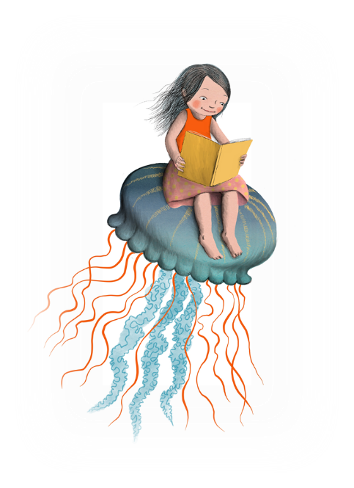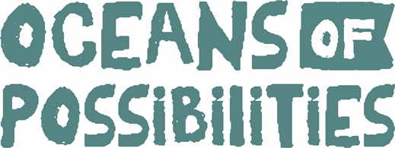
© CSLP 2022

“2022 Oceans of Possibilities” Summer Reading Program

The Maryland Library for the Blind and Print Disabled’s (LBPD) Summer Reading Program is making waves! Our summer theme this year focuses on the ocean and all the wonders that live there. This summer enjoy online options, as well as in person, so everyone can participate. Read below for more details.

When does it Begin?
Registration Starts: May 9th
Program Starts: June 15th – August 15th

Summer Themes
Throughout the summer we will explore several themes related to “Oceans of Possibilities.”
June Teen and Tweens: Vikings and Norse Mythology
Kids: Our Blue Planet
July: Exploring the Deep
August: Mythical Sea Creatures

How Do I Participate?
Make a Splash & Earn 20 points! Complete any of the options below and earn points towards completion.
Do:
- Read a book
- Read for one hour
- Complete a summer reading activity listed on the game board.
- Participate in additional LBPD summer activities, games, and programs to gain more chances into raffle drawings.
Record:
- Mark your summer reading game board or use Beanstack to track your progress.

Return/ Complete (Select an Option):
- Your game board by Monday, August 22 to earn a completion prize and entry into a raffle.
- Complete the program on Beanstack by Monday, August 22

There are Several Ways to Sign Up
- Use this registration link: https://forms.gle/qZuGjgfwyhegcvaa8
- Email kidsdesk.lbpd@maryland.gov with your name & phone number. Include if you want the summer reading audiobooks on a cartridge, and if you need your information sent in Braille.
- Go Paperless! Use Beanstack at https://marylandlbph.beanstack.org
- Call 410-230-2424, option 8. Be sure to leave your name, phone number, and requests a call back.

After You Register
By registering for summer reading, you will receive
- A large print or Braille summer reading book list, which will be mailed or emailed.
- A game board to track the number of books read throughout the summer.
- A multiple books cartridge loaded with the summer reading audiobooks (only if requested)
- Your first prize!!!! (Register by June 2, as it will be while supplies last)

Did I Mention Prizes?
Everyone who completes 20 points earns one entry into a raffle prize of their choice.
Each additional activity, program, or summer game can earn you additional chances into the raffles of your choice.

A Special Visitor is Coming!
Would you like to visit with a 40 foot humpback whale? Come, climb inside and get to know this fascinating creature. The MD LBPD will have a special visit from the Whale Mobile for all our summer readers on August 13th. It is an event you don’t want to miss. Stay tuned as there will be more information to come.

Got Questions?
Email: kidsdesk.lbpd@maryland.gov
Call: 410-230-2424, option 8

Follow us on Social Media!
- Facebook - MDLBPD
- Twitter - MDLBPD
- Linked In - Maryland State Library for the Blind and Print Disabled
- Blog- https://mdlbpd.blogspot.com/

