National Federation of the Blind
of Maryland

2025 Convention

AGENDA

Lead, Love, Live!

Thursday, February 13 to Sunday, February 16

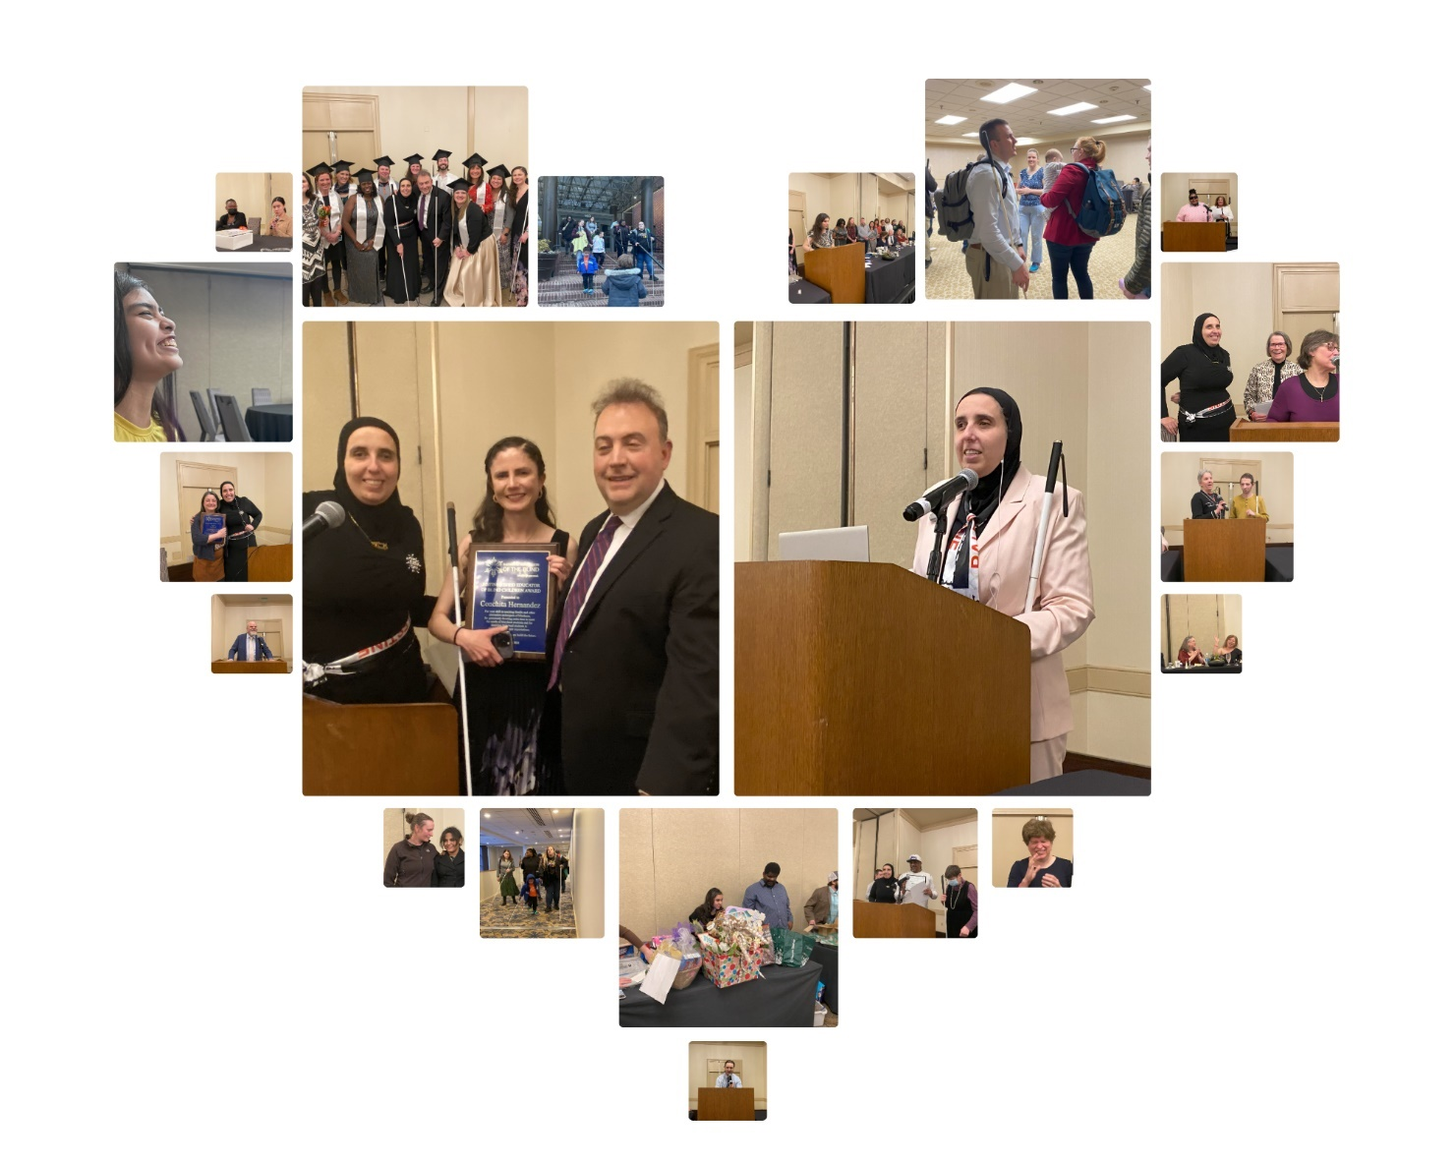
Image description: Twenty photos from state convention are laid out in various sizes to form a heart — various NFBMD members and leaders smile and laugh together, present at podium, receive awards, manage door prize table, and participate in cane walk.

The Members of the Board of Directors and the
Host Chapter welcome you to the
59th Annual Convention of the
National Federation of the Blind of Maryland

Ronza Othman, President
National Federation of the Blind of Maryland

Justin Young, Chairperson
Convention Logistics Committee

Heather Guy, President
Eastern Shore Chapter

Welcome

Welcome to the 59th annual convention of the National Federation of the Blind of Maryland! This year’s convention will be held in Ocean City at the Ashore Resort and Beach Club.

Ashore Resort and Beach Club
10100 Coastal Highway, Ocean City, MD 21842
410-524-3535

A detailed description of the layout of the hotel can be found later in this agenda. When you check into the hotel, you will be asked to confirm your departure date. If you decide to leave earlier than the departure date you confirm when you check in, there may be an additional fee.

Special Information for First-Time Attendees
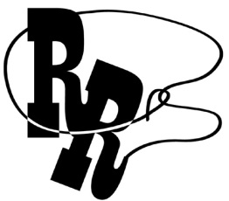
All first-time convention attendees are cordially invited to attend a First-Timers Orientation from 8 to 9:30 p.m. on Tuesday, February 11. The Ambassadors Committee will walk you through the events that will take place throughout the weekend, explain processes such as door prizes and voting, as well as make sure every first-time convention attendee is matched with a mentor. This orientation will be held virtually, the codes to join via web conference or via conference call are below.
Zoom Meeting ID: 624 813 8327
One-Number Conference Call: 339-209-4083

Diversity, Equity, Inclusion, and Social Conduct
We are committed to providing a safe and harassment-free environment for everyone. Thank you for cultivating an atmosphere in which participants from diverse backgrounds can learn, network, and share with each other in an environment of mutual respect. We are committed to diversity, equity, inclusion, and the free expression of ideas. These principles have been outlined in our code of conduct, which can be found at
NFB.org/About-Us/History-and-Governance/Code-Conduct.
We recognize a shared responsibility to create and uphold an atmosphere that benefits everyone. Prohibited behaviors include harassment, unwelcome sexual attention, and inappropriate use of the NFBMD convention space and platforms. Prohibited behavior or misuse of our space and platforms will not be tolerated and may result in removal from the convention and/or other consequences.
For assistance, or to report an incident at the convention,
please call 585-770-4073 or
email convention@nfbmd.org for immediate attention.
Formal reports can be submitted to the NFB national office at: NFB.org/About-Us/History-and-Governance/Code-Conduct/
Report-Form
All formal reports will be thoroughly investigated according to the
code of conduct. We thank you for contributing to the integrity
of our community and the high expectations we strive to maintain.

Pre-Registration and Onsite Registration
Registration activities take place in the Grand Foyer, which is outside of the Grand Ballroom (also called Tideline A and Tideline B), located on the Main Level (first floor) of the Conference Center, Friday between 1 and 6 p.m.; Saturday between 7:45 and 8:25 a.m., and 11:45 a.m. and 12:15 p.m.; and Sunday between 8:30 and 8:45 a.m. All convention attendees — both local and from out of town — are asked to register.

- Those who pre-registered for the convention may pick up their registration packets in the area designated pre-registration.

- Those who did not pre-register may go to the area designated registration. Please have your check, credit card, Zelle, or cash ready to pay the onsite registration fee of $35 per person.

Convention registration is a requirement for voting, door prize eligibility, and other convention activities. All registrants will receive wrist bands, which will indicate voting eligibility. Additionally, discounted rates for hotel rooms are contingent on proof of registration.

Fun with Friends: Convention Childcare Activities
All childcare (for children ages 6 weeks to 9 years) will take place in Seaside 6 on the Terrace Level (second floor). Hours are: Friday 8:30 a.m. to 5:15 p.m.; and Saturday 8:15 a.m. to 5:15 p.m., and 6:45 to 10:15 p.m., or at conclusion of the banquet, whichever is earlier (lunch and dinner will be provided). Contact Garret Mooney at james.garret.mooney@gmail.com for details.

Exhibit Hall
The exhibit hall is located in Atlantic 1 on the Terrace Level. The exhibit hall will operate on Friday from 11 a.m. to 6 p.m.

Special Attention Items
- Banquet tickets may be purchased for $70 at the onsite registration area. We will accept cash, credit cards, Zelle, and checks. No tickets will be available after 12:15 p.m. on Saturday. At the banquet ticket exchange table, you may make arrangements to reserve a specific seat for yourself or for a group of up to 10 people. On the evening of the banquet, tickets will be required to enter the ballroom and will be collected at the tables. Anyone who pre-registered but who has not picked up their banquet tickets by 12:15 p.m. on Saturday will forfeit them and will not receive a refund.

- Tickets may be exchanged for vegetarian or meat meals at the banquet ticket exchange table prior to 2 p.m. on Saturday.

- Individuals with dietary restrictions must submit those requests in advance, as such meals must often be ordered and/or prepared off-site. Requests related to dietary restrictions should be sent to President@nfbmd.org by February 1, 2025.
- Requests for reasonable accommodations — other than Braille and large print agendas, which will be available for all — must be submitted in advance, as such accommodations often require advanced arrangements. Requests for accommodations should be sent to President@nfbmd.org by February 1, 2025.
- All business will be suspended during the Presidential Report.

- Teens and tweens will have programming throughout the convention. Some of this programming will take place in Cabana rooms off the Dune Deck. For more information and specific schedules, contact Garret Mooney at James.Garret.Mooney@gmail.com.

- Banquet ticket exchange will be located in the Grand Foyer, on the Main Level, outside Tideline A and Tideline B on Saturday between 1:20 and 2 p.m.
- General sessions will be in Tideline A on the Main Level.

- The banquet will be in Atlantic Ballroom 1 and 2 on the Terrace Level.
- Boxed lunches will be resold if not picked up by 12:30 p.m. on Friday. Those interested in boxed lunches on Friday should visit the Grand Foyer. Those who fail to pick up their boxed lunches by
12:30 p.m. on Friday will forfeit them and will not receive a refund.
- Tickets for other meals may be purchased on a first-come, first-serve basis from the registration table. The costs are:
  - Dinner and a Play: $35
  - Senior Issues Luncheon: $40
  - Parents Luncheon: $40
  - Students Luncheon: $40
  - Banquet: $70
- All purchases are final and no refunds are available.

- Juhi Narula and Carley Mullin are the co-chairs of the Door Prize Committee. Please turn in your door prizes to Carley and/or Juhi as soon as possible. You must be registered for the convention and be present when your name is called in order to win a door prize. Door prizes will be awarded during the general sessions on Saturday and Sunday and during the convention banquet.
- Joel Zimba and Erin Zobell are the co-chairs of the National Funding Support Committee, which manages our Bake and Experience Auction. Please consider bringing baked goods and donating experiences such as dinners, cooking lessons, etc., for this auction.

- All tabs related to the Bake and Experience Auction must be cashed out prior to adjournment on Sunday. We accept cash, credit cards, checks, and Zelle. All purchases are final. Anyone who bids on and wins an auction item and fails to pay for their item prior to adjournment will be banned from bidding in the auction in the future.

- The Student Division will host a fire sale for individually wrapped baked items, e.g., single cupcakes, brownies, and cookies.
- We will have a cane walk with individualized cane travel instruction by an NOMC by appointment only. To reserve a slot for your child or for yourself, please contact Garret Mooney at james.garret.mooney@gmail.com.
- On Sunday, you must check out of your room before 11 a.m. Please note that the convention is not scheduled to adjourn until 1 p.m. After check-out, you may store your luggage by dropping it off at Seaside 4 on the Terrace Level between 7:30 and 9 a.m., Sunday. Please be sure your luggage is clearly labeled with your name, address, and telephone number. All luggage must be picked up by 1:30 p.m. or 15 minutes after adjournment, whichever is earlier.

- If you are leaving the hotel on an NFB of Maryland bus, please bring your luggage to Seaside 4 on the Terrace Level between 7:30 and 9 a.m. on Sunday. Your luggage will be tagged and held, and then loaded onto the buses at 1 p.m. Please be sure your luggage is clearly labeled with your name, address, and telephone number. Please identify when checking in your luggage if you are assigned to the New Carrollton Bus, Baltimore Bus 1, or Baltimore Bus 2.
- There are two guide dog relief areas. The first is located just outside Tideline A and Tideline B on the Main Level (outside of General Session). The second is located outside the Dune Deck near the Cabana sleeping room area on the Terrace Level just beyond the Tap Room; this guide dog relief area is down some steps on the beach side of the hotel, so those needing an accessible guide dog relief area will want to use the one adjacent to Tideline A and B.

Organization Information

National Federation of the Blind of Maryland
1800 Johnson Street, Suite N1, Baltimore, MD 21230
443-426-4110; President@nfbmd.org

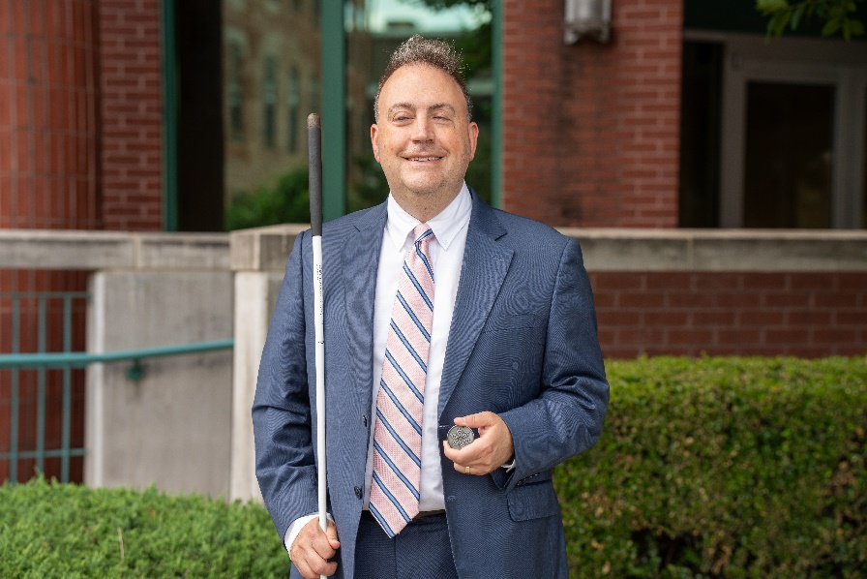 | 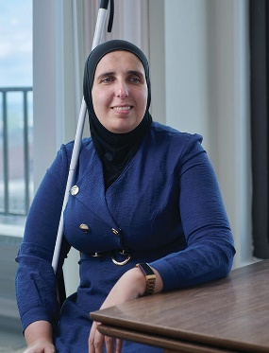
Image: Mark Riccobono  President  National Federation of the Blind | Image: Ronza Othman  President  National Federation of the Blind  of Maryland

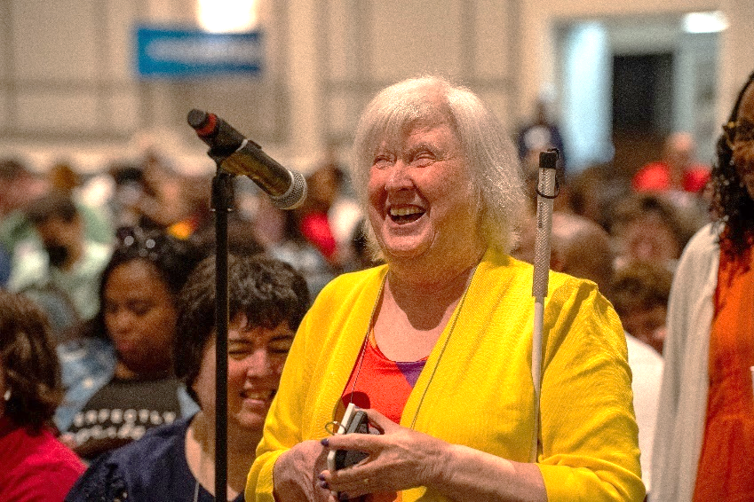
Image: Norma Crosby
National Representative
Treasurer, National Federation of the Blind;
President, National Federation of the Blind of Texas

Officers:

Ronza Othman, President, Baltimore
Deborah Brown, First Vice President, Rockville
Christopher Danielsen, Second Vice President, Baltimore
Judy Rasmussen, Secretary, Kensington
Jenivieve White, Treasurer, Owings Mills

Board of Directors:

Qualik Ford, Baltimore
Sharon Maneki, Columbia
Garret Mooney, Baltimore
Mildred Rivera, Lutherville
Melissa Riccobono, Baltimore
Marguerite Woods, Baltimore

Our Belief Message
The National Federation of the Blind advances the lives of its members and all blind people in the United States. We know that blindness is not the characteristic that defines you or your future. Every day we raise the expectations of blind people, because low expectations create obstacles between blind people and our dreams. Our collective power, determination, and diversity achieve the aspirations of all blind people.

The National Federation of the Blind Pledge
I pledge to participate actively in the efforts of the National Federation of the Blind to achieve equality, opportunity, and security for the blind; to support the policies and programs of the federation; and to abide by its constitution.

About the National Federation of the Blind of Maryland
The National Federation of the Blind of Maryland (NFBMD), an affiliate of the National Federation of the Blind (NFB), is an organization of blind people and their family and friends. We believe in the full capacity of blind people; we have the power, influence, diversity, and determination to help transform our dreams into reality. Our members work together for a brighter tomorrow by raising the expectations for blind people everywhere so that blind persons can live the lives they want.

Who We Are
The National Federation of the Blind of Maryland is a 501c(3) nonprofit comprised of blind people of all ages, their families and friends. Our strong local chapters and divisions, and well-trained leaders help newly blind people adjust to vision loss and promote the full participation and integration of blind people in our communities. We bring our collective experiences together to effect change at the state and national level.

What We Do
- Assist blind and low-vision persons to acquire the skills of independence
- Help blind and low-vision persons to develop confidence in themselves through our many service activities
- Teach blind and low-vision persons the skills of leadership through active participation in conventions, chapter meetings, and civic activities
- Encourage blind and low-vision seniors to continue their active and meaningful lifestyles
- Prepare blind and low-vision students for productive tax-paying careers through academic and training scholarships
- Inform people with diabetes about options for coping with vision loss
- Support parents and friends of blind and low-vision children with information about the capabilities of the blind
- Protect and promote the civil rights of blind and low-vision persons through public education and legislative action
- Advocate for policies that eliminate discrimination and guarantee equal access to educational programs and high-quality rehabilitation
- Educate the public through seminars, community activities and our publications

Thank You, Convention Sponsors

We extend profuse thanks to the following convention sponsors.

Blind Industries and Services of Maryland, Title Level Sponsor
Vanda Pharmaceuticals, Equality Level Sponsor
Aira Tech Corporation, Equality Level Sponsor
Brown, Goldstein and Levy LLP, Opportunity Level Sponsor
Election Systems and Software, Opportunity Level Sponsor
Friends of the Maryland State Library for the Blind and Print Disabled, Opportunity Level Sponsor
Democracy Live, Freedom Level Sponsor
Sipbound Corporation, Freedom Level Sponsor

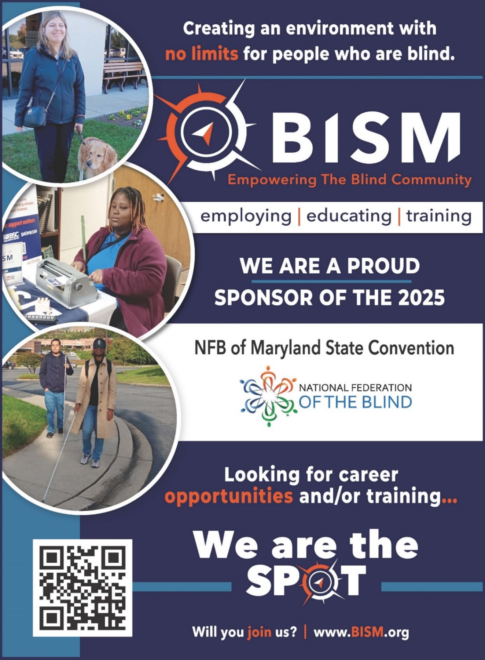
Full page BISM ad description. Heading: “Creating an environment with no limits for people who are blind,” followed by the BISM logo, which contains the text “BISM Empowering the Blind Community.” Images: On the left side of the ad, there are three pictures, including a blind person with a guide dog (top), a blind person using a Braille writer (middle), and two blind people walking on a street using long white canes (bottom. There is also a QR code (bottom left). Text: Following the BISM logo is the text, “Employing. Educating. Training. We are a proud sponsor of the 2025 NFB of Maryland State Convention [NFB logo]. Looking for career opportunities and/or training... We are the spot. Will you join us? www.BISM.org

Navigating the Ashore Resort and Beach Club
This location is an Aira Access Site, meaning you can use the Aira Explorers mobile application free of charge during the convention weekend.

The Ashore Resort and Beach Club is located at 10100 Coastal Highway. This hotel has two buildings that are connected through a hallway on the second floor. Most sleeping rooms and common spaces such as restaurants are in the Tower Building, while meeting rooms and Cabana sleeping rooms are in the Conference Center.

The first floor of both buildings is called the “Main Level,” while the second floor is called the “Terrace Level.”

As you arrive at the hotel and face it, the Conference Center will be on your left and the Tower Building will be on your right. The Conference Center and Tower Building are separated by a covered driveway on the Main Level. Individuals can cross between the two buildings at this level, but they will be outside for approximately 50 feet. Beware of traffic, as this driveway is used both as a loading and unloading zone and also for through traffic for the hotel parking lots. The two buildings are connected on the second or Terrace Level by an internal hallway.

Tower Building
There is one entrance to the Tower Building, which is not facing Coastal Highway but rather on the side of the hotel with the covered driveway entrance. As you come into the tiled lobby of the hotel Tower Building through the entrance from the covered driveway, you will be on the Main Level. Directly to your left along the wall are the hotel check-in desks. With your back to the covered driveway doors, to your left past the check-in desks, you will find a set of three elevators to take you to the Terrace Level and to all other floors of the Tower Building. Again, standing with your back to the doors leading to the covered driveway, straight ahead and to the right, you will find the Grand Staircase that will take you to the Terrace Level. In the middle of the Main Level lobby are several conversation areas with different types of chairs and couches. Past the elevator you can find a small business center. The ATM is at the check-in desk.

If you turn and face the doors to the covered driveway, you can use these doors to get to the Conference Center by walking straight ahead about 50 feet.

On the Terrace Level of the Tower Building, you will find a hallway that connects common spaces and amenities. The furthest amenity to the Conference Center is Ashore Things, which sells coffee, snacks, quick bites, sundries, and tourist merchandise. Past Ashore Things is the Tide Room, which is the hotel restaurant. Connected to the Tide Room and further down the hall towards the Conference Center is the TAP Room, which is the hotel’s bar. The Tap Room has a limited food menu. The hallway outside the Tap Room leads from the Tower Building to the Conference Center. At the end of this hallway, you will be on the Dune Deck, which will be described later.

The third through sixteenth floors of the Tower Building are sleeping rooms.

Those looking for a guide dog relief area from the Tower Building should use the entrance leading to the covered driveway and walk left towards Coastal Highway. At the end of the covered driveway, turn right, and you’ll be outside the Conference Center, where there is a guide dog relief area described in more detail later.

Conference Center
The Conference Center has two floors – the Main Level and the Terrace Level. The Conference Center Main Level has two sets of doors – one is the large set of main doors that face Coastal Highway, and the second faces the covered driveway. If you enter the main doors, you will find yourself in the Grand Foyer. Registration, packet pick-up, boxed lunch distribution, and banquet ticket exchange will all be in the Grand Foyer.

If you put your back to the Coastal Highway set of doors, you will face Tideline A and Tideline B, which together, make the Grand Ballroom. Tideline A is on the left, and Tideline B is on the right closer to the entrance to the covered driveway. Our general sessions will be held on Saturday and Sunday in Tideline A. Tideline A will also house the board meeting, resolutions, and several seminars. Tideline B will host Pizza and a Play and Crab Idol, but there may be times when, as space is needed, we open up the rooms to make one large room which is the Grand Ballroom. If you face the Grand Ballroom, you will find a set of stairs to the Terrace Level on your far left and an elevator on your far right on the wall where the Coastal Highway doors are located.

An accessible guide dog relief area is available just outside the Conference Center entrance on the Coastal Highway side of the Main Level. There, you will find some sandy areas and trash cans. Please don’t forget to bring your own baggies and dispose of them in the trash cans.

Many of our seminars and workshops, childcare, the exhibit hall, and the banquet will be on the Terrace Level of the Conference Center. You can get to this level either through the elevator and staircase in the Conference Center, or through the hallway from the Tower Building.

Resuming our walk from the Tower Building, the hallway that passes the Tap Room opens up into a large tiled seating area called the Dune Deck. This is an inside beach-style seating area, which once housed an indoor pool that has now been filled in. With your back to the hallway you came down, to your far left is a set of doors that lead you to an outside deck. This deck has outdoor seating and a staircase down to the beach.

A guide dog relief area is available just at the bottom of these outside stairs on the beach. There, you will find trash cans. Please don’t forget to bring your own baggies and dispose of them in the trash cans. Those needing an accessible relief area should choose the other guide dog relief area.

Standing on the Dune Deck, directly in front of you, are a set of Cabana sleeping rooms. Some of these rooms will also be used for teen and tween activities. To the far right of the Cabana rooms is a hallway that takes you to the meeting room hallways.

It is noteworthy that the Tap Room has a second entrance directly from the Dune Deck, and individuals can purchase food and beverages from the bar and enjoy them on the Dune Deck while enjoying sweeping views of the Atlantic Ocean in the comfort of an inside venue.

If you move across the Dune Deck to the hallway that leads to the conference rooms, you will find yourself on a carpeted area that is a space that can be broken into four parts. If you stand at the apex of these four sections, the top left section contains the Atlantic Ballrooms. The top right section contains Seaside Conference Rooms 1 through 3. The bottom left section contains the Terrace Lobby, stairs, and elevators. The bottom right section contains Seaside Conference Rooms 4 through 6.

Starting at the bottom left section, you will find yourself in a large open area called the Terrace Lobby. The Terrace Lobby is where we will hold our pre-banquet reception. The staircase is on the far left, and the elevator is on the right.

The top left section of the Terrace Level consists of three conference rooms that, together, make up the Atlantic Ballroom. We will hold our banquet in the Atlantic Ballroom. The three conference rooms that comprise the Atlantic Ballroom include Atlantic 1, which is on the far left and has windows; Atlantic 2B, which is to the right of Atlantic 1 and closer to the Terrace Lobby than Atlantic 2A; and Atlantic 2A, which is behind Atlantic 2B. Atlantic 2A and 2B share a hallway with Seaside 1 through 3. Atlantic 2B has two entrances – one on the same hallway as Seaside 1 through 3 and the other on the same side as Atlantic 1. We will use Atlantic 1, 2A, and 2B for various seminars and some of our Saturday luncheons. Atlantic 1 is also the home of the exhibit hall.

Returning to the apex of the Conference Center on the Terrace Level, the top right section consists of Seaside Conference Rooms 1, 2, and 3. Seaside 3 is closest to the apex and directly across from one of the entrances to Atlantic 2B. Seaside 2 is just past Seaside 3, and Seaside 1 is the furthest from the apex. Seaside 1 and 2 are directly across the hallway from Atlantic 2A. Directly next to Seaside 3 but before the apex, you will find a cloak room and then restrooms.

On the bottom right section of the apex, you will find Seaside 4, which will be used for luggage storage on Sunday, next is Seaside 5, and at the end of the hallway furthest from the apex, Seaside 6, which is where childcare will be held.

LIVE THE LIFE YOU WANT
Lyrics copied from October 2015 Presidential Release

Chorus: Live the life you want. Nobody can stop you.
Shoot for the sun and break on through.
So you're blind. You'll be fine. We've got good news!
You can live the life you want. Yes, we know the truth.

Grab a cane, get trained, gotta get movin’.
Make a change in the wage, that's what we're doin’.
Come with me, yeah.

Chorus
You and me, NFB, let’s dream together.
NFB, you and me, lives on forever.
You will see, yeah.

Chorus
You can live the life you want. You’ll know the truth.

Chapters and Divisions of the National Federation of the Blind of Maryland

At-Large Chapter
Marguerite Woods, President, 443-271-1668, mwoods719@gmail.com
Monthly meetings: third Tuesday at 7:30 p.m., via phone: 339-209-4083

Baltimore County Chapter
Latonya Phipps, President, 443-465-8761, Phippslatonya@gmail.com
Monthly meetings: second Wednesday at BISM

Central Maryland Chapter
Matt Yannuzzi, President, 443-851-1944, Matthew.Yannuzzi@gmail.com
Monthly meetings: first Tuesday in Columbia

Eastern Shore Chapter
Heather Guy, President, 410-430-8954, hguy403@comcast.net
Monthly meetings: second Saturday in Salisbury

Greater Baltimore Chapter
Chris Danielsen, President, 410-262-1281, Cdanielsen@nfb.org
Monthly meetings: third Saturday in Baltimore

Greater Carroll County Chapter
Brian Keseling, President, 410-855-5605, bkmaverick@gmail.com
Monthly meetings: second Saturday in Westminster

Maryland Association of Blind Merchants
Melba Taylor, President, 240-381-1637, m.taylor@encoreassoc.com
Periodic meetings throughout the year

Maryland Association of Blind Students
Qualik Ford, President, 301-312-9813, qsford@outlook.com
Periodic meetings throughout the year

Maryland Parents of Blind Children
Garret Mooney, President, 480-433-8003, james.garret.mooney@gmail.com
Periodic meetings throughout the year

National Harbor Chapter
Amber Woods, President, 301-978-6686, woodsamber83@gmail.com
Monthly meetings: fourth Saturday in Suitland

Senior Issues Division
Marguerite Woods, President, 443-271-1668, mwoods719@gmail.com
Periodic meetings throughout the year

Sligo Creek Chapter
Debbie Brown, President, 301-881-1892, Deborahb14@verizon.net
Monthly meetings: second Saturday primarily in Silver Spring

TLC Chapter
Millie Rivera, President, 202-494-5687, Millie.Rivera0027@gmail.com
Monthly meetings: second Tuesday in Towson

Western Maryland Chapter
Wendy Ruth, President, 301-991-8312, Wendyruth966@gmail.com
Monthly meetings: first Saturday in Cumberland
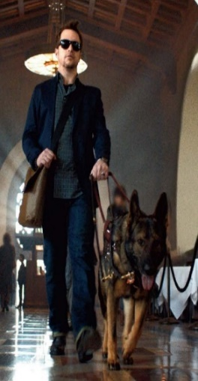
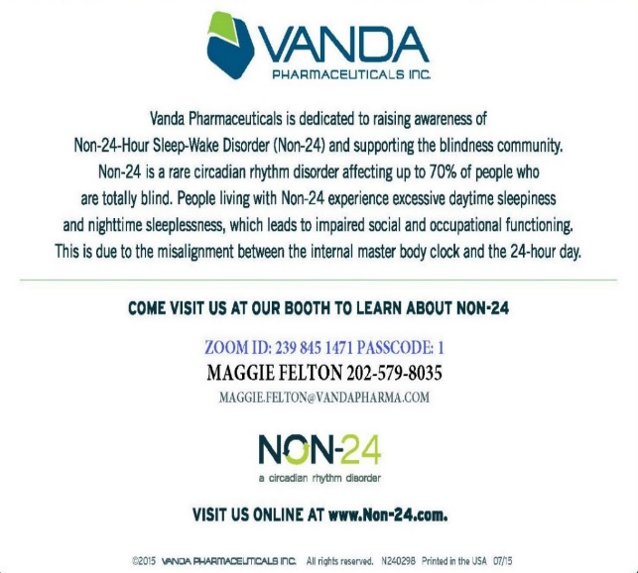
Quarter Page Vanda Pharmaceuticals ad description. Heading: The Vanda Pharmaceuticals logo. Images: On the left side, a man wearing dark glasses walking with a guide dog. Text: “Vanda Pharmaceuticals is dedicated to raising awareness of Non-24-Hour Sleep-Wake Disorder (Non-24) and supporting the blindness community. Non-24 is a rare circadian rhythm disorder affecting up to 70% of people who are totally blind. People living with Non-24 experience excessive daytime sleepiness and nighttime sleeplessness, which leads to impaired social and occupational functioning. This is due to the misalignment between the internal master body clock and the 24-hour day. Come visit us at our booth to learn about non-24.

Stay Connected and Informed:

Follow and like the National Federation of the Blind of Maryland on Facebook: facebook.com/NationalFederationOfTheBlindOfMaryland

Stay connected with your fellow Maryland Federationists by joining our state email listserv. You’ll receive affiliate and national announcements, plus you can start and participate in discussions regarding blindness and blindness issues. Sign up at NFBnet.org, select “join or drop NFB mailing lists,” and activate “NFBMD” link, and follow the instructions. Many of our local chapters now also have a listserv. Talk to your chapter President to learn how to sign up so you don’t miss important news and events.

Visit our website at NFBMD.org. Check out our blog for the President’s Messages. Be sure to check out the Blindness Resources link, and the Know Your Rights link to keep up to date on important information. Be sure to download and print “About NFBMD,” in the “About Us” tab on NFBMD.org, to use as handouts at chapter outreach events.

Braille Spectator
The Braille Spectator is published for members of the National Federation of the Blind of Maryland and others who share an interest in the work of this organization. The Braille Spectator can be read on the web at NFBMD.org/Newsletter or can be listened to on the local channel of NFB-Newsline.

GLORY FEDERATION
Blind eyes have seen the vision of the Federation way;
New white cane legislation brings the dawn of a new day;
The right of the blind to organize is truly here to stay;
Our cause goes marching on.

Chorus
Glory, glory Federation;
Glory, glory Federation;
Glory, glory Federation;
Our cause goes marching on.

To aid the blind's long struggle we have formed the NFB
To free them from their bondage of workshop and agency,
To give a hand to all the blind wherever they may be;
Our cause goes marching on.

Chorus

Memorable Moments: Snapshots in Maryland
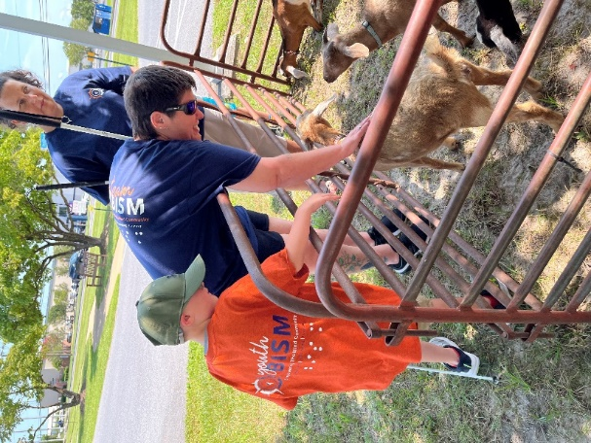
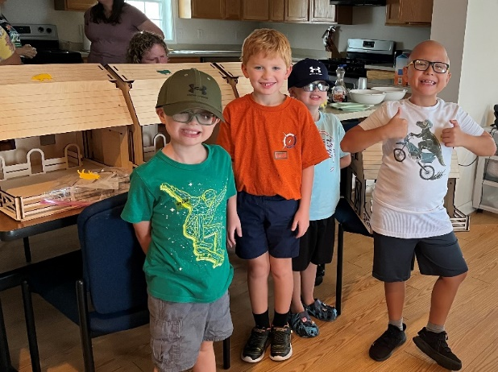

Eastern Shore Images: NFB BELL students smile with 3D model barns behind them (left). Student with two adults at petting zoo (right).

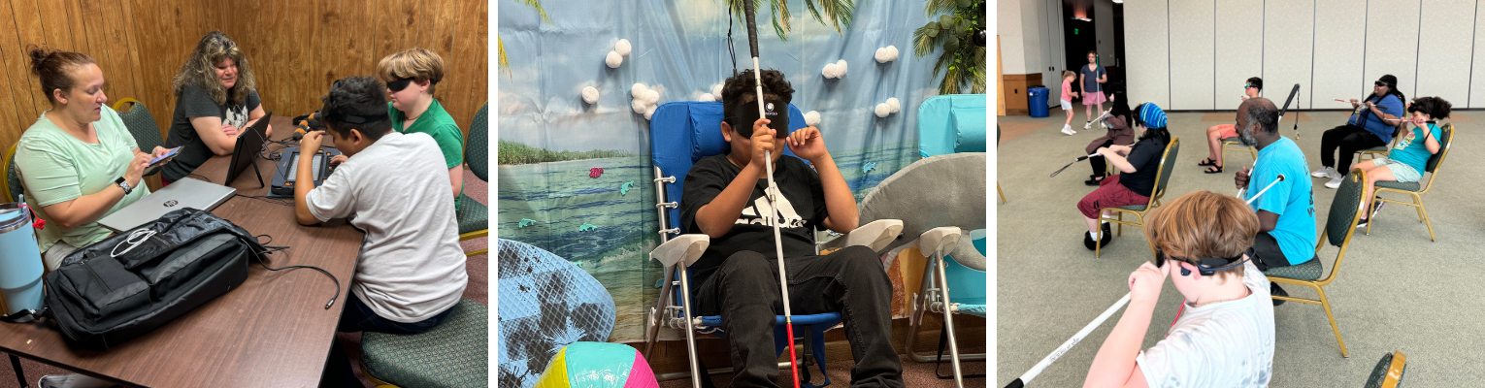
Baltimore Images: Two teachers teach NFB BELL students chess on Monarch (left). At BELL beach, blind student sits on beach chair in front of beach backdrop surrounded by beach ball and surf board (center). Kids and staff wearing learning shades do a cane workout while seated on chairs (right).
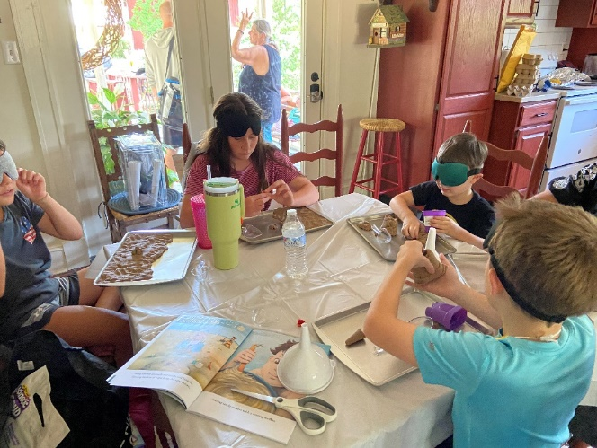
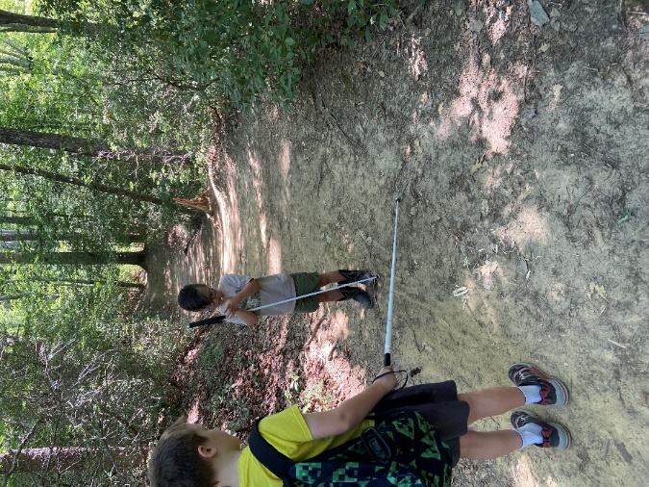

Southern Maryland Images: NFB BELL Academy students explore an outdoor trail (left). Students create a sand display on a table (right).

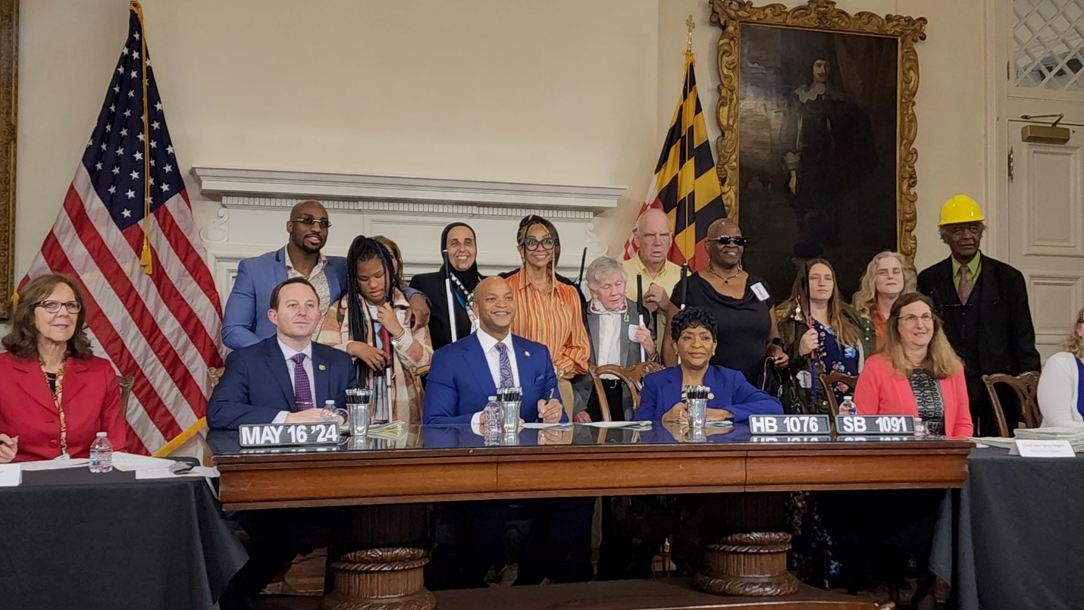
Image: Governor’s bill signing in May 2024 for HB1076/SB1091 the Textbook Equity Act for Blind Students with Governor Moore, President Ferguson, Speaker Jones, Delegate Roberts, and NFBMD members

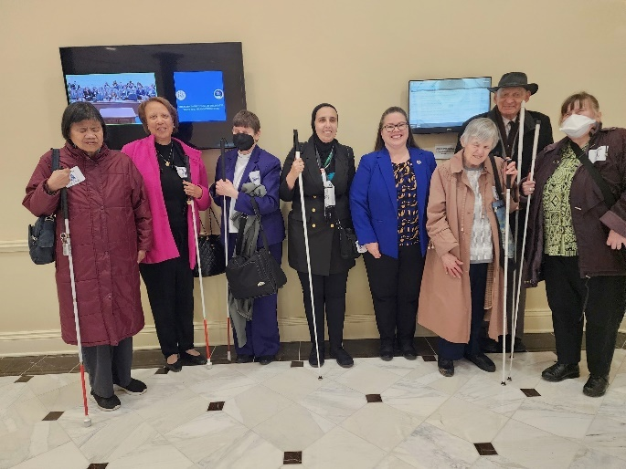
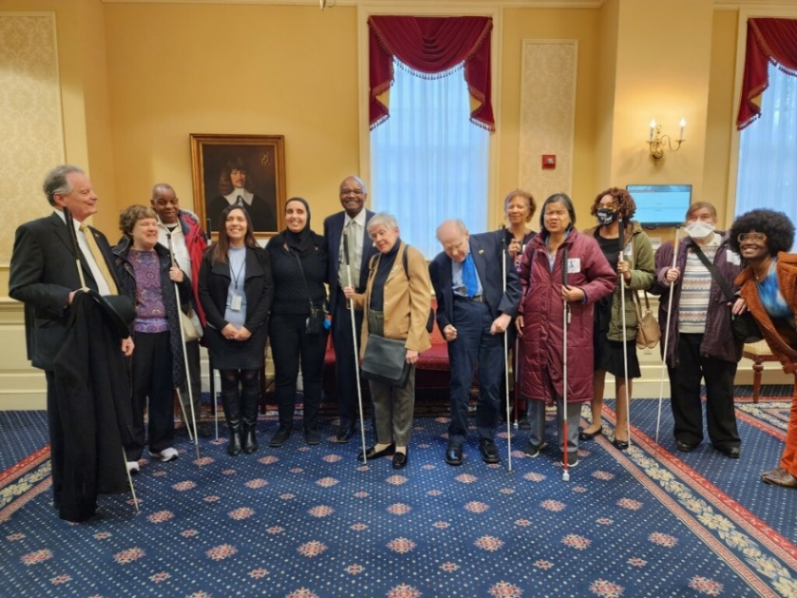
Images: NFBMD members stand with sponsor Senator Benjamin Brooks (left) and Delegate Jessica Feldmark (right) at the hearings for the Accessible Electronic Ballot Return Voting bill

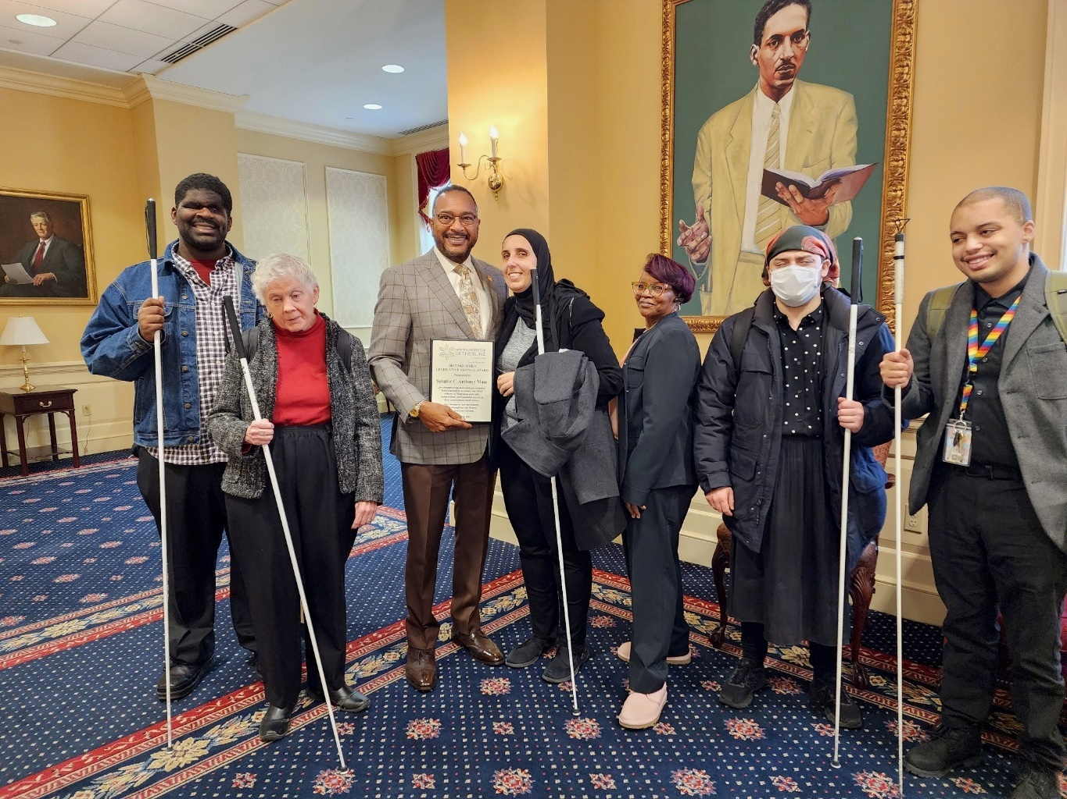
Image: NFBMD members stand with Senator Anthony Muse who receives the 2024 Legislative Service Award for his advocacy.
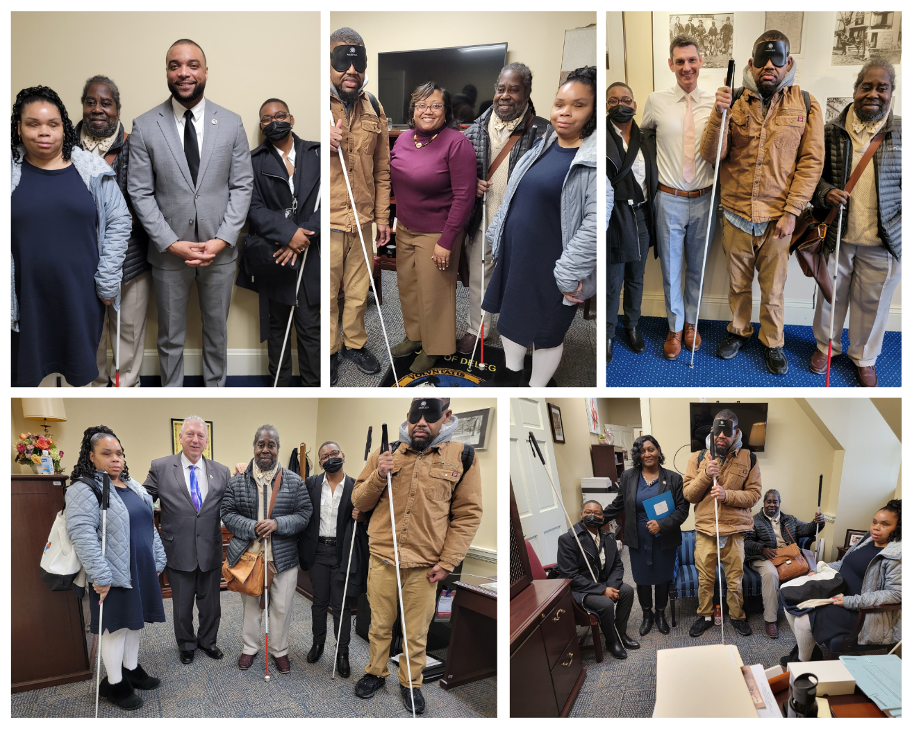
Images: NFBMD members meet with five different congressional representatives at the 2024 NFB Washington Seminar.
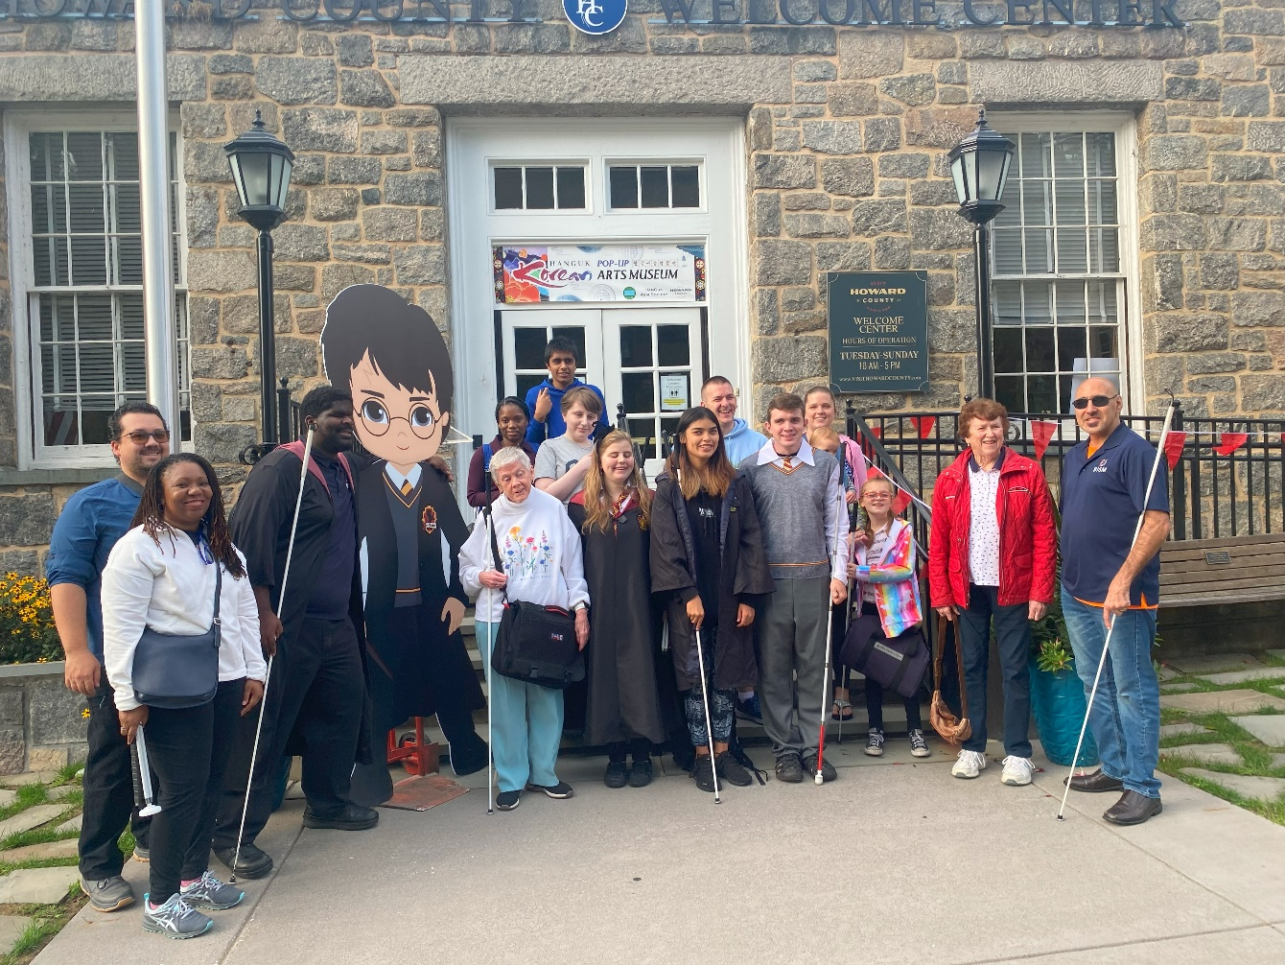
Image: NFBMD members host Wizarding Weekend on Magical Main in Old Ellicott City to commemorate Blind Equality Achievement Month and White Cane Awareness Day.

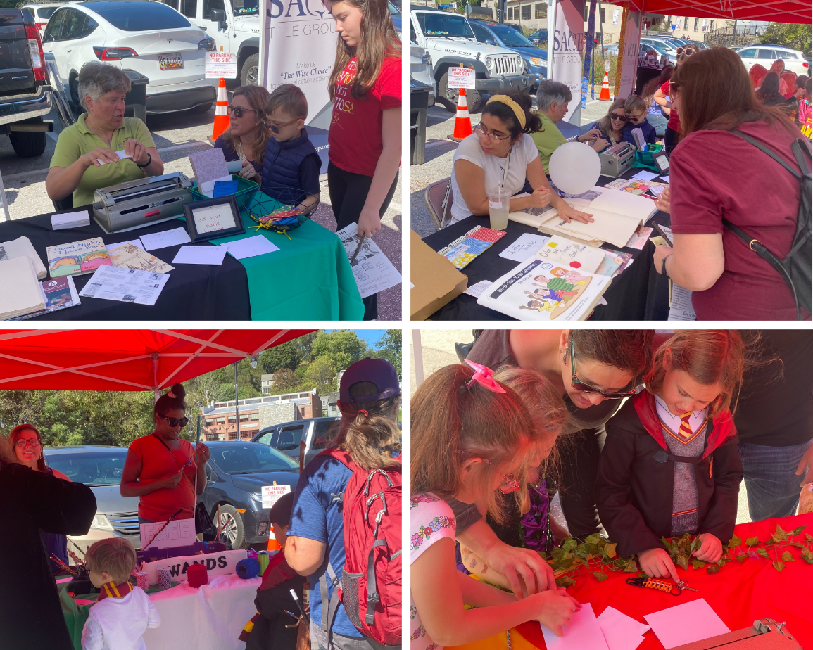
Images: NFBMD members exhibit activities during Wizarding Weekend: Brailling names, showing tactile books, decorating wands, and Brailling more names.

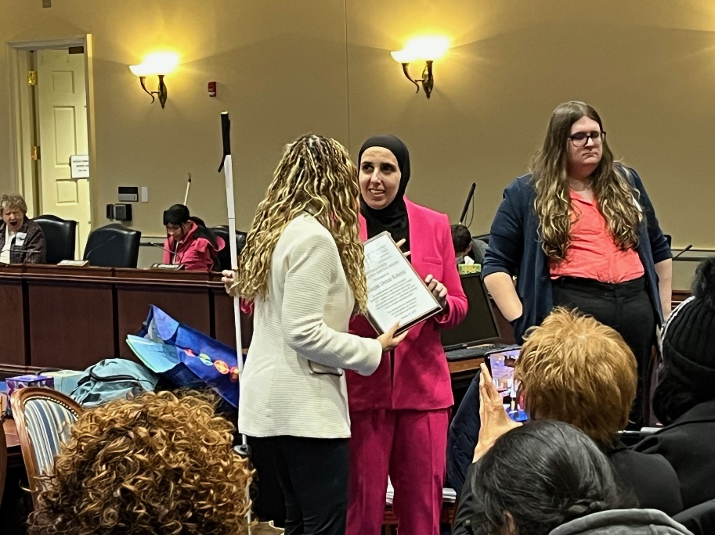
Image: Ronza Othman smiles as she talks with Delegate Denise Roberts who was the sponsor in the House for our textbook equity bill (HB1076).
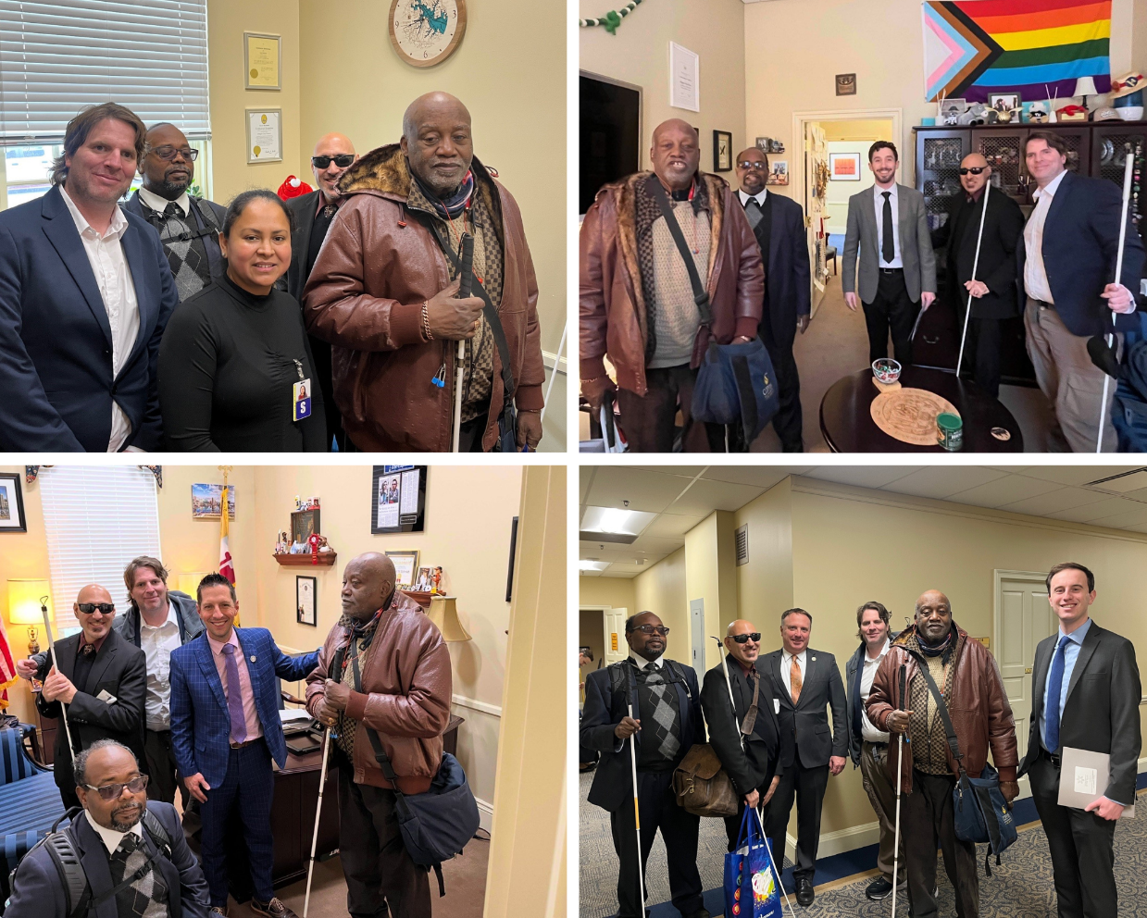
Image: NFBMD members smiling with different MD House of Delegates and Staff at Day in Annapolis

Committees of the National Federation of the Blind of Maryland
If you’re interested in being appointed to a particular committee, notify the NFBMD President at President@nfbmd.org or 443-426-4110.

Advocacy Committee
Sharon Maneki and Melissa Riccobono, Co-chairpersons

Ambassadors Committee
Judy Rasmussen and Debbie Brown, Co-chairpersons

Audit Committee
Barry Hond and Justin Young, Co-chairpersons

NFB BELL Committee
Brittany Bomboy, Amy Crouse, Judy Rasmussen, and Erin Zobell, Co-chairpersons

Braille Spectator Committee
Ronza Othman and Sharon Maneki, editors

Deaf-Blind and Hearing Loss Issues Committee
Janice Toothman and Heather Guy, Co-chairpersons

Development and Fundraising Committee
Jenivieve White and Justin Young, Co-chairpersons

Diversity, Equity, and Inclusion Committee
Juhi Narula and Qualik Ford, Co-chairpersons

Employment Committee
Pam Goodman and Judy Rasmussen, Co-chairpersons

Guide Dog Issues Committee
Sherry Shirek, chairperson

Legislation (Federal) Committee
Sharon Maneki and Joel Zimba, Co-chairpersons

Legislation (State) Committee
Ronza Othman and Sharon Maneki, Co-chairpersons

Membership Committee
Dezman Jackson and Ellen Ringlein, Co-chairpersons

Nominating Committee
Debbie Brown, Chairperson

PAC Plan Committee
John Paré and Ann-Marie Laney, Co-chairpersons

Public Relations Committee
Chris Danielsen, Chairperson

Resolutions Committee
Chris Danielsen, Chairperson

Scholarship Committee
Juhi Narula, Chairperson

Sharon Maneki Youth Empowerment Grant Committee
Sharon Maneki, Chairperson

Social Media Committee
Karen Anderson and Stephanie Cascone, Co-chairpersons

Spanish Services Committee
Teresa Graham, Chairperson

Sports and Recreation Committee
Qualik Ford and Derique Simon, Co-chairpersons

Transportation Committee
Aloma Bouma and Sheryl Fogle-Hatch, Co-chairpersons

Website and Technology Committee
John Berggren, Chairperson

Youth Activity Committee
Erin Zobell, Chairperson

Convention-Related Committees

Anna Freysz Cable Award Committee
Debbie Brown, Chairperson

Convention Childcare Committee
Brittany Bomboy, Chairperson

Convention Logistics Committee
Justin Young, Chairperson

Convention Registration Committee
Marie Marucci, Chairperson

Distinguished Educator of Blind Children Award Committee
Teresa Graham, Chairperson

Door Prize Committee
Juhi Narula and Carley Mullin, Co-chairpersons

Gold Cup Crab Race Committee
Juhi Narula and Jenivieve White, Co-chairpersons

Jennifer Baker Award Committee
Melissa Riccobono, Chairperson

Kenneth Jernigan Award Committee
Sharon Maneki, Chairperson

National Funding Support Auction Committee
Joel Zimba and Erin Zobell, Co-chairpersons

Groups of the
National Federation of the Blind of Maryland
If you’re interested in joining a particular group, contact that group’s chairperson.

Blind Crafters Group
Danielle McCann and Karen Anderson, Co-chairpersons

Blind Parents Group
Denna Lambert and Melissa Riccobono, Co-chairpersons

Blind Young Persons Group
Jeff Baer and Juhi Narula, Co-chairpersons

Diabetes Action Network
Eileen Ley, Chairperson

Performing Arts Group
Chris Danielsen, Chairperson

Significant Others and Loved Ones Group
Jenivieve White and David Waybright, Co-chairpersons

Veterans Group
Ed Jackson, Chairperson

Leaving A Legacy: Dream Makers Circle
You can help build a future of opportunity for the blind by becoming a member of our Dream Makers Circle. It is easier than you think. Just visit your bank and convert an account to a P.O.D. (payable on death) bank account which is payable after your passing to the National Federation of the Blind or the National Federation of the Blind of Maryland. Your legacy gift to the National Federation of the Blind or the National Federation of the Blind of Maryland can be made in the form of a will or living trust, an income generating gift, or by naming us as the beneficiary of a retirement plan, IRA, pension, or a life insurance policy. You can designate a specific amount, a percentage, or list NFB as one of several beneficiaries. For additional information, please contact Patti Chang at 410-659-9314, ext. 2422 or at pchang@nfb.org.
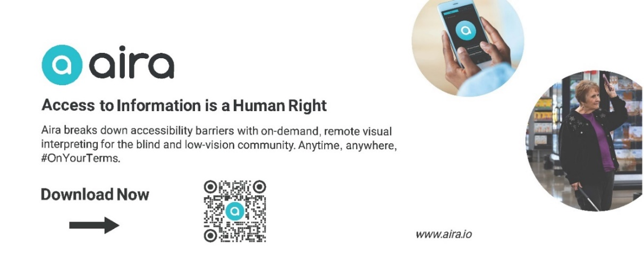

Quarter page Aira ad description. Heading: Aira logo (top left) followed by “Access to information is a human right.” Images: Two images on right: hands holding a cell phone (top), a woman holding a cell phone upright in one hand and a cane in the other (bottom). Text: “Aira breaks down accessibility barriers with on-demand, remote visual interpreting for the blind and low-vision community. Anytime, anywhere, #OnYourTerms. Download Now [QR code] www.aira.io”

STRIVE
Lyrics by Barbara Elliott
Sometimes people tell me blind people should be quiet and sit down
But I say "No!" I say "No!" I say "No."
They contend that I should be content to let others lead me around,
But I say "No!" I say "No!" I say "No."
Everybody needs somebody to help sometimes, but I'm in charge of me.
Chorus: I've gotta strive, strive, strive a little farther,
Reach, reach, reach a little longer,
Work, work, work a little harder,
Hope, hope, hope a little stronger.
Watch me, watch me, watch me.
Nothin's gonna stop me, stop me, stop me.
I'm spreading my wings, soaring on a dream,
I can do anything!
I gotta be brave even when I'm afraid to do hard things.
I'll tell myself "Go!" I'll just go, I will go.
I'm not a fool; I need training and tools to live out my dreams.
So I'll say "Go!" I'll just go, I will go.
I'm not a passenger in my life. I'm gonna take control and drive.
Chorus

Convention Agenda

Thursday, February 13
6 to 7:45 p.m. — Scholarship Dinner
(Invitation Only)

Millie Rivera, Chairperson, 2024-2025 Scholarship Committee; Lutherville, Maryland

6 to 7 p.m. — NFBMD Deaf-Blind and Hearing Loss Issues Committee Meeting
Seaside 4

Heather Guy, Co-chairperson; Salisbury, Maryland
Janice Toothman, Co-chairperson; Bowie, Maryland

7 to 8 p.m. — NFBMD Guide Dog Issues Committee Meeting
Seaside 4

Sherry Shirek, chairperson; Baltimore, Maryland

8 to 9:30 p.m. — Seminar: Living Our NFB Philosophy
Atlantic 2A
Everyone is encouraged to attend!

Mark Riccobono, President, National Federation of the Blind; Baltimore, Maryland
Norma Crosby, Treasurer, National Federation of the Blind and President, National Federation of the Blind of Texas; Alvin, Texas

Friday, February 14
8:30 a.m. to 5:15 p.m. — Fun with Friends: Childcare
Seaside 6
Brittany Bomboy, Convention Childcare Coordinator; Baltimore, Maryland

9 to 10:55 a.m. — NFBMD Board of Directors Meeting (Open to All)
Tideline A

11 to 11:55 a.m. — NFBMD Resolutions Committee Meeting
Tideline A
Everyone is encouraged to attend!

Chris Danielsen, Chairperson; Baltimore, Maryland

11 a.m. to 6 p.m. — Exhibit Hall
Atlantic 1
Check out the latest offerings from a variety of companies and organizations that provide technology and services for the blind. Meet our sponsors.

Jenivieve White, sponsorship and exhibits coordinator and NFBMD Treasurer; Owings Mills, Maryland

11 a.m. to 5 p.m. — Annual Conference for Parents and Teachers of Blind Children: Maryland Parents of Blind Children
Seaside 1 and 2
What are the skills and tools blind students need in school and to live the lives they want? What are the rights of blind and low-vision students, and what are the legal obligations of the school system? How do we best prepare transition-age students for life beyond school? How do you make sure school and rehabilitation services are appropriately addressing their needs? What can you do to support them at home and in school? Learn about resources, opportunities, blindness skills, and how to have and model a positive attitude on blindness. These are only some of the topics to be discussed at this seminar.

Garret Mooney, President; Baltimore, Maryland

11:30 a.m. — Boxed Lunch Distribution
Grand Foyer
Note: You paid for a boxed lunch at pre-registration. Lunches must be picked up by 12:30 p.m., or they will be resold with no refunds.

Noon to 12:55 p.m. — Sports and Recreation Committee Town Hall
Seaside 5
Come to share insight into what you want our Sports and Rec Committee to do. There will be pop-up exercises at this seminar.

Derique Simon, Co-chairperson; Baltimore, Maryland

Noon to 12:55 p.m. — NFBMD Blind Young Persons Group
Tideline A
Those who no longer identify as students can come to meet one another and to help us get ready for our special entertainment session. Bring along your boxed lunch.
Hosted by the NFBMD Blind Young Persons Group

Jeff Baer, Co-chairperson; Potomac, Maryland
Juhi Narula, Co-chairperson; Baltimore, Maryland

Noon to 1:55 p.m. — Home is Where the Heart Is: Tips on Finding Housing and How to Make It Yours Once You Move In Seminar
Atlantic 2A
Come join us at a housing seminar. The seminar will include your rights as a blind home buyer, resources and opportunities for housing assistance and support, and much more. Hosted by the NFBMD Advocacy Committee and the NFBMD Senior Issues Division.

Sharon Maneki, Co-chairperson, NFBMD Advocacy Committee; Columbia, Maryland
Marguerite Woods, President, NFBMD Senior Issues Division; Baltimore, Maryland

1 to 1:55 p.m. — Live! Storytelling: Ghosts, Spirits, and Spooky Things Seminar
Tideline A
Storytelling is at the heart of Maryland culture, and we have some of the best ghost and spooky legends in the world. Mindie Burgoyne, author of “Haunted Eastern Shore: Ghostly Tales from East of the Chesapeake” will describe some of the captivating stories that have interested visitors and locals alike. Students and those who identify as young adults are free, and though all are welcome, the NFBMD Blind Young Persons Group encourages a donation of $5 per person for nonstudents and those who either have or are supposed to have mastered adulting. Proceeds will go to future NFBMD Blind Young Persons Group activities.
Hosted by the NFBMD Blind Young Persons Group

Jeff Baer, Co-chairperson; Potomac, Maryland
Juhi Narula, Co-chairperson; Baltimore, Maryland

1 to 4 p.m. — NFB of Maryland Employment Seminar
Atlantic 2B
Join the NFBMD Employment Committee to observe role-playing interviews in industries like non-profit, rehabilitation, and customer service. You will learn interview techniques, what a behavioral interview question is, how to ask or answer questions related to disability, and interact with the role players.

Pam Goodman, Co-chairperson; Linthicum, Maryland
Judy Rasmussen, Co-chairperson; Kensington, Maryland

1 to 6 p.m. — Convention Registration and Packet Pickup
Grand foyer

2 to 3:55 p.m. — Lead! NFB of Maryland Technology Seminar
Tideline A
Come learn about new and emerging technology, how to get your hands on it, and what it can do to help you with work, play, life, and leadership.

Joel Zimba, Vice President, NFBMD TLC Chapter; Baltimore, Maryland

2 to 3:55 p.m. — Live! Maryland ABLE Seminar
Atlantic 2A
Come celebrate the seven year anniversary of the ABLE Program. Learn about how this program can help you save for your future while protecting your social security benefits. Hear about changes to the age eligibility rules so that thousands more are now eligible to enroll.

Kelly Nelson, Outreach and Communications Manager, Maryland ABLE; Baltimore, Maryland

2 to 3:55 p.m. — Teens and Tweens: Storytelling - Ghosts, Spirits, and Spooky Things Seminar
Seaside 3
Storytelling is at the heart of Maryland culture, and we have some of the best ghost and spooky legends in the world. Come listen to some local legends and fascinating stories. For teens and tweens only.
Hosted by the NFBMD Blind Young Persons Group

Jeff Baer, Co-chairperson; Potomac, Maryland
Juhi Narula, Co-chairperson; Baltimore, Maryland

2 to 4:55 p.m. — Legislative Advocacy: Letter Writing Workshop
Seaside 5
Come write letters to the Maryland General Assembly about issues of importance to the blind. Assistance is available for those who want it.

Sharon Maneki, Co-chairperson, NFBMD Legislation (State) Committee; Columbia, Maryland
Melissa Riccobono, Board Member, National Federation of the Blind of Maryland; Baltimore, Maryland

4 to 5:55 p.m. — Maryland Association of Blind Students Seminar
Seaside 3
Registration from 3:45 to 4 p.m.
Come learn about matters of interest to students including how to self-advocate in school, with potential employers, and in the world. Learn what resources are available for students.

Qualik Ford, President, Maryland Association of Blind Students; Baltimore, Maryland
Naudia Graham, Vice President, Maryland Association of Blind Students; Ellicott City, Maryland

4:30 to 6:30 p.m. — BISM Bingo
Atlantic 2A
Come play everyone’s favorite game — Bingo — and win prizes.
Sponsored by Blind Industries and Services of Maryland (Title Sponsor).

5 to 5:55 p.m. — NFBMD BELL ACADEMY REUNION
Seaside 4
Reunite with the NFB BELL Academy students from the 2024 session and prepare for the general session NFB BELL presentation. Kids are asked to attend, and their families are welcome too.

Melissa Riccobono, 2024 NFBMD BELL Coordinator; Baltimore, Maryland

6:30 p.m. —NFBMD Association of Blind Merchants Networking Dinner
Tide Room Restaurant
Join blind merchants and those in the Business Enterprise Program for a networking dinner. Individuals will pay for their own meals.

Melba Taylor, President, NFBMD Association of Blind Merchants; Bowie, Maryland

6:30 to 7:55 p.m. — Pizza and a Play
Tideline B
The Braille is Beautiful Players will entertain and delight.

Debbie Brown, play director; First Vice President, National Federation of the Blind of Maryland; Rockville, Maryland

7 to 8:30 p.m. — Annual Networking Social for Families of Blind Children
Seaside 1 and 2
Participants of the Parents and Educators Seminar are invited to come meet and network.

Garret Mooney, President, Maryland Parents of Blind Children Division; Baltimore, Maryland

8:30 to 11 p.m. — Crab Idol
Tideline B
This American Idol-style evening promises to be fun for all ages. Those wishing to perform songs can do so for $5 per person per performance. Chapters and Divisions will battle it out to determine which has the most talent. Enjoy snacks and fellowship thanks to the Maryland Association of Blind Students, Maryland Parents of Blind Children, and NFBMD Eastern Shore Chapter. Proceeds support NFBMD, MDABS, and MDPBC.

To sign up to perform, contact Heather Guy, Naudia Graham, or Garret Mooney.

Saturday, February 15
7 to 8:15 a.m. — At-Large Chapter Meeting
Seaside 3
The At-Large Chapter will meet face-to-face. Continental breakfast will be available.

Marguerite Woods, President; Baltimore, Maryland

7:45 to 8:25 a.m. — Convention Registration and Packet Pickup
Grand foyer

8:15 a.m. to 5:15 p.m. — Fun with Friends: Childcare
Seaside 6
Brittany Bomboy, coordinator; Baltimore, Maryland

8:30 a.m. to 11 a.m. — Saturday Morning General Session
Tideline A
8:30 a.m. — Call to Order and Opening Ceremonies

8:45 a.m. — Living Large: Our Internal Programs Get on the Pac Plan
John Pare, Maryland PAC Plan Co-chairperson; Baltimore, Maryland
Ann-Marie Laney, Maryland PAC Plan Co-chairperson; Randallstown, Maryland

Gold Cup Crab Race
Juhi Narula, ticket agent; Baltimore, Maryland

9 a.m. — Leading from the Heart of the Federation: Welcoming Remarks
Mark Riccobono, President, National Federation of the Blind; Baltimore, Maryland

9:10 a.m. — Leading Our Own Employment Journeys, Loving the Process, and Living the Lives We Want
Panel Moderator: Pam Goodman, Co-chairperson, NFBMD Employment Committee; Linthicum, Maryland
Judy Nelson, Triage Nurse, Annapolis Pediatrics; Bowie, Maryland
Joel Zimba, Product Specialist, Humanware; Baltimore, Maryland
Lina Howard, Accessible Technology Instructor, BISM; Baltimore, Maryland

9:40 a.m. — Leading the Way: A Report from Our National Organization
Norma Crosby, Treasurer, National Federation of the Blind; President, National Federation of the Blind of Texas; Alvin, Texas

10:20 a.m. — Living Your Best Life: Maryland ABLE Celebrates Seven Years
Kelly Nelson, Outreach and Communications Manager, Maryland ABLE; Baltimore, Maryland

10:30 a.m. — Employment for the Win: We’re Loving It
Toni March, Director, Office of Blindness and Vision Services, Maryland Division of Rehabilitation Services (DORS); Baltimore, Maryland
Erikk Bonner, Assistant State Superintendent, Maryland Division of Rehabilitation Services, Maryland State Department of Education; Baltimore, Maryland

10:50 a.m. — Reports and Resolutions

11 a.m. — Adjourn

11 a.m. to 12 p.m. — Breakout: Legislative Advocacy
Seaside 5
Interested in learning about legislative advocacy on the state and federal level? Learn what goes into getting bills introduced, how we educate our elected officials on issues of importance to the blind, and what strategies besides legislation help us advance the rights of the blind.

Sharon Maneki, Co-chairperson, NFBMD Federal and State Legislation Committees; Columbia, Maryland
John Pare, Executive Director for Advocacy and Policy, National Federation of the Blind; Baltimore, Maryland

11 a.m. to 12 p.m. — Breakout: Membership — Making Chapter Meetings More Engaging
Seaside 4
Those interested in exploring strategies for making chapter meetings more engaging are encouraged to attend this workshop. Each chapter should designate at least one representative.

Dezman Jackson, Co-chairperson, NFBMD Membership Committee; Baltimore, Maryland

11 a.m. to 12 p.m. — Breakout: Blind Parents Group Meeting
Seaside 2
Share tips and tricks on how to parent using non-visual techniques. Network with other blind parents and caregivers.

Melissa Riccobono, Co-chairperson; Baltimore, Maryland

11 a.m. to 12 p.m. — Breakout: Blind Young Persons Group Workshop
Seaside 1
Come learn about and contribute to our ideas for the next year. Hear about the plan for the new young adult book club, hear how other young adults are taking leadership roles in their local chapters, and tell us your proposal for the next year of young adult activities in NFBMD.

Jeff Baer, Co-chairperson; Potomac, Maryland;
Juhi Narula, Co-chairperson; Baltimore, Maryland

11:45 to 12:15 p.m. — Convention Registration and Packet Pick-Up
Grand Foyer

12:15 to 1:45 p.m. — Luncheon: The Education of Blind and Low-Vision Students – NFBMD Parents of Blind Children Annual Meeting
Atlantic 2A
For parents, teachers of the blind, and those interested in matters concerning blind children.

Garret Mooney, President; Baltimore, Maryland

12:15 to 1:45 p.m. — Luncheon: Reclaiming Independence After Vision Loss – NFBMD Senior Issues Division Annual Meeting
Atlantic 2B
For seniors and others facing vision loss.

Marguerite Woods, President; Baltimore, Maryland

12:15 to 1:45 p.m. — Luncheon: Maryland Association of Blind Students Annual Meeting
Seaside 3
The Maryland Association of Blind Students will hold its annual business meeting, including planning future workshops and events and holding elections.

Qualik Ford, President; Baltimore, Maryland
Naudia Graham, Vice President; Ellicott City, Maryland

1:20 to 1:50 p.m. — Banquet Ticket Exchange
Grand Foyer

2 to 5 p.m. — Saturday Afternoon General Session
Tideline A

2 p.m. — Call to Order

2:05 p.m. — Lead, Love, Live: A Report from the President
Ronza Othman, President, National Federation of the Blind of Maryland; Baltimore, Maryland

3 p.m. — Leading Through Literacy, Loving Our Library
Morgan Miller, Director and State Librarian, Maryland State Library Agency; Baltimore, Maryland
John Owen, Director, Maryland State Library for the Blind and Print Disabled; Baltimore, Maryland

3:20 p.m. — Living the Dream: The Maryland AG’s Here to Protect Our Rights
Julianne Cozetto, Assistant Attorney General, Maryland Office of the Attorney General; Baltimore, Maryland

3:30 p.m. — Living Our Best Lives: We Play with Sound
Melissa Riccobono, Board Member, National Federation of the Blind of Maryland; Baltimore, Maryland
Chris Danielsen, Second Vice President, National Federation of the Blind of Maryland; Baltimore, Maryland

4 p.m. — Byte-sized Learning: Revolutionizing Education with Technology
W. Robert Hair, Superintendent, Maryland School for the Blind; Baltimore, Maryland
Conchita Hernandez, Educational Consultant, Maryland School for the Blind; Washington, DC

4:20 p.m. — Leading the Nation: Maryland Department of Disabilities
Anne Blackfield, Deputy Secretary, Maryland Department of Disability; Baltimore, Maryland

4:35 p.m. — Living Our Best Life: Seniority Has Its Privileges
Glen Crosby, President, NFB Seniors Division; Alvin, Texas

4:45 p.m. — Reports and Resolutions

5 p.m. — Adjourn

6 p.m. — Reception and Cash Bar
Atlantic Foyer

6:45 to 10:15 p.m. — Fun with Friends: Childcare
Seaside 6
Brittany Bomboy, Coordinator
Childcare ends at 10:15 p.m., or 15 minutes after the banquet ends, whichever is earlier.

7 p.m. — 59th Annual Convention Banquet
Atlantic Ballroom 1 and 2
Master of Ceremonies: Mark Riccobono, President, National Federation of the Blind; Baltimore, Maryland

Keynote Banquet Address: Norma Crosby, Treasurer, National Federation of the Blind; President, National Federation of the Blind of Texas; Alvin, Texas

Scholarships and Awards

Immediately after the Banquet — Maryland Gold Cup Crab Race
Race Callers: Ronza Othman and Juhi Narula

Sunday, February 16

7:00 to 8:30 a.m. — Breakfast: Training Center Information and Alumni Networking
Seaside 1 and 2
Those interested in learning about adjustment to blindness training can talk with training center ambassadors and graduates. Alumni from the Louisiana Center for the Blind (LCB), Colorado Center for the Blind (CCB), BLIND, Inc., and Blind Industries and Services of Maryland (BISM) can reconnect.

Coordinators:
Chris Danielsen (LCB), President, NFBMD Greater Baltimore Chapter; Baltimore, Maryland
Garret Mooney (CCB), President, NFBMD Parents of Blind Children Division; Baltimore, Maryland
Matthew Yannuzzi (BISM), President, NFBMD Central Maryland Chapter; Ellicott City, Maryland

7:30 to 9 a.m. — Luggage Collection
Seaside 4
For anyone needing to store luggage due to 11 a.m. hotel check-out time, including bus passengers.

7:30 to 8:45 a.m. — Christian Nonsectarian Devotions
Tideline A
Judy Rasmussen, Secretary, National Federation of the Blind of Maryland; Kensington, Maryland

8:30 to 8:45 a.m. — Convention Registration and Packet Pick-Up
Grand Foyer

9 a.m. to 1 p.m. — Sunday Morning Session
Tideline A

9 a.m. — Call to Order

9:05 a.m. — Leading the Charge: Chapter Presidents
Moderator: Mark Riccobono, President, National Federation of the Blind; Baltimore, Maryland
Deborah Brown, President, NFBMD Sligo Creek Chapter; Rockville, Maryland
Latonya Phipps, President, NFBMD Baltimore County Chapter; Gwynn Oak, Maryland
Heather Guy, President, NFBMD Eastern Shore Chapter; Salisbury, Maryland

9:45 a.m. — Live, Learn, and Prosper: A Report from Blind Industries and Services of Maryland
Michael Gosse, President, Blind Industries and Services of Maryland; Baltimore, Maryland

10 a.m. — Live Loud, Love Proud, Lead the Crowd: BISM Programs for Transition-Aged Students
Juhi Narula, Director of Youth Programs, Blind Industries and Services of Maryland; Baltimore, Maryland

10:10 a.m. — Live Without Limits: NFB BELL Academy and STEM2U Programs
Erin Zobell, 2024 – 2025 Maryland STEM2U Coordinator and NFB BELL Academy Southern Maryland Coordinator and Lead Teacher; California, Maryland
Sadiqa Al-Salam, 2024 NFB BELL Academy Baltimore Lead Teacher; Upper Marlboro, Maryland
Amy Crouse, 2024 – 2025 NFB BELL Academy Eastern Shore Coordinator; Salisbury, Maryland
Maryland NFB BELL Academy Students
Maryland NFB STEM2U Students

10:50 a.m. — Audit Committee Report
Barry Hond, Audit Committee Co-chairperson; Baltimore, Maryland

11 a.m. — Financial Report
Jenivieve White, Treasurer, National Federation of the Blind of Maryland; Owings Mills, Maryland

11:20 a.m. — 2024 Business Meeting Minutes
Judy Rasmussen, Secretary, National Federation of the Blind of Maryland; Kensington, Maryland

11:40 a.m. — Resolutions Committee Report
Chris Danielsen, Chairperson, NFBMD Resolutions Committee; Baltimore, Maryland

12:10 p.m. — Affiliate Elections

12:30 p.m. — Other Business

12:45 p.m. — Reports and Resolutions

1 p.m. — Adjourn

A Closing Message

On behalf of the Officers and Board of Directors, I’d like to take this opportunity to thank all federationists and friends for your generous monetary donations and gifts of goods and services. We had a very successful year and an outstanding convention because of your help!

Ronza Othman, President

BRAILLE IS BEAUTIFUL
Na na na-na na na, na na na-na nah.
Na na na na nah, na na na-na nah.

Chorus:
Go on and live your life,
Don't need a bit of sight.
In the end you'll find
Braille is beautiful.
Put your fingers on the page.
Tell your friends it's all the rage.
It's all gonna be OK, yeah
Braille is beautiful!

Na na na na na na, Na na na-na nah Braille is beautiful!
Na na na-na nah, Na na na-na nah.

Verse
Louis Braille was his name. Slate 'n' stylus was his game.
They tried to stop him, but we adopted the code that paved the way.

Chorus

Na na na na na na, Na na na-na nah Braille is beautiful!
Na na na-na nah, Na na na-na nah.
Na na na-na nah, Na na na-na nah.

BRAILLE IS BEAUTIFUL!

ODE TO THE CODE

Sligo Creek, Digital Communications Consortium

Going to the school to write an IEP,
The teacher says use print, because your child can see.
The equipment is too big, and large print is too rare,
And fifteen words a minute will not get you anywhere!

Chorus:
Braille is here, Braille is here, Braile is here to stay!
We will keep on using it, we don't care what you say!
Braille is here, Braille is here, we will sing its praise.
It's the system for the blind to get a job that pays.

They say that Braille's too tough to teach the newly blind.
Its codes and its contractions discombobulate the mind.
Contractions we've learned all, and codes we've mastered, too,
For blindness has no negative effect on our IQ!

Chorus

They say that Braille’s complex. They say that it’s too slow.
They say that new technology’s the only way to go.
But we’ll keep using Braille, because it is the key
To making sure that blind folks will be literate and free.

Chorus

2025 NFBMD Exhibitors
The following is a list of organizations that are participating in the 2025 NFBMD Exhibit Hall. Check NFBMD.org for updates and additions to this list.

- National Federation of the Blind of Maryland
- Blind Industries and Services of Maryland
- Aira
- Vanda Pharmaceuticals
- Maryland Technology Assistance Program
- Maryland State Library for the Blind and Print Disabled
- Democracy Live
- Crafted Items by Terry Powers and Yasmin Reyazuddin
- Election Systems and Software
- God Ain’t Done with Me Yet: Uniquely Blessed
- Integration Technologies Group
- Johns Hopkins University Neuroplasticity and Development Lab
- JW.org
- Maryland ABLE
- Maryland Department of Disabilities
- Maryland Division of Rehabilitation Services (DORS)
- Maryland Office of the Attorney General
- National Blindness Professional Certification Board
- NFB Newsline
- NFBMD National Harbor Chapter
- Pioneer Concepts
- PS You Are Fabulous
- Selvas BLV
- Soundpro
- Tangible Service Research, LLC
- The Seeing Eye
- University of Maryland TRACE RERC
- Vispero

