Holiday Gift Ideas

Columbia Lighthouse for the Blind (CLB) is now partnering with The White Cane Store in Silver Spring to provide low-tech devices such as talking clocks and liquid indicators for purchase. For more information on a specific item, please call, CLB’s office at 301-589-0894.

~~~~~~~~~~~~~~~~~~~~~~~~~~~~~~~~~~~~

Holiday Guide for Parents of Children Who Are Visually Impaired
FamilyConnect™ has a number of resources for parents of children and teenagers who are blind or visually impaired. If you are looking for fun, accessible games and activities for the holiday season, we hope you will find the following links helpful.
http://www.familyconnect.org/parentsite.asp?DocumentID=4882

~~~~~~~~~~~~~~~~~~~~~~~~~~~~~~~~~~~~



American Printing House for the Blind
APH is the world's largest provider of accessible educational and daily living products, with over 150 years of service.

http://shop.aph.org

~~~~~~~~~~~~~~~~~~~~~~~~~~~~~~~~~~~~
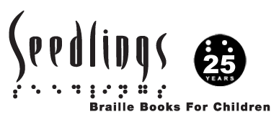

Seedlings

www.seedlings.org

~~~~~~~~~~~~~~~~~~~~~~~~~~~~~~~~~~~~

National Braille Press:

www.nbp.org
~~~~~~~~~~~~~~~~~~~~~~~~~~~~~~~~~~~
AFB’s AccessWorld® Newsletter: November Edition
http://www.afb.org/afbpress/pub.asp?DocID=aw1107toc

Gift Ideas 2010: Great Gift Ideas for People with Vision Loss
http://www.afb.org/afbpress/pub.asp?DocID=aw110702

Accessible Toys for the Young and Young at Heart with Vision Loss
http://www.afb.org/afbpress/pub.asp?DocID=aw110703

~~~~~~~~~~~~~~~~~~~~~~~~~~~~~~~~~~~~
Beulah Reimer Legacy(BRL) offers print/Braille children's picture books at the affordable cost of five dollars per book. BRL's mission is to put Braille in the hands of eager readers. Shipping and Handling is FREE. Please allow two weeks for delivery. Beulah Reimer Legacy, (BRL), was created in loving memory of my grandmother, Beulah Reimer, a wise and knowing sighted woman who learned Braille to encourage me, her blind granddaughter to become literate in Braille. Like me, she believed that literacy is the key to success for blind and sighted alike. Grandma and I enjoyed lots of books together. It is my goal to put Braille at the fingertips of all who can benefit from it.

Sincerely,
April L. Enderton, President
Beulah Reimer Legacy

http://beulahreimerlegacy.webs.com/
~~~~~~~~~~~~~~~~~~~~~~~~~~~~~~~~~~~~
Hallmark Recordable Storybooks:
http://www.hallmark.com/online/in-stores/recordable-storybooks/?mailID=T_E_M_102810_GC_VB_RecStorybook
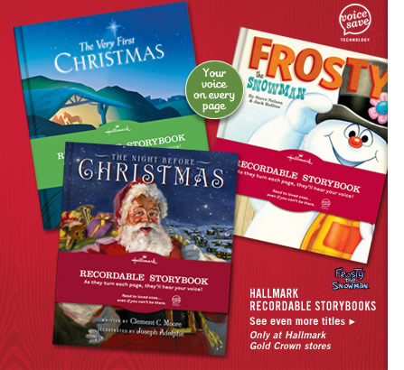

~~~~~~~~~~~~~~~~~~~~~~~~~~~~~~~~~~~~

Dear Education Professionals, NOPBC Members, NAPVI Members, Parents and Friends:

My name is Scott Gagnon. I am the father of an 8 year old visually impaired child named Ethan and we reside in Massachusetts.

A few years ago I decided to change my primary professional focus from engineering design to developing new products that may be used and enjoyed by visually impaired individuals. My first product called PlushTalk Ornaments is the result of trying to find a safe, interactive and fun way Ethan could enjoy decorating and celebrating Christmas.

PlushTalk Ornaments are plush stuffed talking ornament toys that attach to a 24" tall soft plush stuffed Christmas trimming tree. Each themed PlushTalk Ornament has a name and states a different phrase in a unique and interesting voice when squeezed. PlushTalk Ornaments may be played with individually like any traditional plush toy or attached to the trimming tree for decorating. Children of all abilities will enjoy PlushTalk Ornaments. Additionally, there is a companion poem called Santa Finds his Way which tells the story how the PlushTalk Ornaments helped save Christmas when Santa's eyesight became weak. The PlushTalk Ornaments and the poem Santa Finds his Way may be viewed by visiting the website at www.plushtalkornaments.com .

PlushTalk Ornaments are suited for both a home and school setting. The tree and ornaments are portable and all the ornaments easily attach to the trimming tree so that a child knows where to find and store the ornaments. The companion poem Santa Finds His Way is fun to read around the Christmas tree or at circle time as a tradition.

PlushTalk Ornaments may be purchased as a package of Ten (10) PlushTalk Ornaments and the Trimming Tree or purchased separately so that you can build your own tree. PlushTalk Ornaments meet all applicable U.S. Safety regulations for plush toys and is recommended for ages 3 and older.

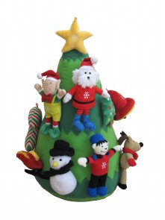
I hope you will enjoy visiting the PlushTalk Ornaments web site at www.plushtalkornaments.com and feel free to give me a call at (978) 371-2303 or e-mail me at scott@plushtalkornaments.com with any questions or inquiries. Please feel free to share this e-mail with any families who may enjoy PlushTalk Ornaments.

Sincerely,

Scott A. Gagnon
Gagnon Design Associates, LLC
39 Walden Terrace
Concord, MA 01742
(978)371-2303

