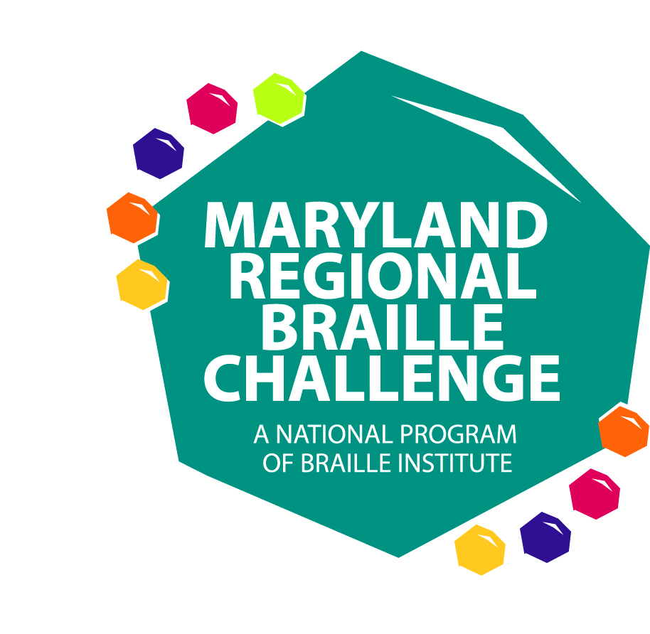
The Maryland State Department of Education and
The Maryland School for the Blind
will be hosting the Maryland 2011 Regional Braille Challenge on
Saturday, February 12, 2011

Braille is an important key to literacy! It allows for the enjoyment of reading, leads to school success, and opens the doors to future employment. Come celebrate braille literacy with a day filled with fun, competition, learning, prizes, and enjoyment!

Students who read braille in grades Prekindergarten through Grade 12 are invited to participate in the Maryland Regional Braille Challenge reading and writing contests. Parents and siblings are invited to participate in workshops while students are taking the tests. Teachers and school staff are invited to assist with test proctoring and scoring and helping to facilitate the day.

WHEN: Saturday, February 12, 2011 (Snow date: February 26, 2011)

COST: FREE

TIME: 8:30 AM to 4:00 PM (Lunch will be provided)

WHERE: The Maryland School for the Blind
3501 Taylor Avenue
Baltimore, MD 21236



Maryland 2011 Regional Braille Challenge
Agenda

8:30-9:00 Registration (Campbell Hall)
9:00-9:30 Opening Ceremony (Campbell Hall)
- Welcome and Introductions
- Group Formation
9:45-10:45 Session 1
    - Students in PreK-12 Testing
    - Parents and siblings attend workshops
11:00-12:00 Session 2
    - Students in PreK-12 Testing
    - Parents and siblings attend workshops
12:00-12:45 Lunch (Dining Hall)
1:00-2:00 Session 3
    - Students in Grades 1-12 Testing
    - Parents attend workshops, siblings and students in Pre-K and K attend activity
2:00-3:15 Session 4
    - Students in Grades 5-12 Testing
    - Parents, siblings, and students Pre-K through Grade 4 and other students as complete testing attend vendor fair
3:15-4:00 Awards (Campbell Hall)
Maryland 2011 Regional Braille Challenge
Contest Categories

Novice (Prekindergarten and Kindergarten) Students in this level only compete in the Maryland Regional contest. This is not a national contest for this grade group.
- Reading (Letters are read orally and student locates and marks the correct letter on the line).
- Writing (Student writes dictated letters and some contractions)
Apprentice (grades 1-2) and Freshman (grades 3-4) Sophomore (grades 5-6) , Junior Varsity (grades 7-9), Varsity (grades 10-12)
- Reading Comprehension (Students read a passage in braille and answer multiple choice questions about it)
- Spelling (The proctor will dictate words orally and the student will write the words on a braillewriter in both contracted and uncontracted form)
- Proofreading (Students will read sentences in Braille and answer multiple choice questions regarding errors in spelling, punctuation, or grammar)
Sophomore (grades 5-6), Junior Varsity (grades 7-9), Varsity (grades 10-12) Additional Contests:
- Speed and Accuracy (Students use a victor Reader Stream or a BookPort Plus to listen to an audio passage and write the passage on braillewriter with speed and accuracy)
- Chart and Graph Reading (Students read and interpret charts and graphs and answer multiple choice questions about them)

All students who participate and remain all day for the Maryland Regional Braille Challenge will be recognized. For those students who are reading below grade level, they may participate in the contest in a younger grade group. Parents need to keep in mind that students who compete in a below grade level group for their age will be grouped with students younger than their child and their contests will not be eligible for the national competition.
Maryland 2011 Regional Braille Challenge
Student Registration and Permission

Student’s Last Name: ______________________________ First Name: ____________________________
Date of Birth: _____________________________________ Grade in School: _____________________
Contest level you would like your child to participate: (NOTE: Only students in Grades 1-12 who compete at age/grade level will have their entries submitted for the national contest.)
PreK Kindergarten Grade 1 Grade 2 Grade 3 Grade 4 Grade 5 Grade 6 Grade 7 Grade 8 Grade 9 Grade 10 Grade 11 Grade 12
T-Shirt Size: Child: Small Medium Large Adult: Small Medium Large X-Large

Address: _____________________________________________________________________________
City: _________________________________ State: ________ ZIP Code: ______________________
Home Phone: ___________________________ Parent Cell Phone: _______________________________
Parent’s Email: ______________________________________________________________________________
Name of Teacher of the Visually Impaired: ___________________________________________________
For Students in Grade 5-12 Only: Students may bring their own or school system Victor Reader Stream and headphones to use for the “Speed and Accuracy” contest. If they cannot bring one, a Bookport Plus will be provided for use.
I will bring a Victor Reader Stream OR I know how to use a BookPort Plus
Parent Signature
Contest Release
I herby give permission to the Maryland State Department of Education, the Maryland School for the Blind, and Braille Institute for my child to participate in The Braille Challenge preliminary contest. I understand that if my child qualifies, he or she is eligible to attend The Braille Challenge final contest in Los Angeles, CA on June 24-25, 2011.

Photographic Release
I hereby authorize and give full consent to Braille Institute of America, Inc., the Maryland State Department of Education, and the Maryland School for the Blind to copyright, publish, and display in any fashion all photographs and electronic recordings in which the above named contestant appears and may use or permit to be used the contestant’s photographs for or in any and all exhibitions, public displays, publications, commercial are, and advertising purposes.

Parent Name (printed): __________________________________________________________________
Parent Signature: ________________________________________________________________________
THIS FORM MUST BE FAXED TO LISA WRIGHT AT 410-333-8165
Maryland 2011 Regional Braille Challenge
Parent/Sibling Registration

Braille Challenge Participant’s Name: ___________________________________
Name of Parents/Guardians Attending:

__________________________________ __________________________________
Siblings Attending:
Name Age
__________________________ _____________________
__________________________ _____________________
__________________________ _____________________
__________________________ _____________________
__________________________ _____________________
__________________________ _____________________

Workshops will be provided throughout the day for parents.
Workshops will be offered for siblings in Grade 2 and up.
Workshop names and descriptions will be sent to parents following registration.
NOTE: At least one parent must attend and remain on site throughout the day while their child is present and competing. Parents are not allowed in the testing rooms with their child. You are encouraged to participate in the workshops provided. Your children will be escorted and supervised by teachers and staff from the Local School Systems and the Maryland School for the Blind.

THIS FORM MUST BE FAXED TO LISA WRIGHT AT 410-333-8165

