
Access to the General Music Curriculum for Students Who Read Braille
Friday, October 21, 2011
8:30-3:00
Location: Russo Arts Center,
Maryland School for the Blind
Target Audience: Teachers of the Visually Impaired, General Education Music Teachers, Braille Transcribers, Paraprofessionals, and Parents

Outcomes
Participants will:
- Identify grade-level expectations for music notation in the Maryland Fine Arts Content Standards for grades Pre-K through 8
- Identify basic symbols used in the Braille Code of Music Notation
- Identify curriculum and resources to learn Braille Music
- Identify software used to convert music into Braille

REGISTRATION IS FREE.
Lunch and childcare will be provided by the NFB OF MD POBC.

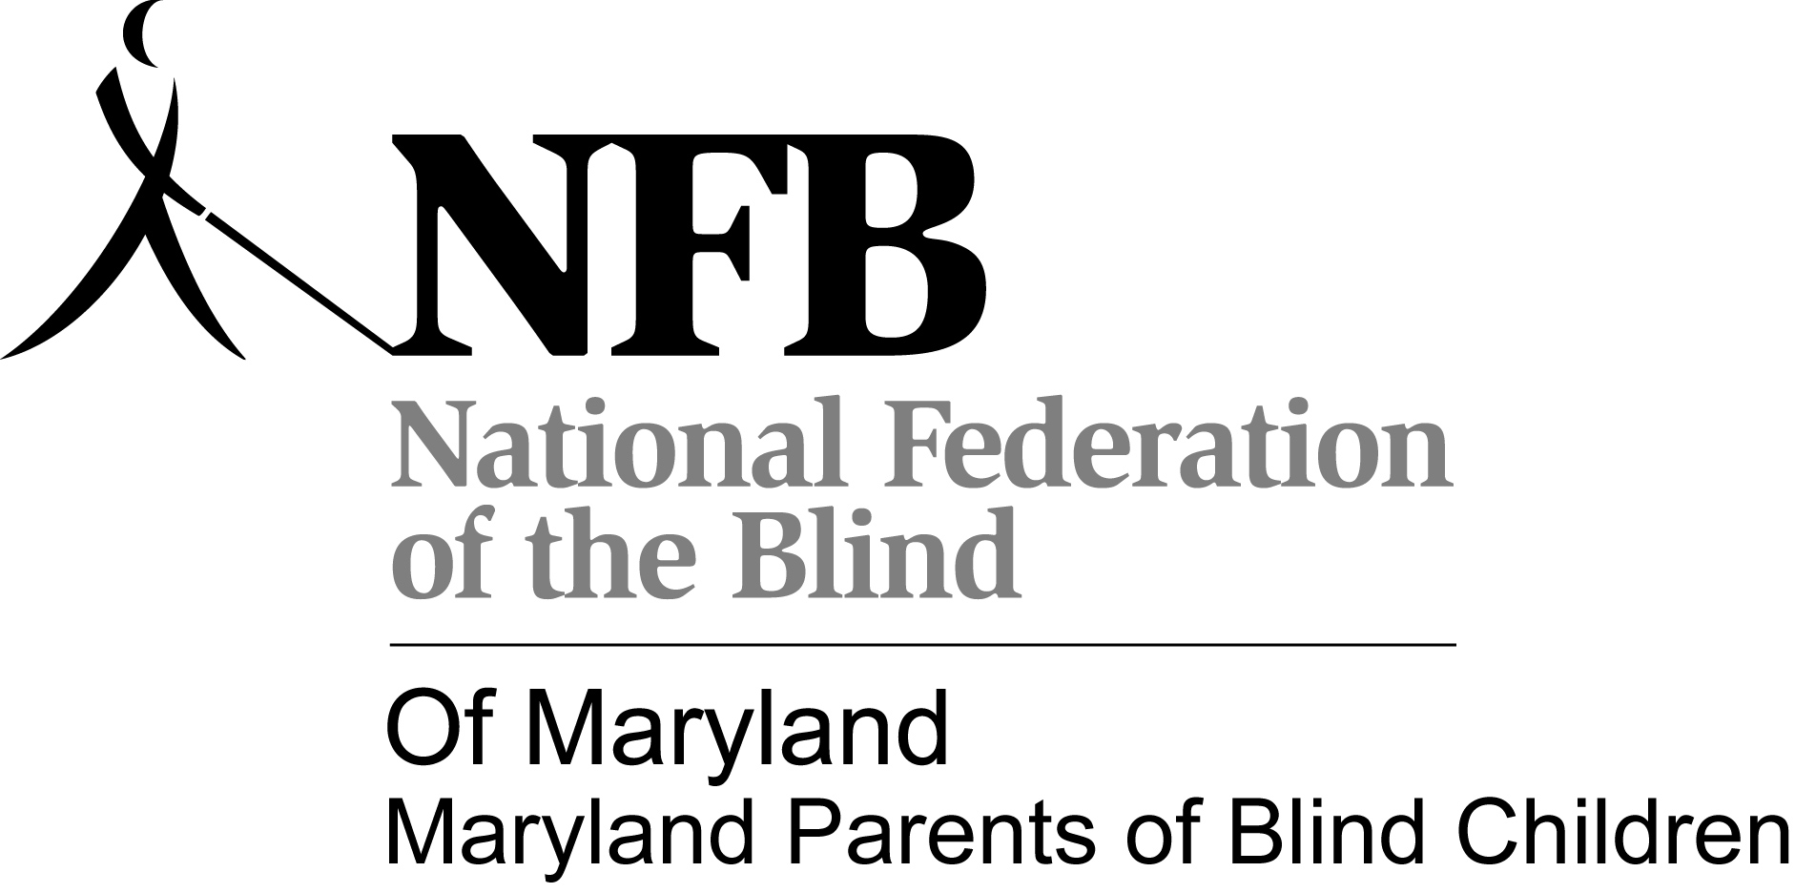

Access to the General Music Curriculum for Students Who Read Braille
Friday, October 21, 2011
Maryland School for the Blind
8:30 - 9:00 Registration and Refreshments
9:00 - 9:30 Welcome and Introduction
Lisa Wright, MSDE, Division of Special Education, Blind/Visually Impaired/Low Incidence Disability Specialist

9:30 – 10:15 The Maryland Fine Arts Content Standards in Music: What All Students Should Know About Music Notation
Dr. Ray Zeigler, Professor Emeritis, Salisbury University and Music Consultant
10:15 - 10:30 Break
10:30 – 12:00 Introduction to the Braille Music Code
Melinda Demaris, Teacher of the Visually Impaired, Wicomico County Public Schools

12:00-1:00 Lunch

1:00-2:30 Braille Music Translations Software, Curriculum, and Services
Bill McCann, Dancing Dots
2:30 – 3:00 Questions, Wrap-Up, and Evaluation

Access to the General Music Curriculum for Students Who Read Braille
Friday, October 21, 2011
8:30-3:00
Location: Russo Arts Center, Maryland School for the Blind

Registration

Name: ___________________________ County: _________________________
Email: _____________________________________________________________
Check One: TVI ____ Music Educator ________ Braille Transcriber _______ Paraprofessional ________ Parent _____________
Background in reading regular music notation:
None _____ A little ______ Some ______ Very good ______ Expert _______
PARENTS: Childcare Needed? No ______ Yes _______
If Yes, Provide Names/Ages/Special Needs of Children:

REGISTRATION DUE: September 30th to Lisa Wright
Email: lwright@msde.state.md.us or FAX: 410-333-8165

