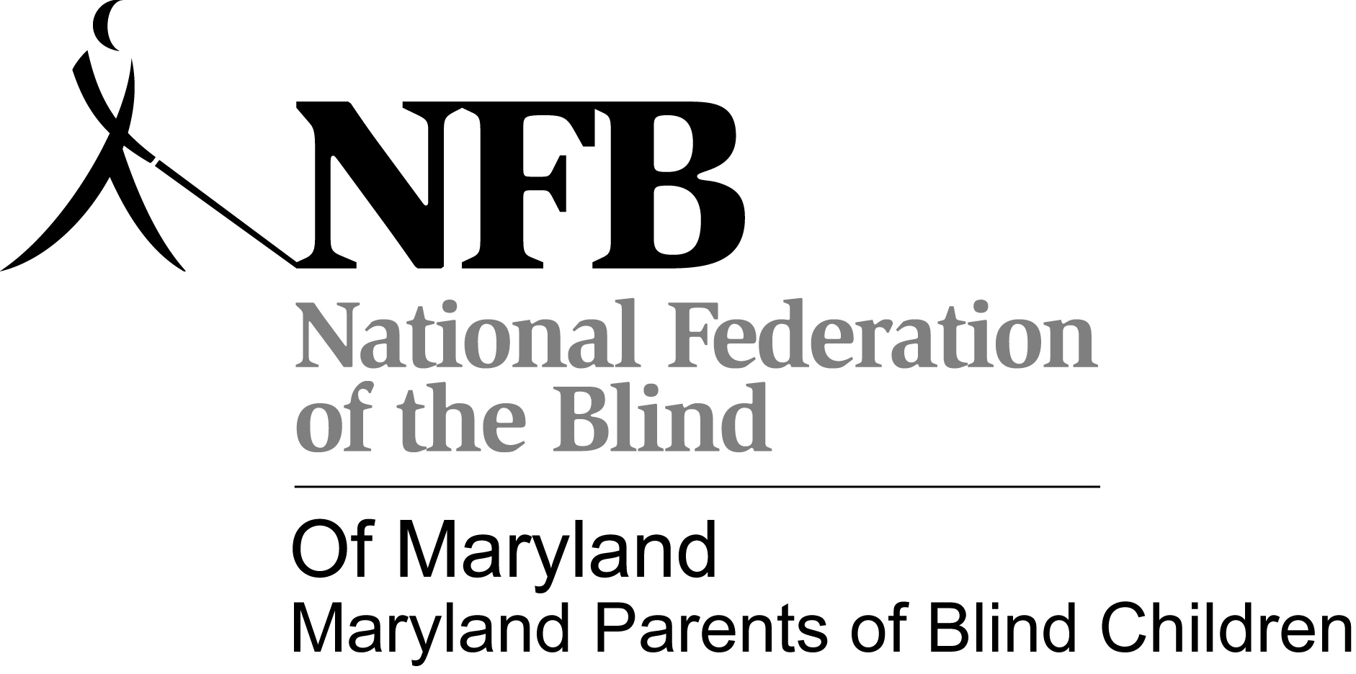

Presents
“Seeing thru the Ocean to the Final Prize”
A Conference for Parents and Teachers
October 28th, 2011

Carousel Hotel
11700 Coastal Hwy
Ocean City, MD
WELCOME TO THE MDPOBC 2011 CONFERENCE!
*Insider Information*
The Maryland Parents Conference is a one day event in conjunction with the National Federation of the Blind of MD State Convention. Here are a few tips to help you stay organized and take advantage of the many opportunities that will be available.
Seminar Day Information- Friday, October 28, 12:30 – 8:30pm
- On Seminar Day, Fri. Oct 28, parents, children and youth start the afternoon together. Listening to the year in review of the MDPOBC and their peers. At 1:00 our Kids that are preregistered with NFBMD child care will be escorted to the Child Care Room. ‘Tweens 10-13 will be escorted to ‘Tween activities. Youth (ages14-up) will go with the Student Division. At 5:00, after the State board meeting, pick up your child from child care for dinner on your own. After dinner children return to child care, and parents attend workshops.
‘Tweens and Teens will have dinner with their groups.
CHILDREN’S ACTIVITIES, CHILD CARE, TEEN ACTIVITIES:
- MDPOBC Friday –Saturday activities for children(6 wks to 9 yrs)will take place in The Child care room. To take part, your child must be registered for child care(form enclosed).
- Tween Activities Friday- Saturday for kids 10-13 Will include Social Skills and Table Manners, visit to the Exhibit Hall, dinner at a sit-down Restaurant (Not McDonalds)bring$15.00. Cane walk/ Scavenger Hunt, and a Field trip tour of Ocean City on Saturday, WOW!!!
- Teens 14-18 Will be with the MD Association of Blind Students for many activities thru out the weekend, including the Cane Walk/Scavenger hunt.
SPECIAL EVENTS & ACTIVITIES ALL WEEKEND :
- Certain special activities for parents, children and youth are listed only in this agenda such as the Cane Walks, MDPOBC workshops and Tween and Teen Activities.
- Other activities that we encourage you and your child to attend are listed in the NFB of MD Convention agenda( this is a separate document and registration. Visit http://www.nfbmd.org/events/2011StateConvention.html).
- Please register for both the MDPOBC conference and the NFB of MD State Convention so that you will be aware of all that is going on.
- Often many activities are going on at the same time and you and your child will have to make choices! Don’t miss all the MDPOBC activities-Listed in this agenda- and the many other fun, educational, and inspirational NFB of MD convention events listed in the Convention agenda, such as:
  - NFB of MD convention sessions Saturday and Sunday; Banquet Saturday evening- Be sure to complete your Banquet Ticket exchange(details at Parents Luncheon)
  - Talent Night(come ready with a talent),
  - NFB MD Division Meetings and activities such as NFB of Maryland Association of Blind Students, etc.
  - The Exhibit Hall where you can browse, try out, and purchase the latest technology, Braille T-Shirts, and other items of interest

SCHEDULE OF EVENTS
Friday October 28, 2011
11:30-12:15 pm REGISTRATION
12:45-5:00 pm CHILD CARE OPEN
12:30 pm FOSTERING EXPERIENCES THAT WILL LEAD TO FUTURE SUCCESS: The role of MDPOBC
Trudy Pickrel, President, MDPOBC
12:45 pm FUTURE SUCCESS THROUGH READING AND SUMMER FUN
Jason Polansky - Independence 2011
Anna Walker - The Buddy Program
At the conclusion of this panel:
- Children (ages 6 wks- 9 yrs old) Blind and/or Sighted Siblings in this age who are enrolled in Child care will be escorted to the Child Care Room, so that parents can attend the workshops which begin at 1:00pm.
- Tweens (10-13 yrs of age) This includes Blind students and/or any siblings in this age will be escorted to the Tween room(to be announced) for activities from 1:00pm to 8:00pm. Which will include a dinner at a sit down restaurant, to work on social skills learned earlier in day (we are asking for parents to send $15.00 for the dinner.) **The MDPOBC will make sure every child has dinner regardless of ability to pay. For more information please contact Trudy Pickrel at 301-501-1818 or by email at tlpickrel@hotmail.com
- Teens (ages14-18.) will go with MD Asssociation of Blind Student Division for an afternoon of activities on Friday
1:00-2:25 pm USING THE IEP TO ENSURE SUCCESSFUL TRANSITIONS
2:30-3:55 pm BUILDING FUTURE SUCCESS WITH AGE APPROPRIATE SOCIAL SKILLS
4:00 pm NFB OF MD BOARD MEETING
6:15-8:35 pm CHILD CARE BACK OPEN Child care available to parents that are attending Workshops or Working with the Conference.
6:30-7:30 pm CREATING SUCCESSFUL, EDUCATIONAL MATH EXPERIENCES
7:30-8:30 pm BEHAVIOR: WHO’S IN CONTROL HERE ANYWAY?
8:00PM TALENT NIGHT

See next page for workshop descriptions
Using The IEP To Ensure Successful Transitions-What you need to have in your IEP when transitioning from PreK to K, thru High School to College or work. Instructor: Carlton Cook Walker attorney and TVI, NOPOBC board member
Building Future Success With Age Appropriate Social Skills –Is your child age appropriate and interacting with peers? How to address the fears of your childs peers and their parents. Instructor: John Fritz, member of the Board of Directors of the National Federation of the blind, Board member NOPOBC, Parent of several blind and Sighted children.
Creating Successful, Meaningful, Educational Math Experiences- Doing arithmetic in braille, using the abacus, preparing assignments with LsTeX,Scientific Calculator, Tactile Graphics, and a Q&A time. Instructor: Al Maneki, PHD & Natalie L. Shaheen, MEd,Director of Education,NFB,Jernigan Institute,
Behavior: Who’s in Control Here Anyway?-Learn about positive behavior supports and how Love, control, independence, and self-determination are all connected. Instructor: Dr. Jerry Petroff, The College of NJ, author, and National conference speaker

Saturday October 29, 2011
8:30 am – 12:00 pm Child Care open
9:00 am - 12:00 pm General Session
12:00pm - 2:00 pm Child Care – Includes lunch for kids. This is only available to parents who attend one of the special luncheons sponsored by our state divisions.
12:00 -3:30pm Walking tour of Assatteague State Park- Kids 10-18yr of age
12:00-1:30pm Parents Luncheon- By the MDPOBC-Enjoy some inspiring words by National Rep John Fritz and our Outstanding Educator for 2011 . Don’t forget to get your luncheon tickets and bring your Banquet Tickets with you for Banquet exchange.
2:00 pm -5:00pm Child Care open
2:00 pm- 5:00pm General Session
6:30 pm – 10:00pm Child Care open (includes supper for kids)
7:00 pm Banquet

Sunday October 30, 2011
9:00am – 12:00pm General Session – No Child care

MDPOBC Seminar Registration
Adult #1: _______________________________________________________
Adult #2:________________________________________________________
Address:_________________________________________________________
__________________________________________________________
Phone: Home _________________________________________
Cell or Work ____________________________________
Email address:_________________________________________
Check all that apply:
Parent ___ Family Member ___Teacher ____ Paraprofessional ______
Administrator ____ Student ____ Other ______
Need Childcare? Yes ____No ____
Please complete the childcare registration form
Tween 9-13 #___ Ages_________ _____$15.00 for Dinner Friday night (bring with you)
Teens 14-18 #____ Ages_________
Mark number attending the sessions you plan to attend:
______ Workshop I: Using The IEP To Ensure Successful Transitions
______ Workshop II: Building Future Success With Age Appropriate Social Skills
______ Workshop III: Creating Successful, Maningful, Educational Math Experiences
______ Workshop IV: Behavior: Who’s in Control Here Anyway?

Please make checks payable to MDPOBC and mail to NFB of Maryland at 9013 Nelson Way, Columbia, MD 21045.
The MDPOBC Workshops Are Free But you need to also register for The State Convention

Convention Child Care(Provided by the Maryland Parents of Blind Children)
Child-care for (name)________________________________ age_______
2nd Child__________________________________________ age_______
3rd Child __________________________________________ age_______
Times: (please check)
_____Friday 12:15- 5pm childcare is available only to parents attending parent workshops
_____Friday 6:15- 8:35pm
_____Saturday: 8:30 am – Noon _____
_____Saturday: Noon - 2:00 pm Includes lunch for your child. This is only available to parents who attend one of the special luncheons sponsored by our state divisions.
Please note if the child has any food allergies:_______________________________________ ____________________________________________________________________________
_____Saturday, 2:00 pm -5:00 pm
_____Saturday Banquet, (includes supper) 6:30 pm until 10:00 pm
Name of parent/responsible adults who are allowed to pick up child from the child care room (No more than 2 names):
1.____________________________________________________________________________
2. ___________________________________________________________________________
Home phone: _____________________________ Cell phone:___________________________
Email: ________________________________________________________________________
Special considerations/needs/anything we should know about your child/children (allergies, blind/visually impaired, sighted, difficulty walking, etc) _______________________________________________________________________________________________________________________________________________________________________________________________________________________________________
Recommended fee/donation per child**
Friday: $10/single child, $ 20 two or more children
All day Saturday including lunch and the banquet: $30/single child; $40 two or more
1/2 day no lunch: $15/single child; $25 two or more
Banquet only: $10/single child; $20 two or more
**The MDPOBC will make every effort to provide childcare for members who need it regardless of ability to pay. For more information please contact Trudy Pickrel at 301-501-1818 or by email at tlpickrel@hotmail.com
Please make checks (for child care only) payable to MDPOBC and mail to NFB of Maryland at 9013 Nelson Way, Columbia, MD 21045.
WALKING TOUR OF ASSATTEAGUE STATE PARK
Saturday, October 29nd in connection with the NFB of MD State Convention
For youth ages 9 -18.
Advanced registration is required by October 7, 2011
Registration is limited to 15 youth. I give permission for my child/children to participate in The Walking Tour of Assatteague, a Maryland Parents of Blind Children (MDPOBC) sponsored event on Saturday, October 29, 2011.
I release the Maryland Parents of Blind Children, its Officers, Board of Directors, and Volunteers from responsibility should my child be injured in any way while participating in this event.
Youth and chaperones will meet in the hotel lobby at 11:45, and go to Rm 809 for Pizza. Then, they will leave the Hotel at 1:00 PM to go to Assatteague State park for the tour.
The tour will be guided by a park ranger, starting at the Marsh/Board Walk and ending at the touch tank. This is a 1 hr walking tour which will occur rain or shine. Appropriate clothing and shoes should be worn. Participating blind youth must use their canes. Age appropriate siblings and other age appropriate youth attending convention may also register. Youth will be supervised by adults who will be encouraging good cane technique and offering pointers along the way.
Register by returning this form separately to: MDPOBC, 1886 Mosser Rd, McHenry, MD 21541. You may also register by calling Trudy at 301-387-4182 or email at tlpickrel@hotmail.com. If you register by phone or email a signed permission form will need to be received prior to the event [can be signed the day of the event]. Cost per student $3.00 for Pizza and Drink(bring with you)
Name of child/children: __________________________________________________________
______________________________________________________________________________

Paid: yes __________ no _________
Signature parent/guardian: _______________________________________________________
Date: __________________

