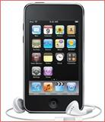

Apple Ipod Touch Raffle
Benefit Maryland Parents of Blind Children (MDPOBC)

MDPOBC is raffling off a Ipod Touch 8G with Internet Capabilities a $200. Value

Tickets $10.00 each
Only 100 tickets being sold!

Drawing October 30, 2011

Call Bill Jacobs at 410-207-0825
Or Trudy Pickrel at 301-501-1818
Or Any MDPOBC Board Member for Tickets

