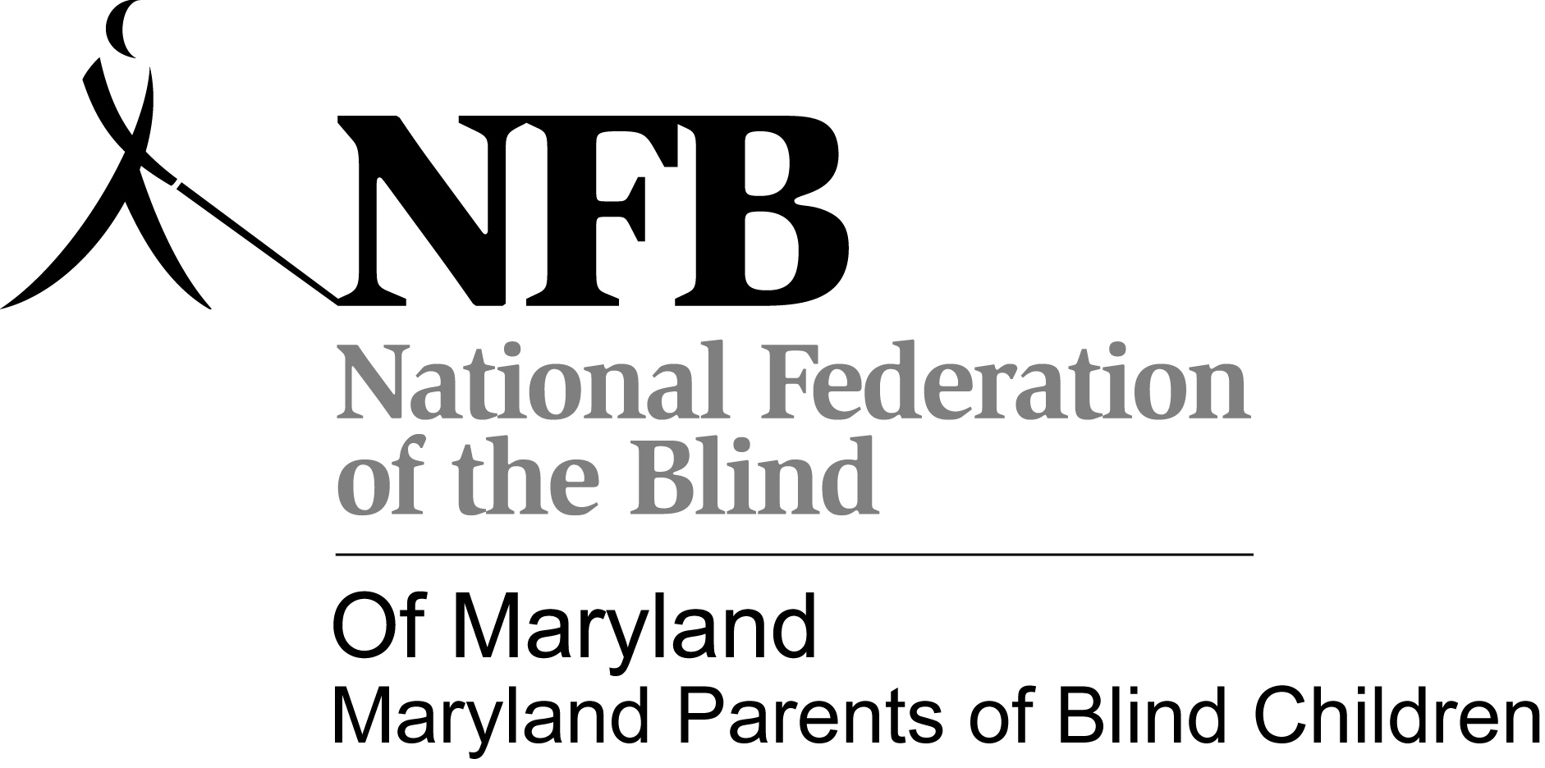
Save the Date
November 9-11, 2012
Maryland Parents of Blind Children Seminar

Presents
“OPENING CLOSED DOORS”

A Conference for Parents and Teachers
November 9, 2012
9:00am – 5:00pm

Double Tree Hotel
210 Holiday Court
Annapolis, MD

