Come one come all !!!

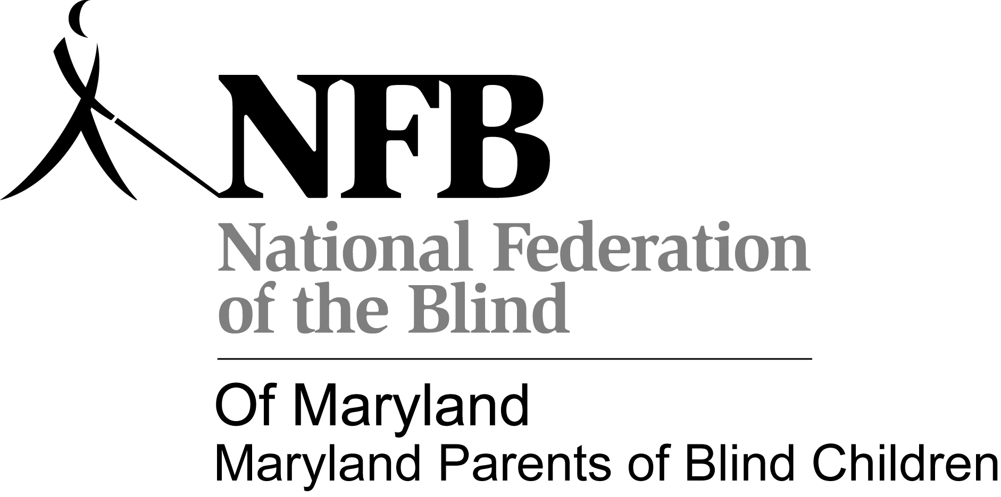

Maryland Parents of Blind Children
Cordially invites:
• All parents, grandparents, and siblings of blind children
• Educators of Blind children
• Others interested in promoting a climate of opportunity for blind children
to a
Maryland Parents of Blind Children Family Picnic
(Menu: Hamburgers, Hot Dogs, & everyone favorite Covered dish they want to bring)
Hamburgers and Hot Dogs, & paper products provided by MDPOBC
and a
Beep Baseball, Games, Back to School Supplies
Saturday, Aug. 24, 2012
2:00 - 7:00p.m.
Hammond Park Pavilion (Howard County)
10700 Glen Hannah Dr
Laurel, MD 20723
Please respond to Trudy at 301-501-1818 or e-mail: tlpickrel@hotmail.com to let us know that you are coming (So we know how much food to have on hand!)

Direction:
From Hagerstown, MD: I-70 East At exit 80 take ramp right for MD-32 South toward How. Co Fairgrounds/West Friendship/Clarksville Keep Straight onto MD-32 2.5 mi. Keep Straight onto MD-32 S .9mi. Bear right onto MD-32 go 4.5mi. Keep Straight onto MD-32 E. At exit 16B, take ramp right for US-29 South toward Silver Spring go 1.6mi. At exit 15, take ramp right for Johns Hopkins Rd toward Gorman Rd. go .4mi. Turn left onto Johns Hopkins Rd go .2mi. At roundabout, take 1st exit go .4mi. Keep straight onto Gorman Rd go .7mi Turn right onto leishear Rd go .6mi. Turn right onto Glen Hannah Dr. go .2mi. Arrive at 10700 Glen Hannah Dr. Laurel, MD 20723

From Baltimore: From I-395 S Take ramp Left for 1-95 South toward Washington go 16.9mi. at exit 35B, take ramp right for MD-216 West toward Scaggsville go 1.3 mi. Turn right onto Leishear Rd. go .2mi. Turn left onto Glen Hannah Dr go .2mi. Arrive at 10700Glen Hannah Dr. , Laurel MD

Maryland Parents of Blind Children goal is to help blind/visually impaired children grow up to be productive, fully functioning, and independent members of society by providing practical information to their parents and teachers. We are also dedicated to providing ideas, assistance, and information that will help blind/VI children with additional disabilities reach their potential.

