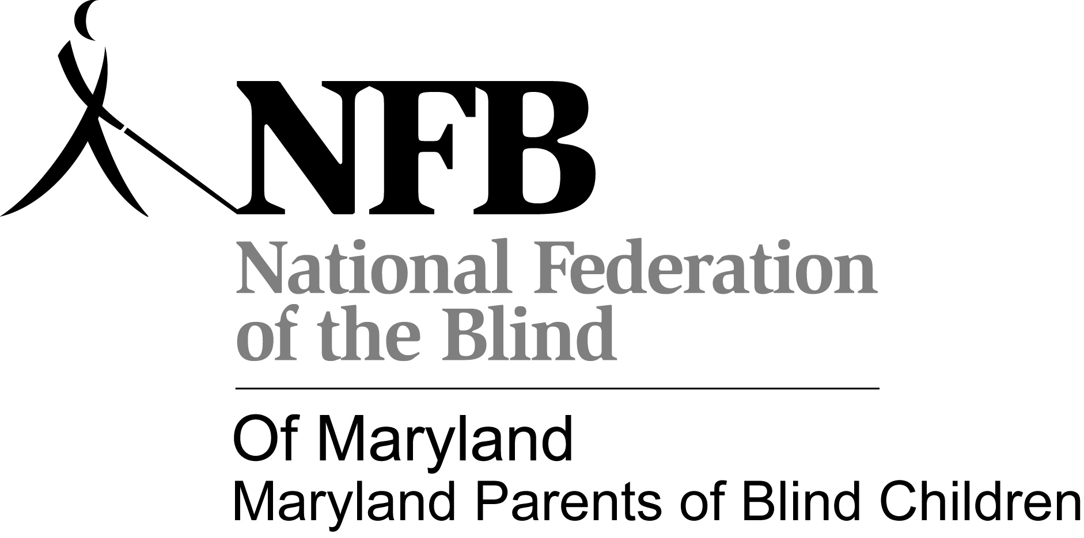
Tween/Teen schedule
The Road to Independence begins with you:
National Federation of the Blind of Maryland Convention- November 8, 2013

November 8, 2013

9:30-10:00 am Registration- Washington Room

10:00-10:45 am: Introductions/Seminar- Shopping independently(Note: Kids may arrive late, they will be integrated into activities, when appropriate upon arrival. Youth who plan to participate in activities must arrive by 11:00 am to be included in the shopping activity. –Meet

10:45 am-12:15 pm: Hotel orientation and travel to store/area travel (BISM staff with drivers on call if inclement weather).

12:15pm-1:30 pm: Prepare lunch and clean-up. 1:30-3:00 pm: Pool Party with MDABS-Inviting all middle school, high school, and college students!
3:15-4 pm: Time to Visit NFB of Maryland Convention Exhibits/Supervised social time- Maryland Room

4-5 pm: NFB of Maryland Board meeting- Virginia Room

5-6:30 pm: Maryland Association of Blind Students Meeting-Want to know more about MDABS and what we do? Want to get to know fellow blind students from all parts of Maryland? Come out, hear from inspiring leaders, learn about upcoming opportunities, and find out how to get involved! This meeting is opened to all middle school, high school, and college students!
BISM staff and NFB of Maryland volunteers to assist with supervision for MD POBC activities until 5:00 pm – Parents need to pick up Tweens. They are welcome to the Student Meeting and Dinner But they will not be supervised by Volunteers.
Dinner with MD ABS!! 6:30 pm-This will be held in the hospitality condo for all middle school, high school, and college students!
7:00pm -Games with MD ABS
9:00 pm - Ice skating

November 9, 2013
10:00 Meet in- Rm 611
11:00 Pizza –Rm 611
11:45 Leave for ASSATTEAGUE WALKING TOUR
3:15 Return to Hotel/ Join main session- Maryland and Virginia Rooms
5:00 Adjourn
7:00 Banquet- Pennsylvania Room

November 11, 2012
9:00 General Session – Maryland and Virginia Rooms
12:00 Adjourn
12:30 Depart Hotel

