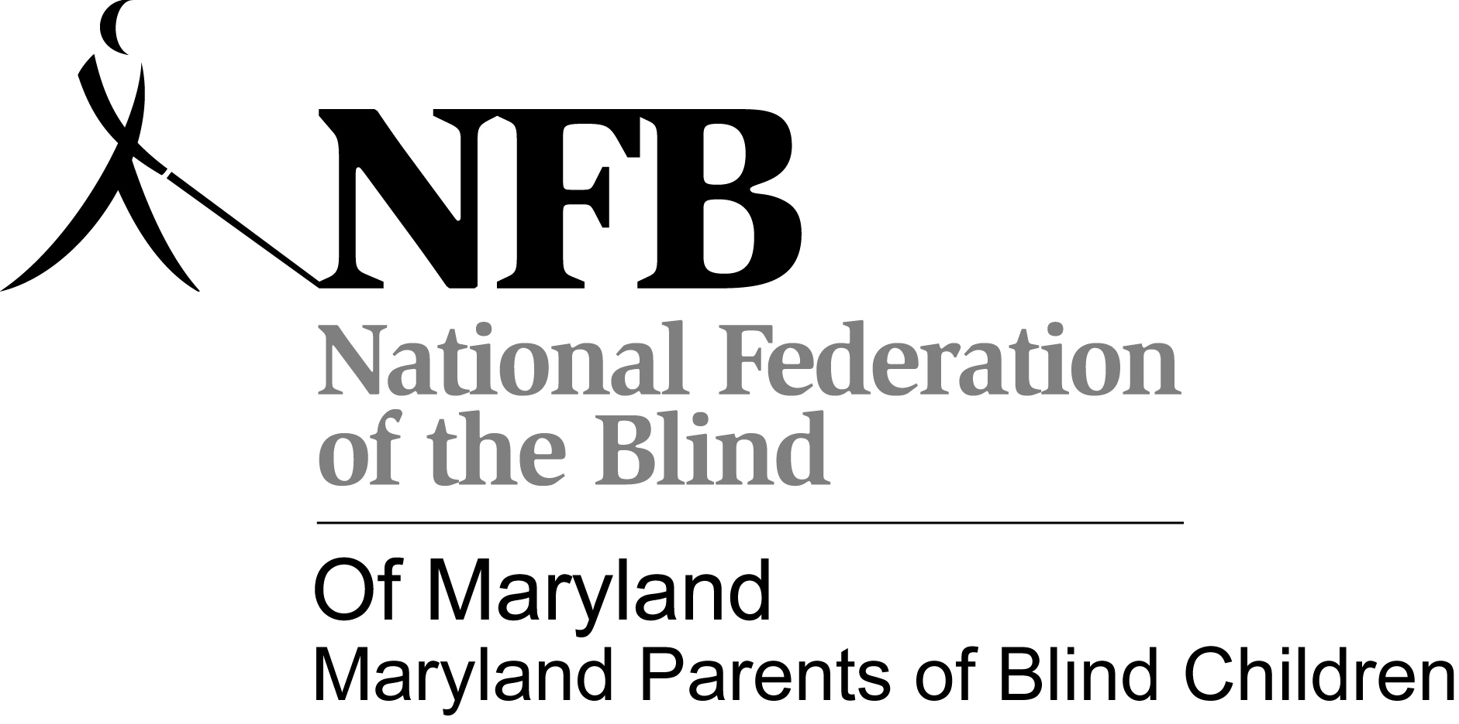
Tween/Teen schedule
The Road to Independence begins with you:
National Federation of the Blind of Maryland Convention-
November 8-10, 2013

November 8, 2013

9:30-10:00 am Registration- Delaware Room

10:00-10:45 am: Introductions/Seminar- Shopping independently(Note: Kids may arrive late, they will be integrated into activities, when appropriate upon arrival. Youth who plan to participate in activities must arrive by 11:00 am to be included in the shopping activity. –Meet Rm 611

10:45 am-12:15 pm: Hotel orientation and travel to store/area travel (BISM staff with drivers if inclement weather).

12:15pm-1:30 pm: Prepare lunch and clean-up. 1:30-3:00 pm: Pool Party with MDABS-Inviting all middle school, high school, and college students!
3:15-4 pm: Time to Visit NFB of Maryland Convention Exhibits/Supervised social time- Maryland Room

4-5 pm: NFB of Maryland Board meeting- Virginia Room

5-6:30 pm: Maryland Association of Blind Students Meeting-Want to know more about MDABS and what we do? Want to get to know fellow blind students from all parts of Maryland? Come out, hear from inspiring leaders, learn about upcoming opportunities, and find out how to get involved! This meeting is opened to all middle school, high school, and college students!
BISM staff and NFB of Maryland volunteers to assist with supervision for MD POBC activities until 5:00 pm – Parents need to pick up Tweens. They are welcome to the Student Meeting and Dinner But they will not be supervised by Volunteers.
Dinner with MD ABS!! 6:30 pm-This will be held in the hospitality condo for all middle school, high school, and college students!-Rm 612
7:00pm -Games with MD ABS
9:30 pm - Ice skating Middle School and High School- ice Hockey and snacks

Saturday, November 9, 2013
10:00 Tween/Teens Learn how to use E.A.S.Y. LLC’s inTACT™ sketchpad to do your own STEM diagrams Rm 611
11:00 Tweens Pizza –Rm 611
11:45 Tweens Leave for ASSATTEAGUE WALKING TOUR- RM 611
3:15 Return to Hotel/ Join main session- Maryland and Virginia Rooms
5:00 Adjourn
7:00 Banquet- Pennsylvania Room

Sunday, November 10, 2012
9:00 General Session – Maryland and Virginia Rooms
12:00 Adjourn
12:30 Depart Hotel

WALKING TOUR OF ASSATTEAGUE STATE PARK
Saturday, November 9nd in connection with the NFB of MD State Convention
For youth ages 10 -18.
Advanced registration is required by October 30, 2013
Registration is limited to 15 youth. I give permission for my child \children to participate in The Walking Tour of Assatteague, a Maryland Parents of Blind Children (MDPOBC) sponsored event on Saturday, November 9, 2013.
I release the Maryland Parents of Blind Children, its Officers, Board of Directors, and Volunteers from responsibility should my child be injured in any way while participating in this event.
Youth and chaperones will meet in Rm 611 at 11:00 for Pizza, then leave Hotel at 12:00 PM to go Assatteague State park for the tour.
The tour will be guided by a park ranger, starting at the Marsh/Board Walk and ending with at the touch tank. This is a 1 hr walking tour which will occur rain or shine. Appropriate clothing and shoes should be worn. Participating blind youth must use their canes. Age appropriate siblings and other age appropriate youth attending convention may also register. Youth will be supervised by adults who will be encouraging good cane technique and offering pointers along the way.
Register by returning this form separately to: MDPOBC, 1886 Mosser Rd, McHenry, MD 21541. You may also register by calling Trudy at 301-387-4182 or email at tlpickrel@hotmail.com. If you register by phone or email a signed permission form will need to be received prior to the event [can be signed the day of the event]. Cost per student $3.00 for Pizza and Drink(bring with you)
Name of child/children: __________________________________________________________
______________________________________________________________________________

Paid: yes ___________ no ___________
Signature parent/guardian: _______________________________________________________
Date: __________________

