MD PARENTS OF BLIND CHILDREN
MDPOBC and BISM * 1886 Mosser Rd, McHenry, MD 21541* 301-501-1818* http://mdparentsofblindchildren.org*
presents
4th- Be OK With Blindness
A Seminar for Parents and Teachers of BVI Children
SATURDAY, May 10, 2014
8:00 AM to 5:00 PM

Jernigan Institute of the NFB
*200 Wells Street
Baltimore, MD 21230 *

REGISTRATION Open Now:
Continental breakfast, lunch, child care, and Tween & Teen programs all included!

Join us for a day of
inspiration and information. Learn, share, meet new families and blind/VI adults.

PROGRAM HIGHLIGHTS
* Structured Discovery in Cane Travel * Ideas for Children with Additional Disabilities *
* Travel Technology *
* Traveling for Independence * Summer Programs for Youth *
* What is Your Child’s Rights * IEPs for Success * Advocacy *
* Arts & Crafts & Activities for the Kids, Tween & Teens *

For more info, contact Trudy Pickrel, POBC-MD Pres., at 301-501-1818 or TLPickrel@hotmail.com
Please feel free to photocopy this form to share with other families & teachers.
_ _ _ _ _ _ _ _ _ _ _ _ _ _ _ _ _ _ _ _ _ _ _ _ _ _ _ _ _ _ _ _ _ _ _ _ _ _ _ _ _ _ _ _ _ _ _ _ _ _ _ _ _ _ _ _ _ _ _ _ _ _ _

Registration: 4th Annual “Be OK With Blindness” Seminar
Mail to POBC-MD & mail ASAP with form to: POBC-MD * 1886 Mosser Rd * McHenry, MD 21541

Name/s _______________________________________________________________________
Address __________________________________ City _______________________________
State ____ Zip ________ Phone ( )________________ Email _________________________
Name of blind/VI child/ren ___________________________ Date of birth __________________
Name of blind/VI child/ren ___________________________ Date of birth __________________
Will child/ren need child care? ____ Age/s ______ Total # attending _____
___ I cannot attend Seminar, but put me on the POBC-MD mailing list. ___ $10 dues enclosed

SPECIAL GUEST SPEAKERS

Carol Castellano, is Director of Programs for the National Organization of Parents of Blind Children and President and Co-Founder of Parents of Blind Children-NJ. She is the author of four books: The Bridge to Braille, Because Books Matter, Making It Work, and Getting Ready for College Begins in Third Grade: Working Toward an Independent Future for Your Blind/Visually Impaired Child. Carol’s work has been recognized internationally and appears on blindness services websites of countries around the world.

Mark Riccobono, is the Exec. Director, NFB Jernigan Institute, Baltimore, Graduated University of Wisconsin-Madison with a degree in business administration. 1999. During his senior year, Mark was elected, at age 22, to the presidency of the National Federation of the Blind of Wisconsin and was re-elected twice for successive two year terms until resigning in 2003 to move to Baltimore to work the NFB. Mark completed a Master’s of Science in Educational Studies from the Johns Hopkins School of Professional Studies in Business and Education in May 2009.

Carlton Cook Walker is the president of National Parents of Blind Children, an attorney and a TVI, Carlton trains parents, teachers and Para’s around the Country on IEP’s and Advocacy.

Maurice Peret, is the Rehabilitation trainer at Blind Industries and Services of Maryland. Has traveled ++++

Be Ok With Blindness
A Seminar for Parents and Teachers of BVI Children
SATURDAY, APRIL 20, 2013
8 AM – 5 PM

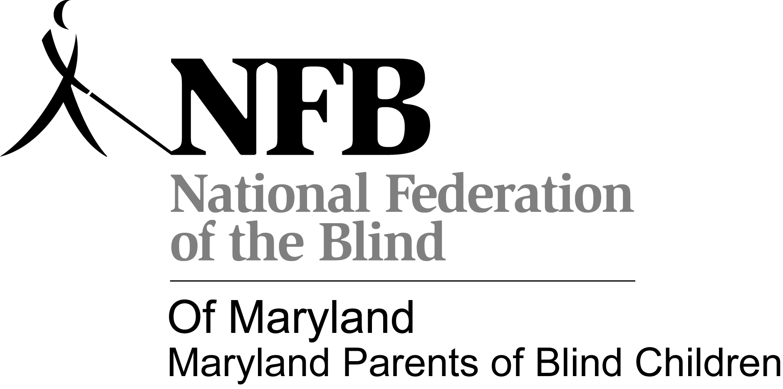

SEMINAR — APRIL 20, 2013
Parents of Blind Children-MD
1886 Mosser Rd
McHenry, MD 21541

Tentative Teens “Be OK with Blindness” Activities

“The world is a book and those who do not travel read only one page.”
― Augustine of Hippo

Cane Travel "Trechnolgy" Rally for Blind High School Students) Ages 14 and up):

Overview: On Saturday, May 10, 2014 blind/low vision high school students will enhance their ability to utilize accessible, portable technology while traveling in various parts of Baltimore with peers and experienced instructors. Teams will walk and access public transportation while using apps, GPS systems and maps to find interesting land-marks/businesses in different areas of Baltimore. Students will also have a chance to socialize with friends during a lunch out in Baltimore. So grab your canes and get ready for an action-packed day out and about in B-More!

8:30 am: Students meet at the Jernigan Institute to discuss group travel rules, including problem solving tips.

8:45 am to 9:30 am. Travel as a large group to the starting point for cane travel "trechnology"

9:30 am: Rally Round 1- Instructions distributed. Groups must provide proof (business cards, etc.) showing they visited the place(s) specified on their Round 1 Rally Information Sheet

11:00 am: Rally Round 2- Instructions distributed at the Second Rally Point upon the arrival of the groups and the presentation of the evidence of their successful completion of Rally Round 1

12:30-1:15 PM Lunch upon presentation of proof of successful completion of Rally Round 2

1:15 PM: Rally Round 3 Instructions distributed at the third Rally Point upon completion of lunch. Students will travel to their final destination.

3:00 PM Students convene at the Jernigan Institute for a presentation from the Maryland Association of Blind Students- Missy Lomax, President

3:45 PM Group activity/small group presentations- Using Cane Travel "Trechnology" in your Neighborhood.

4:30 PM Wrap-up

Travilin' Tweens- Developing the Skills for Safe Travels

Overview: Blind/Low Vision students 8-13 years of age will work with experienced blind adult mentors to learn about techniques they can use to practice safe age appropriate travel. Students will also tour one of the ships and/or explore the inner-harbor with their friends and blind adult mentors. Students will travel as a group with adults, using public transportation to travel from the Jernigan Institute to the Inner Harbor.

8:30 AM: Students meet with adults to go over the plans for the day and review the group travel rules.

9:00 AM: Group travel to the Inner Harbor using the Circulator.

10:00 AM: Ship tours/exploration of the Inner Harbor (Includes snack and break)

1:00 PM: Lunch at Jernigan Institute

1:45 PM -3:30 PM Travlin' Tweens simulations: Students will pack for their trip, figure out how they will get to the airport and go through security.

3:30 PM to 4:30 PM: Arts and crafts- Cane decoration and make a pass-port. Group wrap-up.

