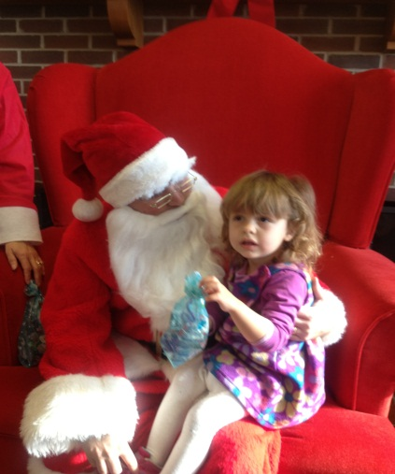
Maryland Parents of Blind Children [MDPOBC] and the National Federation of the Blind of Maryland
Invite you to celebrate the holiday season with us. Fun for the whole family!
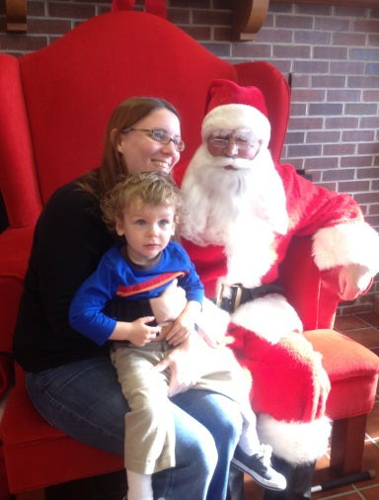
Sponsored by MDPOBC
Date: December 21st , 2014
Time: 10:00am to 12:00
Location: 200 Wells Street
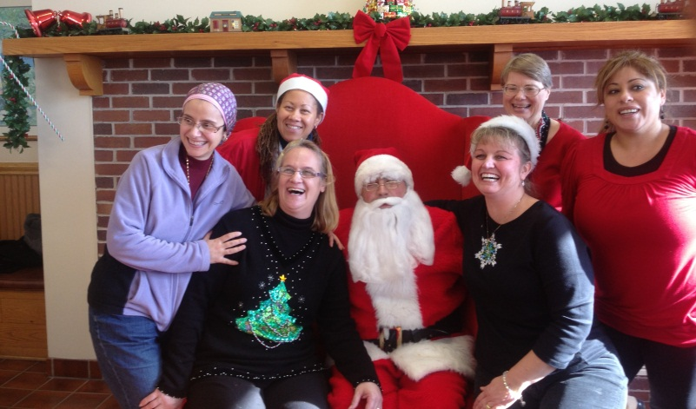
Baltimore, MD 21230
Arts & Crafts Snacks, Gifts

