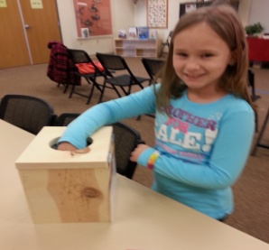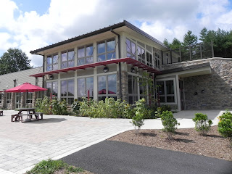 **The Frederick County Division**

**of Parks and Recreation**

**Cordially invites you to preview our new**

**Sensory Trail**

**at Catoctin Creek Park and Nature Center**

***The Catoctin Creek Sensory Trail is the first of its kind in Frederick County!***

*We hope you will be able to join us for this special preview of our new sensory trail. Activities will include a puppet show presented by Thurmont Public Library staff, a meet & greet with our furry friends from Wags for Hope pet assisted therapy program, and guided tours of our new hands on sensory trail.*

**When: Saturday, April 5th, 2014**

**Time: 10 am-12pm**

**Where: Catoctin Creek Park & Nature Center**

**2929 Sumantown Road**

**Middletown, MD 21769**

**#301-600-2051**

**Schedule:**

**10:00 AM: Opening Remarks**

**10:30 AM: Family Story Time Hour**

**11:00AM: Sensory Trail Tours Begin**

**12:00 PM: Appetizers**

**Please RSVP to Susan Matthews, Park Naturalist, by Saturday, March 22nd, 2014:** [smatthews@frederickcountymd.gov](mailto:smatthews@frederickcountymd.gov)

**This project would not be possible without the help of the following contributors:**

*Dawne Howard (Master Naturalist) for inspiring this project; Frederick County Parks Crews, Maggie Walker (Master Naturalist), Scout Garrett Johnson & Troop #476, The Middletown Lions Club, Cubmaster Pack 476, Girl Scout Brownie Troop 81213, Frederick County Nature Council, Wags for Hope, Leader Dogs for the Blind, and our Nature Center volunteers.*

Thank you!

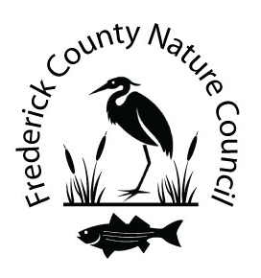



[](http://www.leaderdog.org/index.php)