**Service Day**

**at**

**Catoctin Creek Park and Nature Center**

Save the Date!

**•Great opportunity for students, scouts, and volunteers to beautify the park and earn service hours!**

**•Ages 8 and up with adult**

**• Light refreshments provided!**

**Volunteers will help mulch, groom and place logs along the new Sensory Trail which is opening in the Spring of 2014.**

**Catoctin Creek Nature Center**

**Saturday, March 29th**

**10 am—12 pm**

**•To register, please e-mail**

[**smatthews@frederickcountymd.gov**](mailto:smatthews@frederickcountymd.gov)

**2929 Sumantown Rd•Middletown, MD•21769**

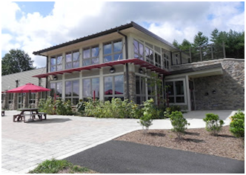 **301-600-2051**



Save the Dates!

Save the Dates!

Save the Dates!