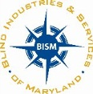 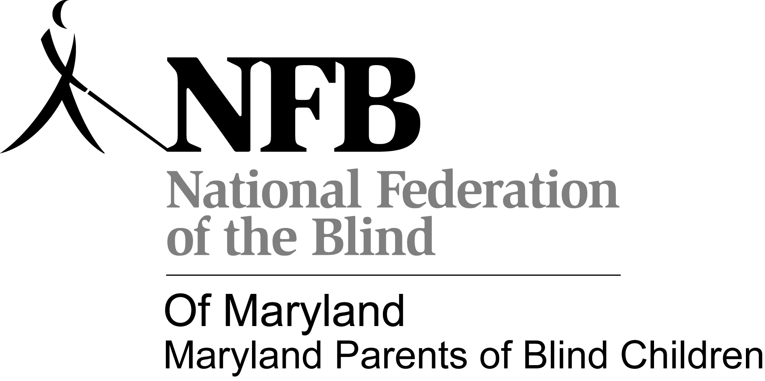

Maryland Parents of Blind Children, a division of the National Federation of the Blind of MD

And

Blind Industries and Services of Maryland

Presents

***“The 4th Annual Be OK with Blindness”***

A Workshop for Parents, Students and Teachers

May 10st , 2014

8:00am- 5:00pm

National Center For the Blind

Jernigan Institute

200 E. Wells St., Baltimore, MD 21230

**Parents Agenda**

**Childcare** **Harbor Room**

8:30–12:15 PM and 12:45– 5:15 PM

Parents must sign children in and out of childcare. Only approved parents can sign out children.

**Parents and children**

8:00 AM Registration – **Lobby**

Breakfast – **Lunch Room**

8:30 Tweens/Teens- **East Mall**

8:45 AM Students (9 and up) Depart for offsite Cane Travel - "Trechnolgy"

**Parents**

9:00 AM *Welcome-* **Auditorium**

Trudy Pickrel, President, Maryland Parents of Blind Children

, Director of Youth Programs

Melissa Riccobono, President, NFB of Maryland

Sarah Baebler and Melissa Lomax, BISM Youth Services Coordinators

9:15-10:00 AM ***“White Canes for Blind Kids”- Movie and Discussion-***

Sharon Maneki, Facilitator

10:00- 10:25 AM ***“On the Move with Cane and Confidence: Throughout the US, To Erope, To North Africa, and More”***

Conchita Hernandez, Teacher of Blind Students, Early Childhood, District of Columbia Schools- **Auditorium**

10:25 AM **Questions and Discussion**- **Auditorium**

10:35 AM **“Teaching Mobility for a Lifetime Through Structured Discovery”**

Dezman Jackson, Orientation and Mobility Instructor, Blind Industries and Services of Maryland- **Auditorium**

10:55 AM **Questions and Discussion**

11-11:45 **Roundtable: “Making the Right Decisions about Cane Travel”- Auditorium**

Who needs a cane; Cane vs. Dog, and when; the challenge of letting go: when to start.

Conchita Hernandez, Orientation and Mobility Instructor

Melissa Riccobono, Dog-guide User

Alex Castillo, Experienced Traveler, Mentor, and Instructor

11:45 Questions and Discussion- **Auditorium**

12pm Lunch**- Lunch Room**

1:00 “**Trusting Your Cane: A Hands-On Experience and Discussion for Parents”**

Christine Day, Parent and MDPOBC Board Member, with other O&M instructors- **Members Hall**

2:15 Break

2:30 “Beware of Evaluation Pitfalls: The NOMA Solution”- **Auditorium**

Mandi Bundren, Teacher of Blind Students, DC Public Schools

3:00 Questions and Discussion- **Auditorium**

3:10 “**Using the IEP Process to Gain Orientation & Mobility Services**”- **Auditorium**

Carlton Walker, President, National Organization of Parents of Blind Children, Attorney, and Teacher of Blind Students

4:00 **Questions and Discussion**- **Auditorium**

4:10 **“Helping Our Children Lead the Lives They Want”- Auditorium**

Mark Riccobono, Executive Director, Jernigan Institute

4:30 **NFB Activities, Scholarships, and Important Dates**- **Auditorium**

Melissa Riccobono, President, National Federation of the Blind of Maryland

Trudy Pickrel, President, Maryland Parents of Blind Children

Melissa Lomax, President, Maryland Association of Blind Students

4:40 **“Who Are We? NFB”**, a Presentation by Teens and Tweens, followed by a presentation by the children-**To be announced**