 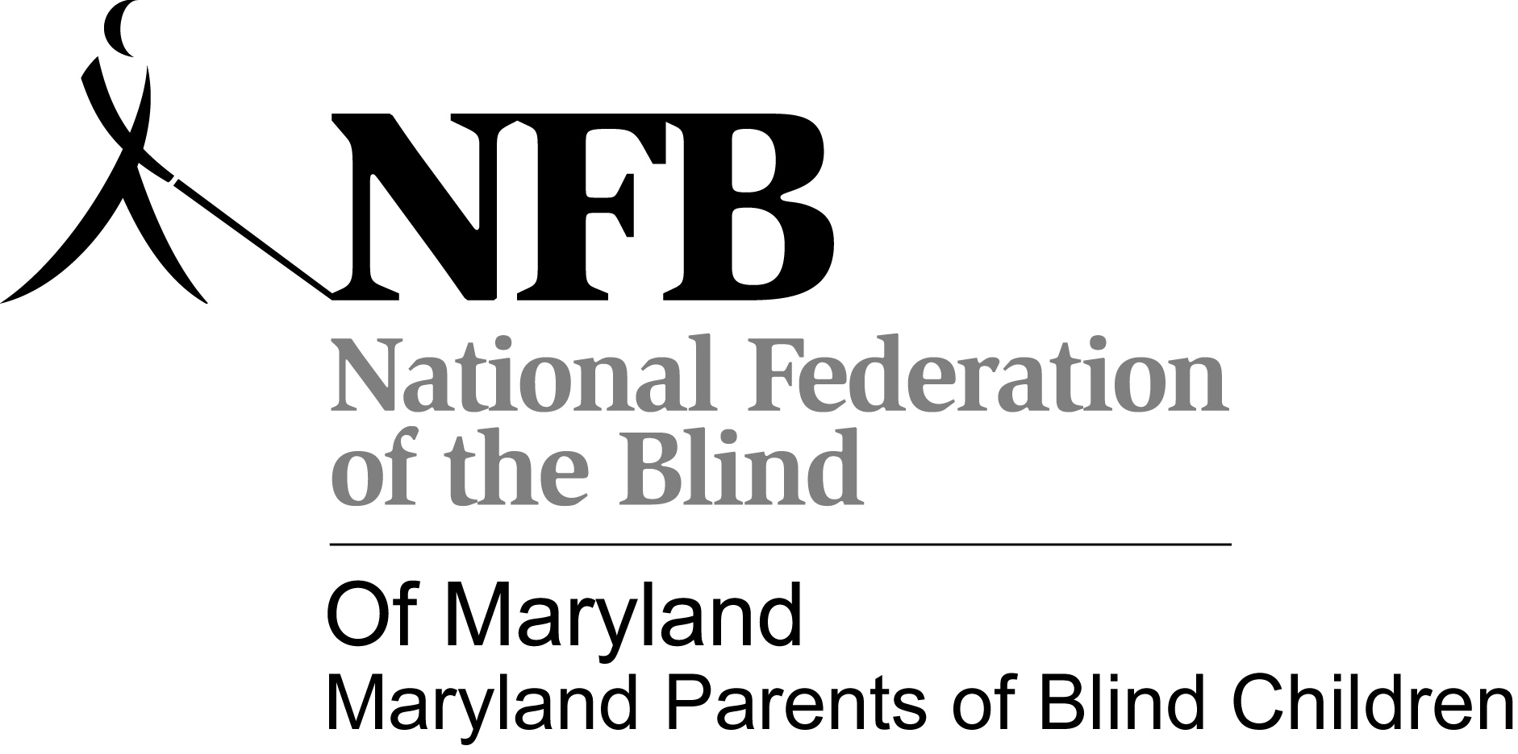

Maryland Parents of Blind Children, a division of the National Federation of the Blind of MD

And

Blind Industries and Services of Maryland

Presents

***“The 4th Annual Be OK with Blindness”***

A Workshop for Parents, Students and Teachers

May 10th , 2014

8:00am- 5:00pm

National Center For the Blind

Jernigan Institute

200 E. Wells St., Baltimore, MD 21230

**Parents Agenda**

**Childcare** **Harbor Room**

8:30–12:15 PM and 12:45– 5:15 PM

Parents must sign children in and out of childcare. Only approved parents can sign out children.

**Parents and children**

8:00 AM Registration – **Lobby**

Breakfast – **Lunch Room**

**Parents**

9:00 AM *Welcome-* **Auditorium**

Trudy Pickrel, President, Maryland Parents of Blind Children

, Director of Youth Programs

Melissa Riccobono, President, NFB of Maryland

Sarah Baebler and Melissa Lomax, BISM Youth Services Coordinators

9:15-10:00 AM ***“White Canes for Blind Kids”- Movie and Discussion-***

Sharon Maneki, Facilitator

10:00- 10:25 AM ***“On the Move with Cane and Confidence: Throughout the US, To Europe, To North Africa, and More”***

Conchita Hernandez, Teacher of Blind Students, Early Childhood, District of Columbia Schools- **Auditorium**

10:25 AM **Questions and Discussion**- **Auditorium**

10:35 AM **“Teaching Mobility for a Lifetime Through Structured Discovery”**

Dezman Jackson, Orientation and Mobility Instructor, Blind Industries and Services of Maryland- **Auditorium**

10:55 AM **Questions and Discussion**

11-11:45 **Roundtable: “Making the Right Decisions about Cane Travel”- Auditorium**

Who needs a cane; Cane vs. Dog, and when; the challenge of letting go: when to start.

Conchita Hernandez, Orientation and Mobility Instructor

Melissa Riccobono, Dog-guide User

Alex Castillo, Experienced Traveler, Mentor, and Instructor

11:45 Questions and Discussion- **Auditorium**

12pm Lunch**- Lunch Room**

1:00 “**Trusting Your Cane: A Hands-On Experience and Discussion for Parents”**

Christine Day, Parent and MDPOBC Board Member, with other O&M instructors- **Members Hall**

2:15 Break

2:30 “Beware of Evaluation Pitfalls: The NOMA Solution”- **Auditorium**

Mandi Bundren, Teacher of Blind Students, DC Public Schools

3:00 Questions and Discussion- **Auditorium**

3:10 “**Using the IEP Process to Gain Orientation & Mobility Services**”- **Auditorium**

Carlton Walker, President, National Organization of Parents of Blind Children, Attorney, and Teacher of Blind Students

4:00 **Questions and Discussion**- **Auditorium**

4:10 **“Helping Our Children Lead the Lives They Want”- Auditorium**

Mark Riccobono, Executive Director, Jernigan Institute

4:30 **NFB Activities, Scholarships, and Important Dates**- **Auditorium**

Melissa Riccobono, President, National Federation of the Blind of Maryland

Trudy Pickrel, President, Maryland Parents of Blind Children

Melissa Lomax, President, Maryland Association of Blind Students

4:40 **“Who Are We? NFB”**, a Presentation by Teens and Tweens, followed by a presentation by the children-**To be announced**

**Students Agenda Teens/ Tweens**

**“The world is a book and those who do not travel read only one page.”**

**― Augustine of Hippo**

Cane Travel "Trechnolgy" Rally for Blind High School Students (Ages 9 and up):

Overview: blind/low vision high school students will enhance their ability to utilize accessible, portable technology while traveling To Fort McHenry of Baltimore with peers and experienced instructors. Teams will walk and access public transportation while using apps, GPS systems and maps. Students will also have a chance to socialize with friends during a lunch out in Baltimore. So grab your canes and get ready for an action-packed day out and about in B-More!

8:00- 9:00 am: Students meet at the Jernigan Institute For Registration and Breakfast- **Lunch room**

9:15 am. Meet in **Members Hall** to discuss group travel rules, including problem solving tips. Travel as a large group to Fort McHenry for cane travel Adventure

10:00-1:00 PM Outdoor Travel Experience. Both teens and tweens will travel with experienced blind mentors and Orientation and Mobility Instructors to Fort McHenry. Box lunches will be driven from the National Center to the students and mentors, and together, the group will enjoy a picnic. Students will also explore portions of Fort McHenry. Students will travel to and from Fort McHenry on public transportation; parents need not worry about transportation fees.

12:00 Picnic Lunch- **Fort McHenry**

1:00- 2:30pm Stylize Your Independence - **Members Hall**

White canes promote independence and confidence, but they also can promote style! Teens and Tweens will have time set aside to customize their white canes to make them reflect their personalities, interests, or sense of humor. Supplies will be provided, and mentors will be available to assist in the creativity process. During the closing ceremony, students will have a little time to show off their designs to parents, teachers, and other supporters.

2:30pm – 4:30pm - Step with Confidence – Salsa Dancing and more! -**Members Hall**

Participants will have time to unwind while dancing. Instruction in famous dance styles and moves will be provided. Conchita Hernandez and Alex Castillo will instruct participants in salsa dancing using the braille cell to determine dance moves.

4:30pm – Closing Ceremony and White Cane Fashion Show (Auditorium)