Come one come all !!!

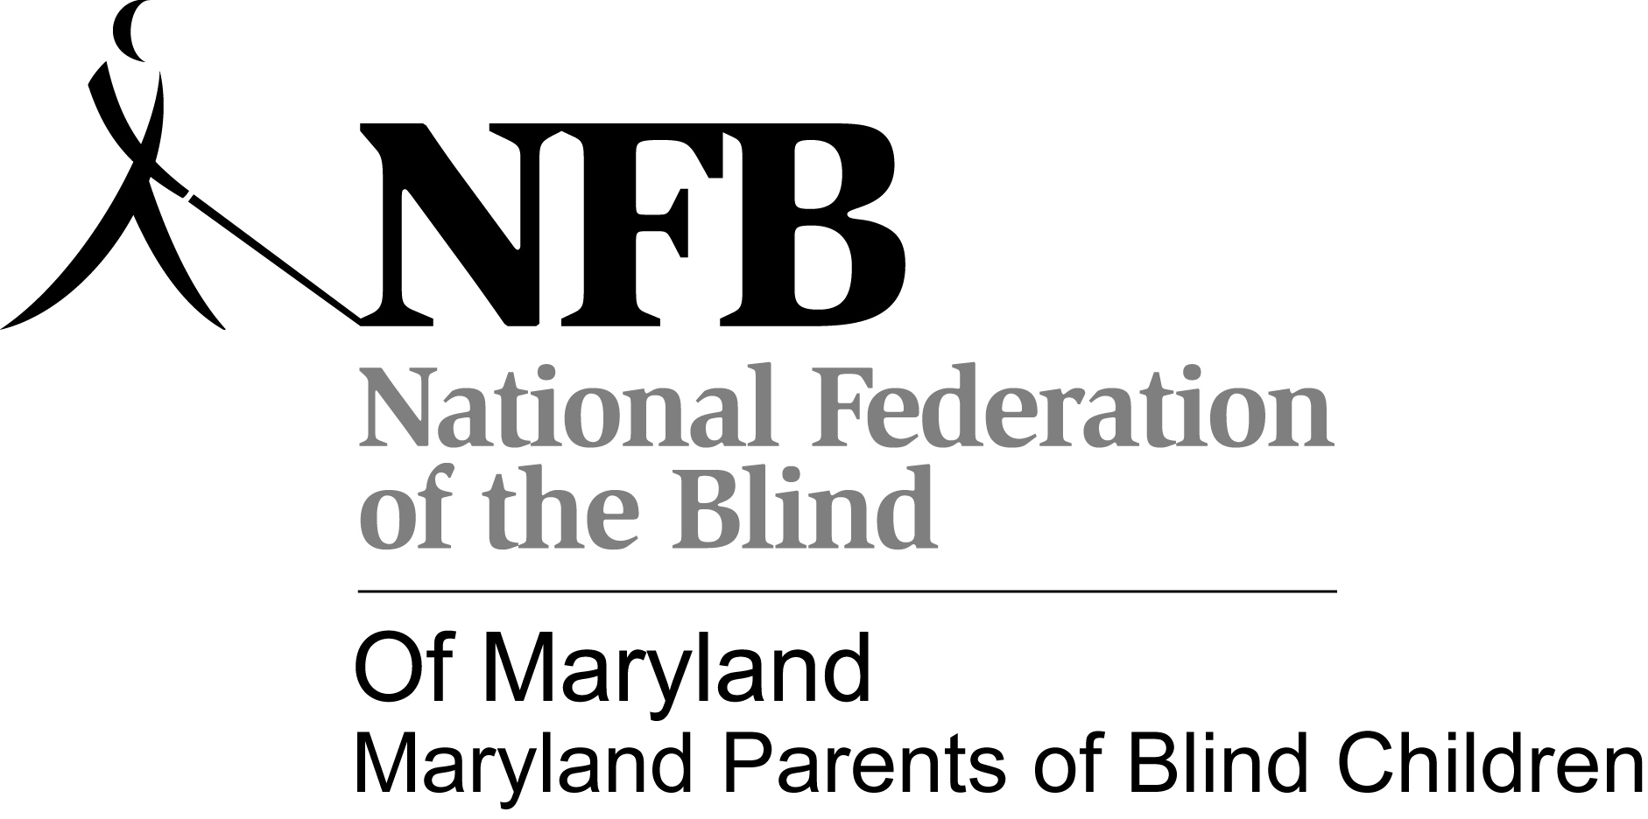

Maryland Parents of Blind Children
Cordially invites:
• All parents, grandparents, and siblings of blind children
• Educators of Blind children
• Others interested in promoting a climate of opportunity for blind children
to a
Maryland Parents of Blind Children Family Picnic
(Menu: Hamburgers, Hot Dogs, & everyone favorite Covered dish they want to bring)
Hamburgers and Hot Dogs, & paper products provided by MDPOBC
and a
Beep Baseball, Games, Back to School Supplies
Saturday, Aug. 23, 2014
2:00 - 7:00p.m.
Centennial Park South Pavilion C

Please respond to Trudy at 301-501-1818 or e-mail: tlpickrel@hotmail.com to let us know that you are coming (So we know how much food to have on hand!)

Direction:
http://www.centennialmd.org/index.php?dove=maps
From Hagerstown-
Take ramp right for I-70 East toward Frederick go 55.3 mi
At exit 87A, take ramp right for US-29 South toward Columbia / Washington go 3.0 mi
At exit 22, take ramp left for MD-100 East toward Glen Burnie go 2.0 mi
At exit 1C, take ramp right and follow signs for Centre Park Drive go 158 ft
Keep straight onto Centre Park Dr go 0.3 mi
Turn right onto MD-108 / Old Annapolis Rd
ROYAL FARMS on the corner go 1.1 mi
Bear right onto MD-108 W / Old Annapolis Rd go 206 ft
Arrive at 10000 Route 108 Columbia, MD 21045 (410) 313-7271

From Baltimore:
Keep straight onto I-395 S go 0.7 mi,
Take ramp left for I-95 South toward Washington go 9.8 mi
At exit 43B, take ramp right for MD-100 West toward Ellicott City go 3.2 mi
At exit 2, take ramp right and follow signs for MD-104 go 0.3 mi
At roundabout, take 3rd exit onto MD-104 / Waterloo Rd go 0.2 mi
Turn right onto MD-108 / Old Annapolis Rd go 1.7 mi
Bear right onto MD-108 W / Old Annapolis Rd go 206 ft
Arrive at 10000 Route 108 Columbia, MD 21045

Maryland Parents of Blind Children goal is to help blind/visually impaired children grow up to be productive, fully functioning, and independent members of society by providing practical information to their parents and teachers. We are also dedicated to providing ideas, assistance, and information that will help blind/VI children with additional disabilities reach their potential.

